Monday 4 jan

Do you know why today is EXTRA special?

It’s Get To Know Your Followers Day and that means it’s all about YOU!

In my career as a coach and therapist, I have encountered all kinds of amazing people and one of my favorite things to learn about my clients is what they love to do everyday as a routine.

What is that habit that you do daily?



Tuesday 5 jan

We all deserve a trophy for our adulting efforts, right? Today, my adulting tasks include folding laundry and answering emails at the same time, bringing multitasking to a whole new level.

What adulting task are you going to conquer today?

Whatever it is, I’m cheering you on!

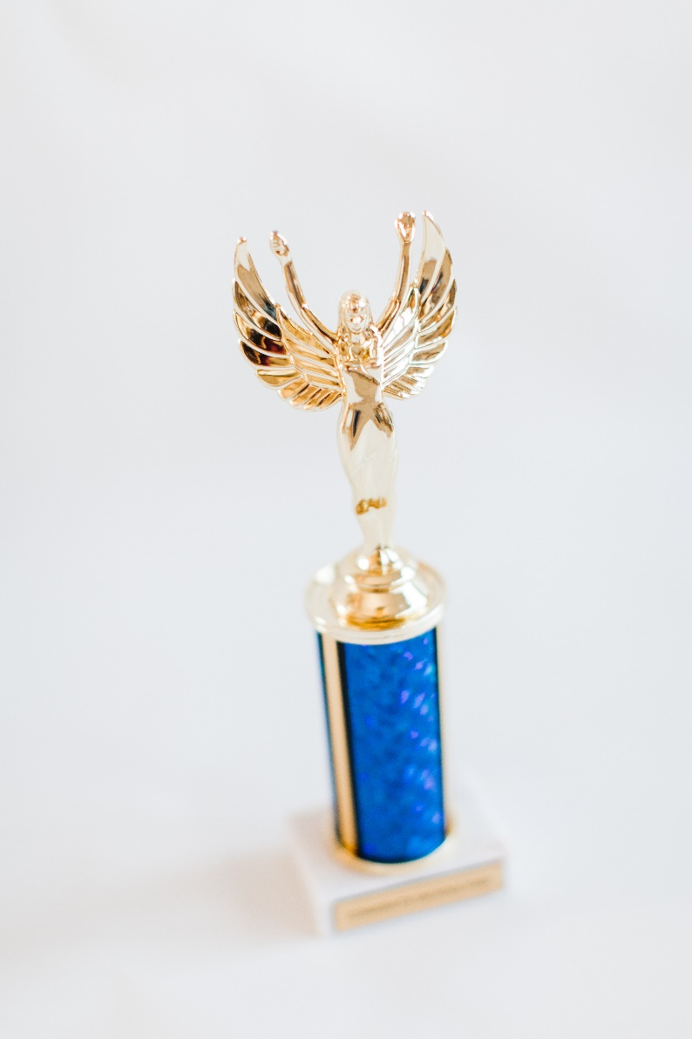

Wednesday 6 jan

Who could use a break today?

If you’re in the mood to treat yourself, take a minute and relax!

Have a cookie or a hot cocoa, a tea, anything that tickles your senses.

Be with yourself and enjoy every moment.



Thursday 7 jan

Calling all creatives! Do you agree that your environment impacts your creativity?

If you’re like me, you need a space that’s conducive to creativity. As a coach and therapist, I’ve tested out quite a few places, but here are a few of my favorite spaces to get my creative juices flowing.

Like this park that is near my house, there is a tree that I love so much.

I hope this helps you! Let me know below if you need more ideas or encouragement to jumpstart your creativity!

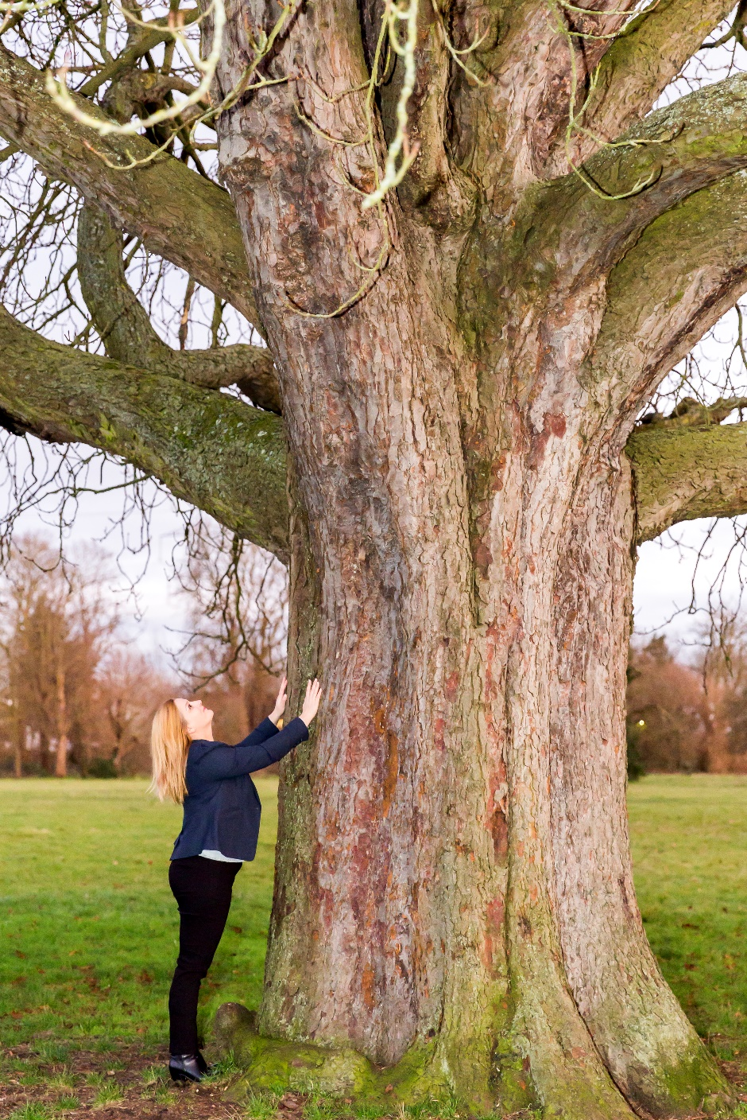

Friday 8 jan

Can I bring up something a little controversial?

I want to chat about boundaries.

So often they get a bad rap, and if I’m honest, I have often struggled with keeping up with my fitness routine during busy seasons.

But no one can be at their best without putting some real, solid effort into drawing a few lines.

What do you need to say ‘no’ to, to thrive even more? I want to encourage you to do it!

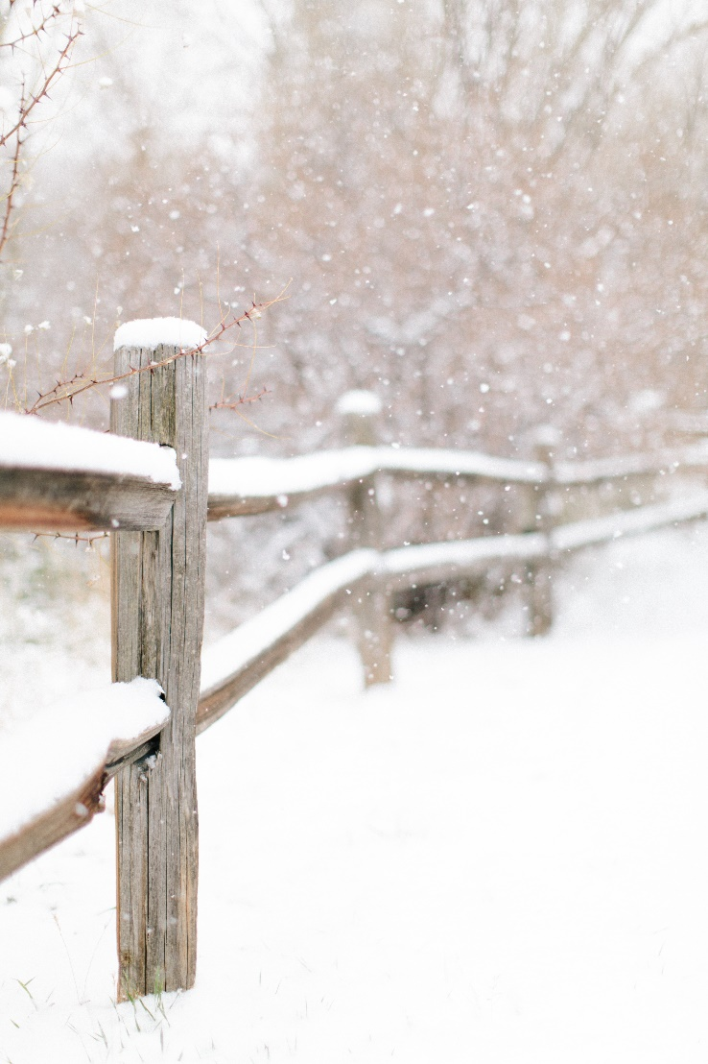

Saturday 9 jan

What plans do you have for the weekend?

I m planning to finish up what work is left and relax with my family.

Time is precious, that is why I like to plan my days ahead so I know what I am going to do. That way I don’t feel like I am “losing my time”.

Remember: Time flies but you are the pilot!

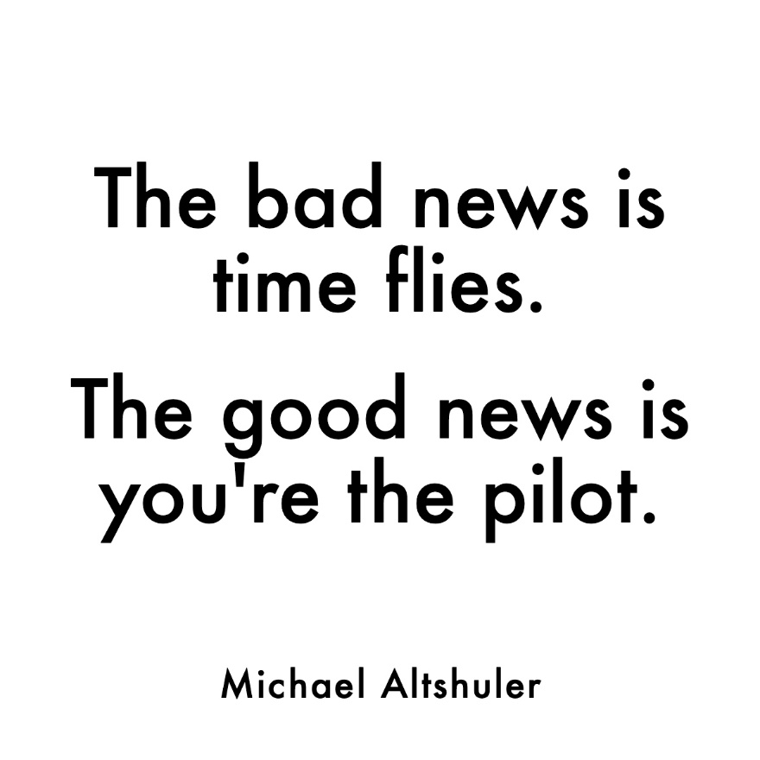

Sunday 10 jan

Can I get sappy for a second?

When I’m old and grey, I don’t want to think about what could’ve, should’ve, or would’ve been.

I want to reflect on the “good ol’ days” without regret, knowing I did what made me happy.

Being a therapist and a coach has given me the opportunity to bring joy not only to myself, but to others, and for that, I’m happy. I’m no fortune teller, but I think my future self will be pretty pleased, too!

Drop an emoji in the comments below if you’re living your best life NOW so your FUTURE self will be proud!

