Monday 28th

Christmas is over and New Year’s is on its way.

But in the meantime, December 28 is National Call a Friend Day!

Who is that friend that you haven’t talked to in ages?

Pick up the phone and call! Between the stress of the daily grind at work, the needs of your family, and ensuring you have a little time for yourself, our lives can get awfully hectic.

Today is the perfect day to call that friend! Stop for a minute and enjoy friendship!

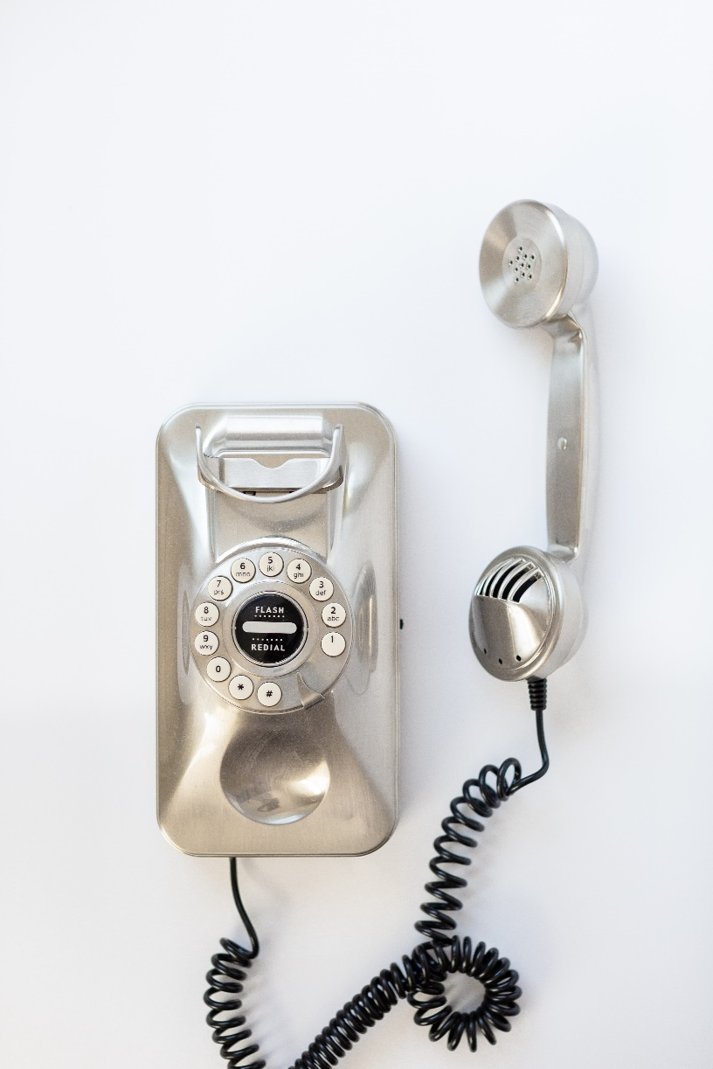

Tuesday 29th

Between Christmas and New Year you try to do the last things you have left undone.

Which are those things for you?

Do you have a “Last minute – to do list”?

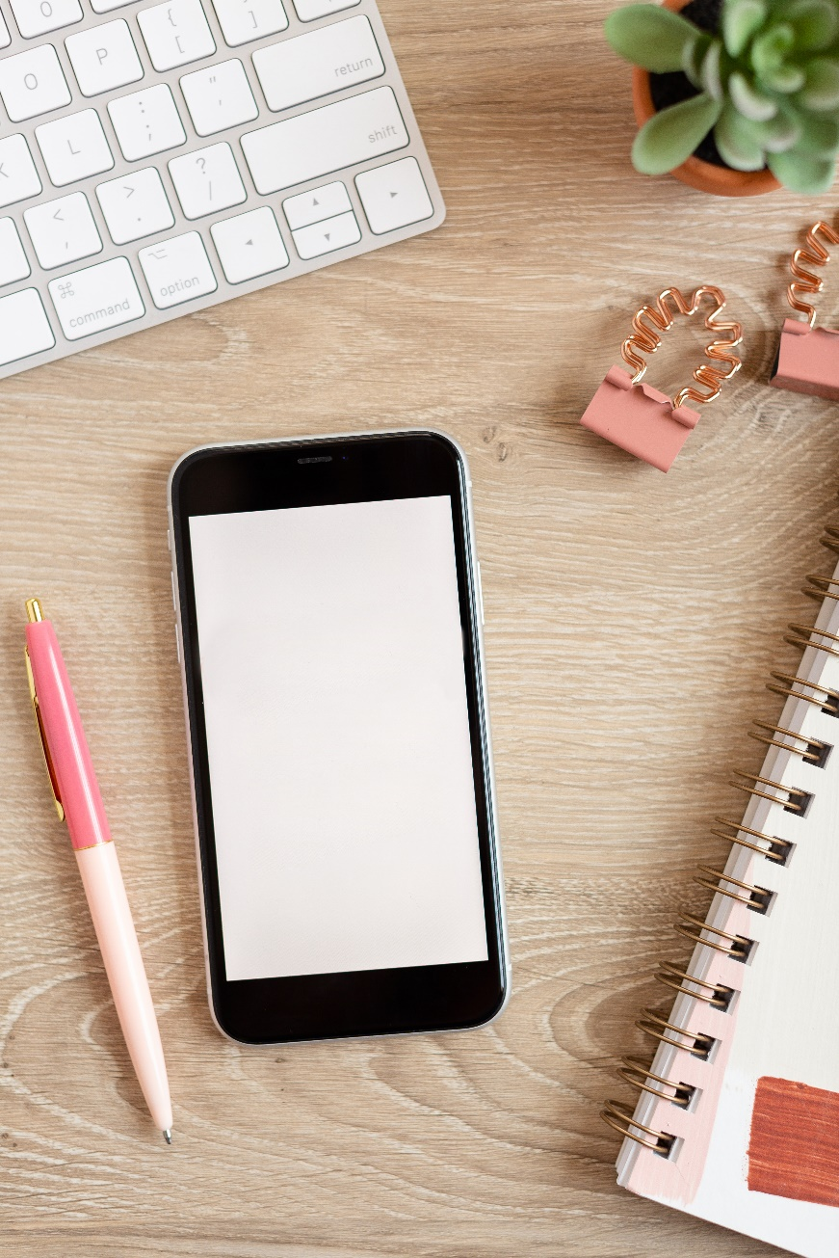

Wednesday 30

In the end… you can regret only the chances you didn’t take.

Leave all the regrets in 2020 and start new! Forgive yourself for all the things you could have done better but in the end didn’t go as planned.

Be kind to yourself! Love yourself!

There will always be other opportunities, other chances, you just have to be ready to take them!

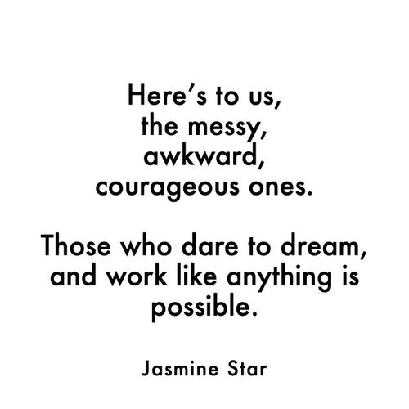

Thursday 31st

Raise your hand if 2020 looked anything like the plans you made for it at the end of last year!

Yeah? Me neither. But you know what?

I never would have guessed I’d have grown my online business 3-fold as a result of a global pandemic and shutdown*.*

I learned adaptation is the key to making it in an ever-changing world.

What unexpected lessons shaped your 2020 vision?

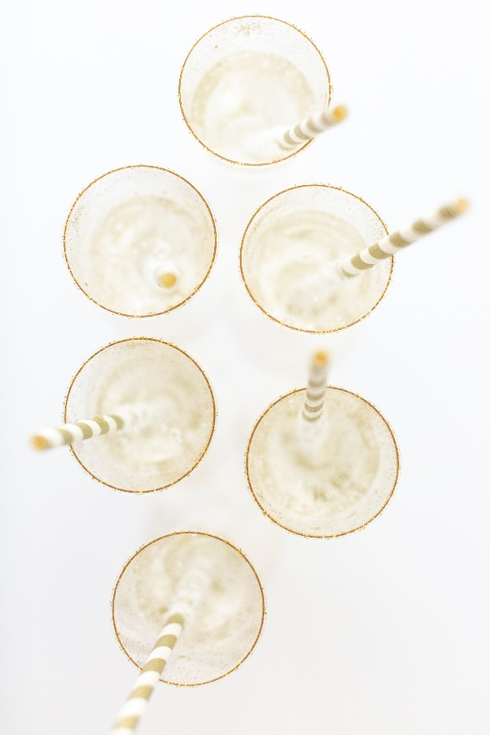

Friday 1st January 2021

Hello New Year!

Set the goals, put the wheels in motion and let’s make 2021 the best of all!

What plans do you have? Which will you start first?

Name 3 goals for this new year.

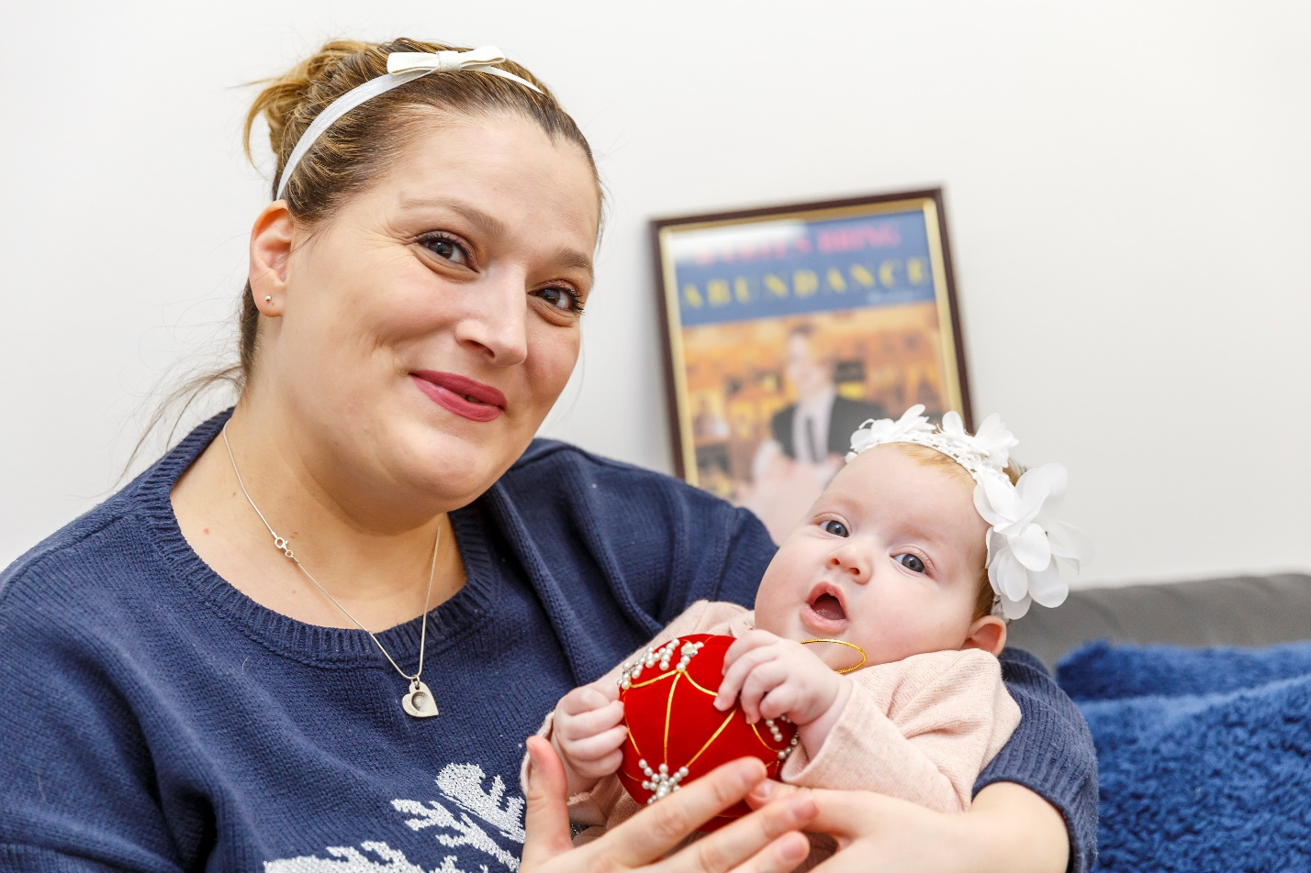

Saturday 2nd

Be grateful! Start with what you have!

Every day means a new chance, a new beginning!

Every day is special and is nothing like the one you had yesterday.

What are you grateful for today? No matter how hard the time is, see the good in everything!

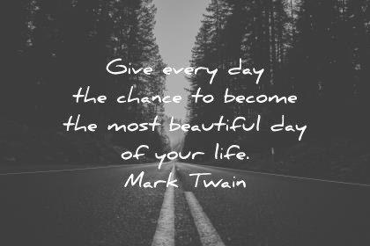

Sunday 3rd

The 3rd of January is the International Mind-Body Wellness Day!

Today we celebrate the connection between mind, body and spirit because this plays an important role in our well being.

Our emotions, purpose, spirituality, experiences, goals, beliefs, habits and actions all have an important impact on mind-body harmony and overall health.

How do you celebrate?

