Monday 25

Imagine you won the lottery.

Woo hoo!

What's the first thing you would buy? #questionoftheday #answerthequestion #anotherrandomquestion  
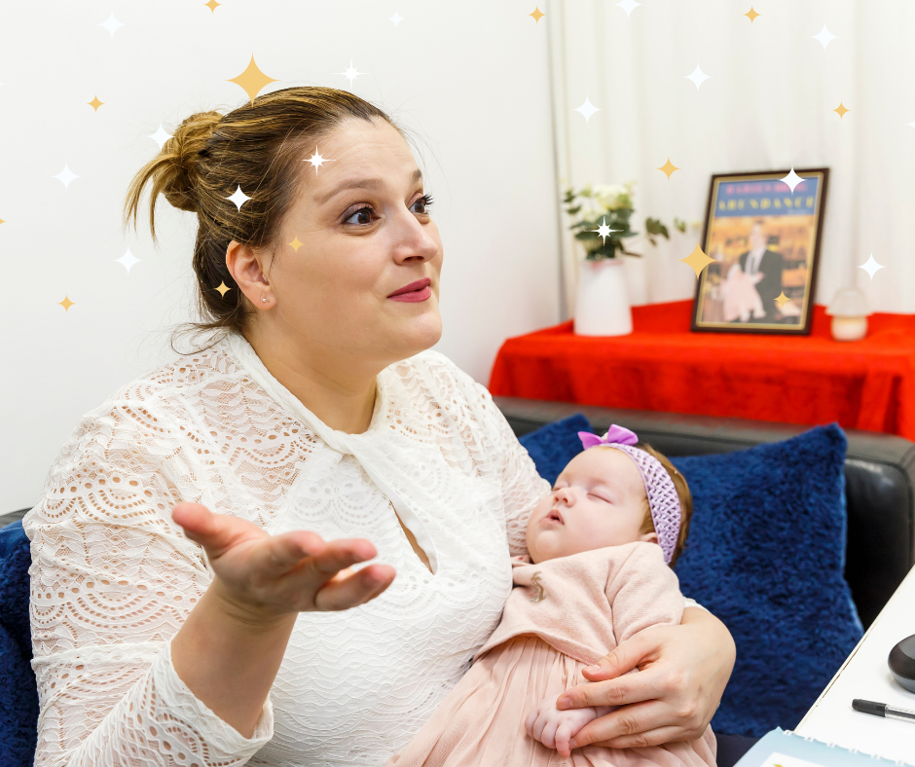

Tuesday 26

Life is pretty great when you focus on the light.

#tuesdaythoughts from you?

What thoughts do you have today?

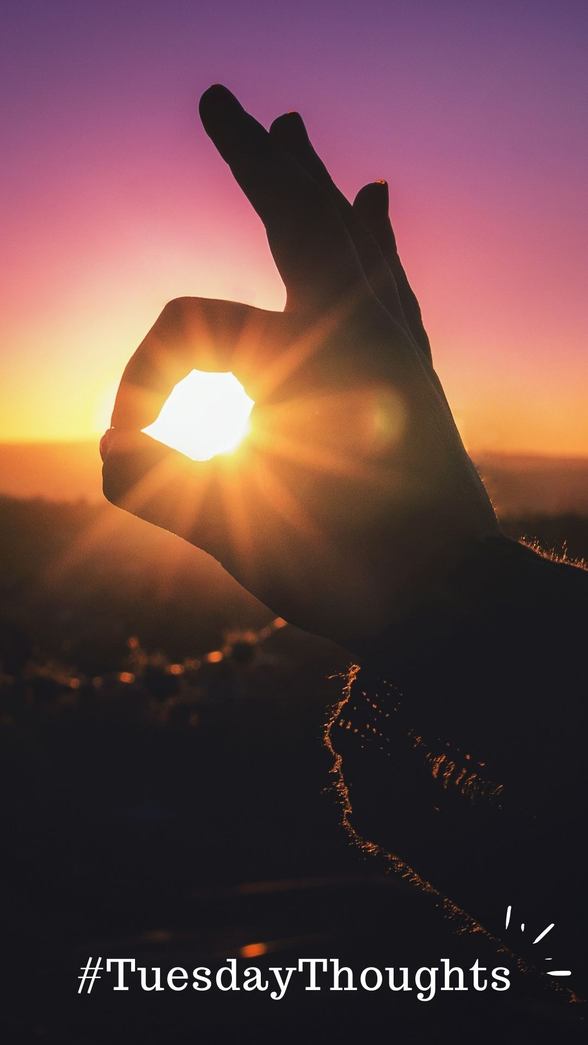

Wednesday 27

The first step to achieving your dreams is to believe it's possible.

Because it is if you want it to be and if you believe you can do it!

So, what is your dream that you know you can achieve?

#motivationalquotes #inspiringquotes #successmindset

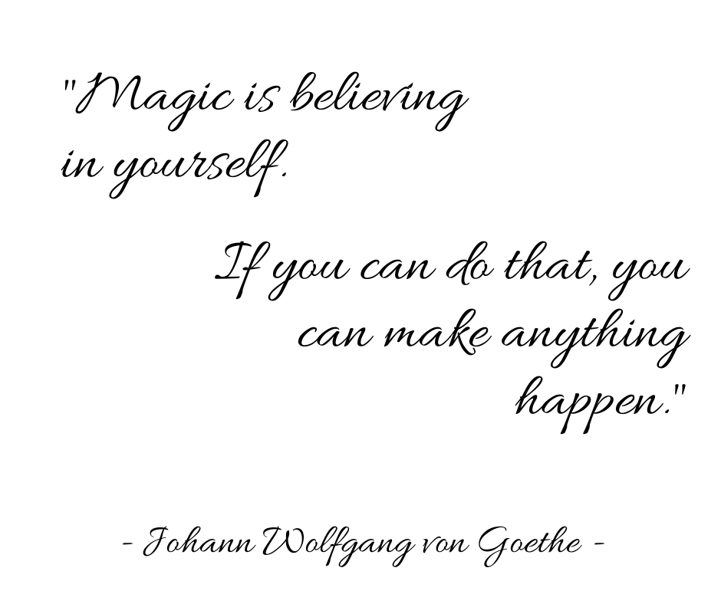

Thursday 28

Ready for a workout?

A BRAIN workout, that is! Grab a pencil and paper, because we’re about to do a 5-minute brainstorming session!

Here’s how it works…

First, set a timer for 3 minutes and do a brain dump of any ideas about your area of expertise that come to mind. In my case would be therapy, for example.

Second, take a minute and write down any potential roadblocks or questions that need to be answered based on the ideas you thought of.

For the last minute of your brainstorming session, think of ways you can get more inspiration for your ideas, like reading magazines, scrolling on Pinterest, or reaching out to a peer.

There you have it! In five minutes flat, you were able to flex your creativity muscle! Wasn’t that fun?

Care to share any ideas you thought of in the comments? I’d love to hear them!

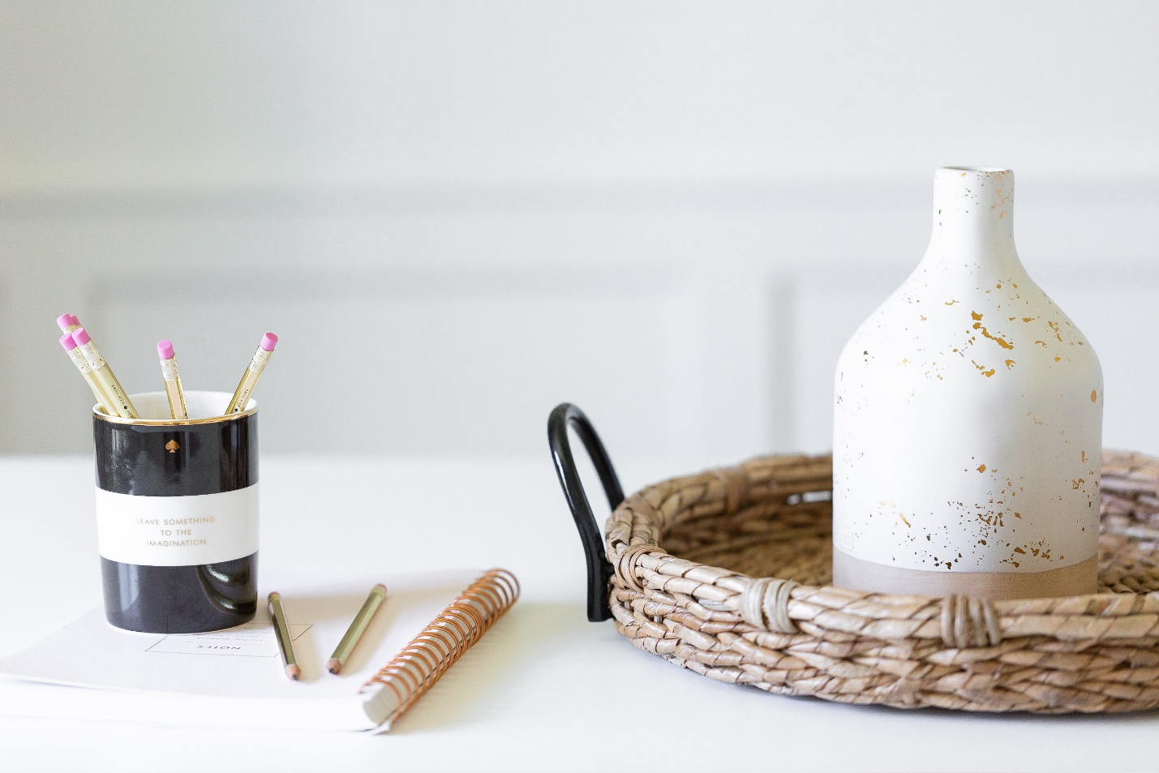

Friday 29

POLL: Are you a pessimist or an optimist?

I’ll be the first to admit that staying positive is not always easy, especially when things are not working as planned.

But when I’m feeling overwhelmed or down about myself, I always remind myself I’m special.

In fact, the best part about me is that I’m ME… not anyone else.

And that’s the best part about you, too!

Are you typically a pessimist or an optimist?

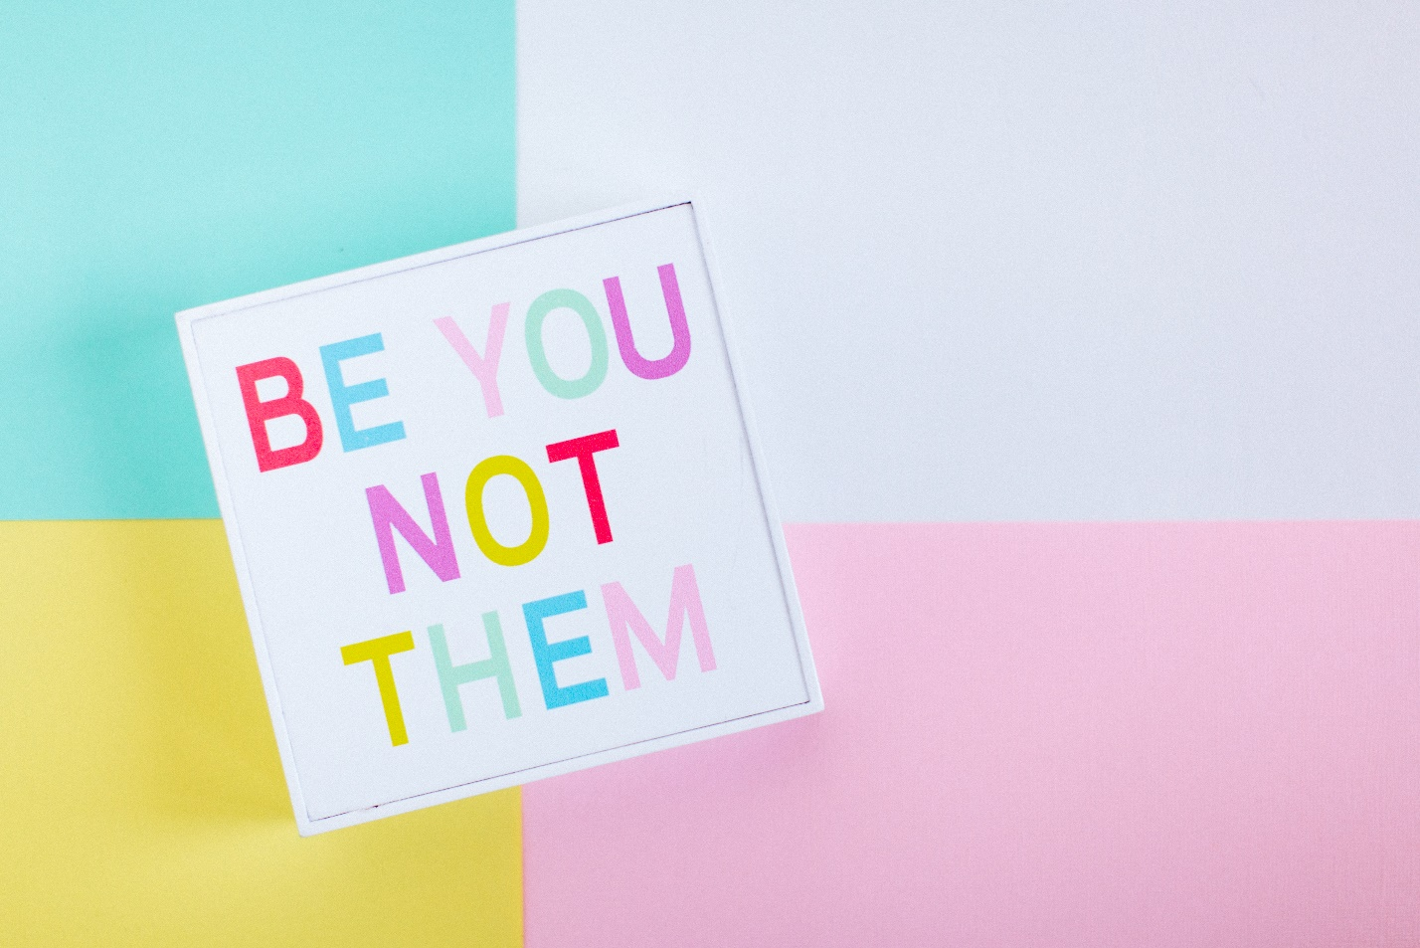

Saturday 30

Was there a time when you did something even though you were scared to death of that action?

That is power! The courage to move forward, to take another step,

I know the feeling. We all go through something like that at least once in our life.

But hey, life is beautiful!

Enjoy the ride 😊

“Courage is being scared to death and saddling up anyway.“ - John Wayne

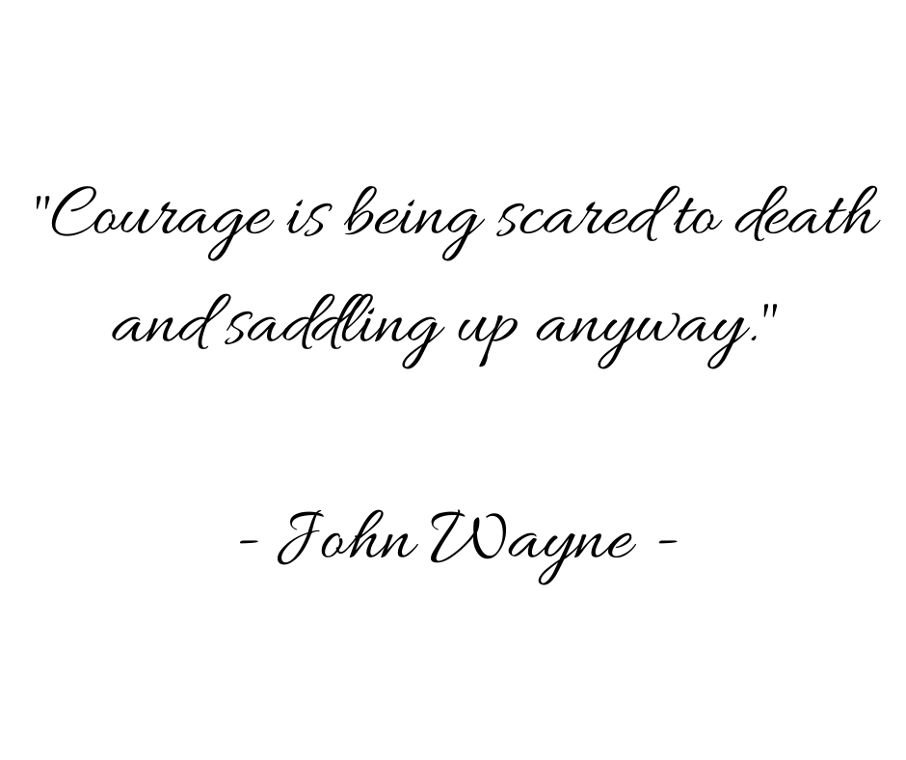

Sunday 31

How do you get yourself motivated on a Monday morning?

I know, I know, is Sunday, but tomorrow is THAT day of the week! The start of a new week and a new month.

For me, enjoying a slow cup of tea starts my day off right.

But not until I’ve done my meditation!

I LOVE what I do, but sometimes I just need a little extra time to get in the right frame of mind before spending the day working on my dream job.

So how about you? I want to hear how you motivate yourself… maybe it will inspire others in the comments!

