Monday 11 time management – Pomodoro method

How to use your time to work more efficiently?

One of the most popular methods is Pomodoro. This technique is a time management method developed by Francesco Cirillo in late 1980s.

How does it work?

You work for 25 minutes straight take a break for 3-5 minutes, then again until you did that 4 times. After the fourth interval of 25 minutes, take a break for 15-30 minutes.

In the original technique there are 6 steps:

1. Decide on the task to be done.
2. Set the timer to 25 minutes.
3. Work on the task.
4. End work when the timer rings and put a checkmark on a piece of paper.
5. If you have fewer than four checkmarks, take a short break (3–5 minutes) and then return to step 2; otherwise continue to step 6.
6. After four periods of 25 minutes, take a longer break (15–30 minutes), reset your checkmark count to zero, then go to step 1.

If you haven’t tried this technique yet, give it a chance.

You will be surprised how productive you can be 😊

Good Luck!



Tuesday 12 – setting goals SMART

Do you know what you need when you have a goal? To know the steps you have to take to achieve it!

In coaching there is a method called SMART.

To make sure your goals are clear and reachable, each one should be:

**Specific (simple, sensible, significant).**

**Measurable (meaningful, motivating).**

**Achievable (agreed, attainable).**

**Relevant (reasonable, realistic and resourced, results-based).**

**Time bound (time-based, time limited, time/cost limited, timely, time-sensitive).**

How do you set your Goals? Do you use other methods?



Wednesday 13th make your dreams come true day

Is a celebration day!

What do we celebrate? “Make your dreams come true” Day!

Today we celebrate our dreams, our deepest desires.

My biggest dreams is to help 1.000.000 people feel safe and secure with themselves.

What is your biggest dreams? What will you do to make it come true?



Thursday 14 Quantum flow – I m working on it

I stepped into 2021 with certain goals, already working on them.

My first task is add the Quantum Flow Method to my certifications.

So, since the 4th of January, I am working on it.

What do you plan for the first month of this marvelous year?



Friday 15 quote

“Be like a flower. Survive the rain but use it to grow.” – Unknown

When you go through difficult times, remember that quote!

You are strong, even if you look fragile to the outside world!

You are powerful, a winner!

Head up, don’t let the crown fall!

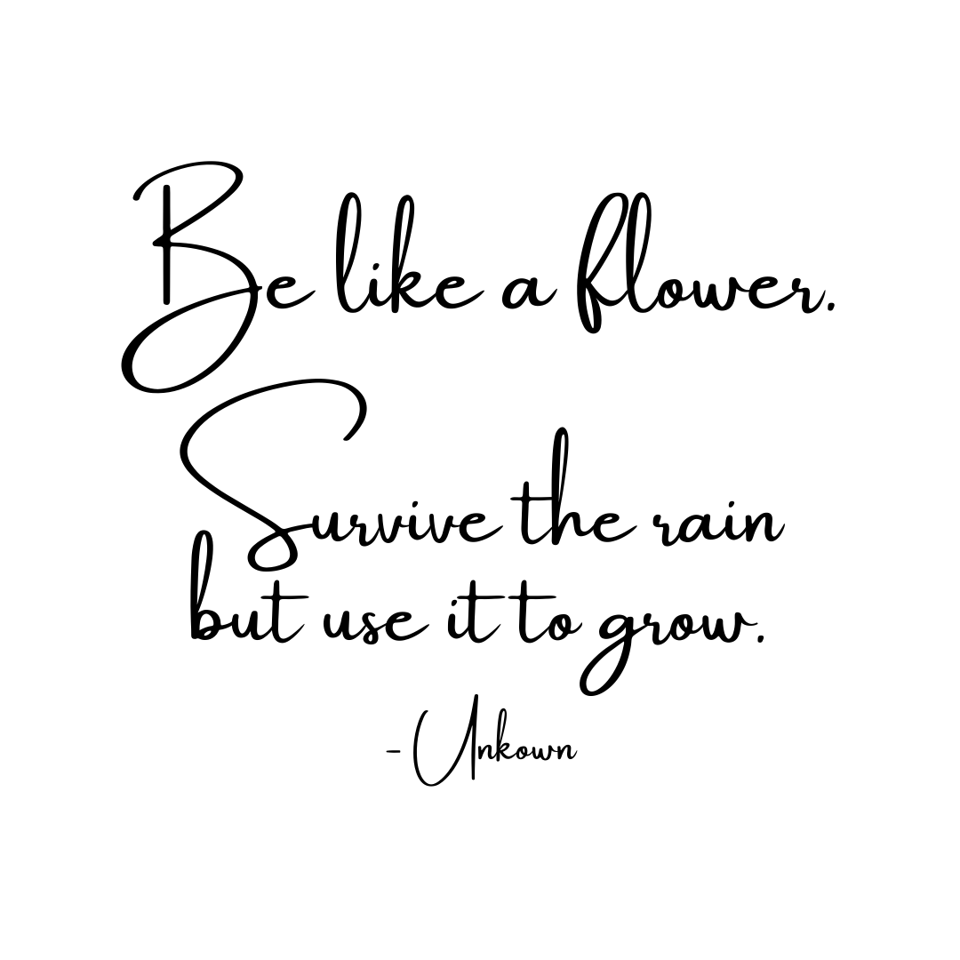

Saturday 16 – brainteaser

Share your answer to this brain teaser in the comments.

Which month has 28 days?

#brainteaser #riddles #riddlemethis

P.S. I will tell you the correct answer at the end of the day 😊

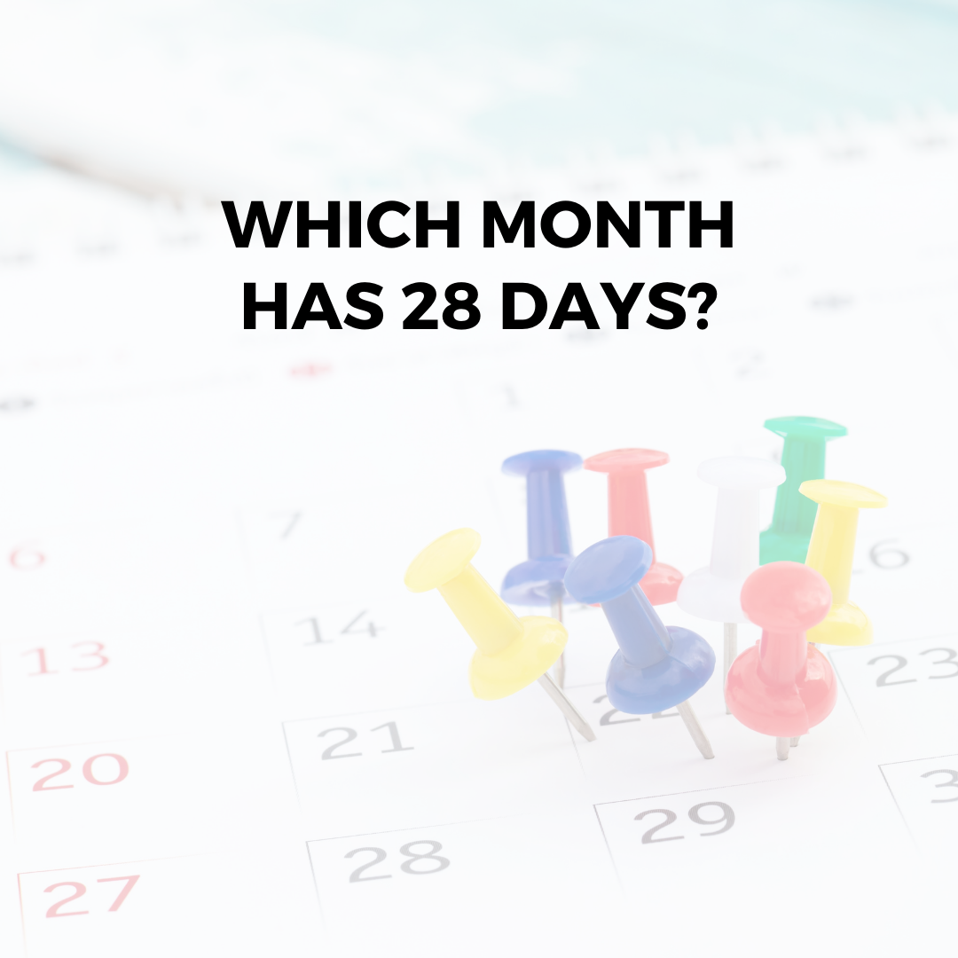

Sunday 17 – make mistake

Sometimes our mistakes bring the greatest reward.

Don't be afraid to make mistakes in life. You'll miss out on all the fun!

Mistakes can make you better, wiser and you can learn valuable lessons from them.

Tell me, what mistake did you make in the past that gave you a valuable lesson?

#makemistakes #wordstoliveby #takerisks

