Monday 22

It's Monday and we all want to start the week with a great attitude. For that, we need a positive attitude first of all.

So, imagine your ideal day, how does it look like?

What can you do to make it happened?



Tuesday 23

You know when you get a new idea and you start to talk about it… “Yea I will do that and this, etc etc.”

But then you just talk and talk and for some reason, you don’t do it.

There it is the procrastination!

Want a piece of advice? Listen to Walt Disney!

“The best way to get started is to quit talking and begin doing.”

Stop looking for reasons why not to begin and use what you can and what you have.

#tuesdayvibe

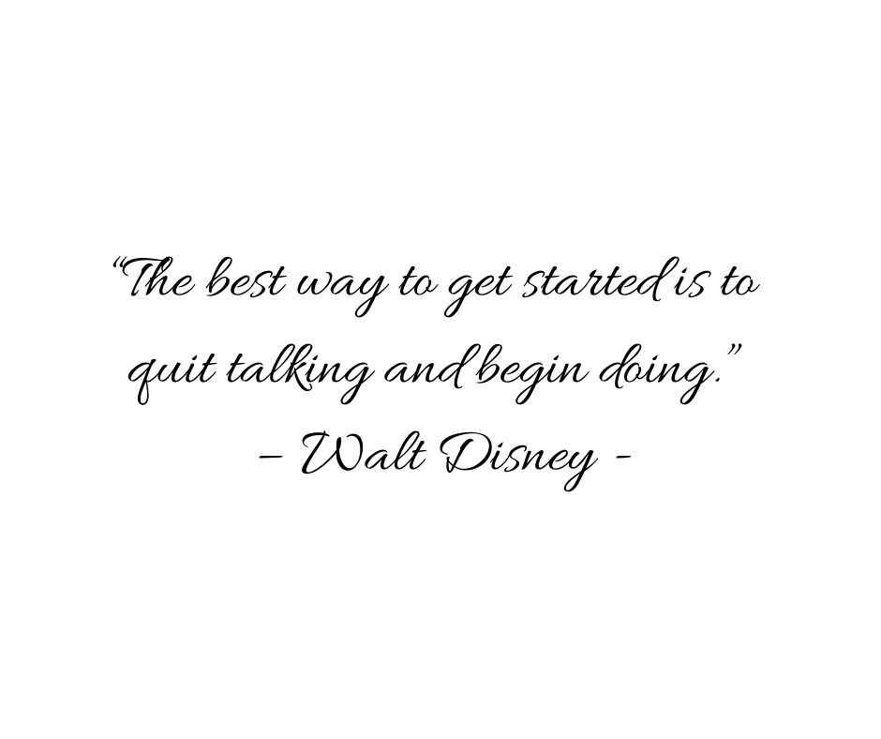

Wednesday 24

How’s your 2021 so far? I set a plan this month to make moves on my projects.

I’m so excited for the next step, but I’m taking a moment today just to *celebrate how far I’ve come.*

How are things with you?



Thursday 25

I want to know something: How do you get started when you have a huge task ahead of you?

 I tend to begin by thinking about the strategyand a step-by-step plan!

If I’m in a time crunch, I usually ask for help.

What gets you from start to finish?

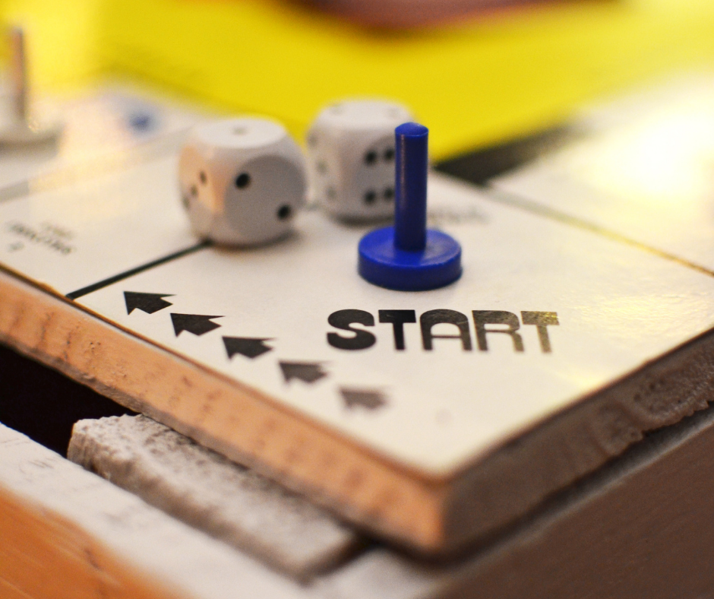

Friday 26

Today I want to take you on the memory lane once again…

Remember when you were in your early days as an entrepreneur?

It was quite an adventure to start your business.

And then the first client… how did it feel to have your first client?

Today is about your first experience with a client. Want to share?



Saturday 27

#saturdaymorning

We all have apps that we use daily, but there is one that is so special that we can’t like without.

What is your special app?

**IF you could have only one app on your phone, what would it be?**



Sunday 28

Goodbye February!

Here comes the 3rd month of 2021 with new opportunities!

Today I will relax and celebrate the end of February and the wins I had.

But tomorrow I will set the wheels in motion for the first month of Spring!

What is your plan for March?

