Monday 22

Monday is getting you down?

Here’s something that helps me: Plan everyday so I don’t get crowded and burnout.

In case you needed an extra boost, I’m sending good vibes your way today and always!

What’s something that makes even the most terrible day of the week better for you?

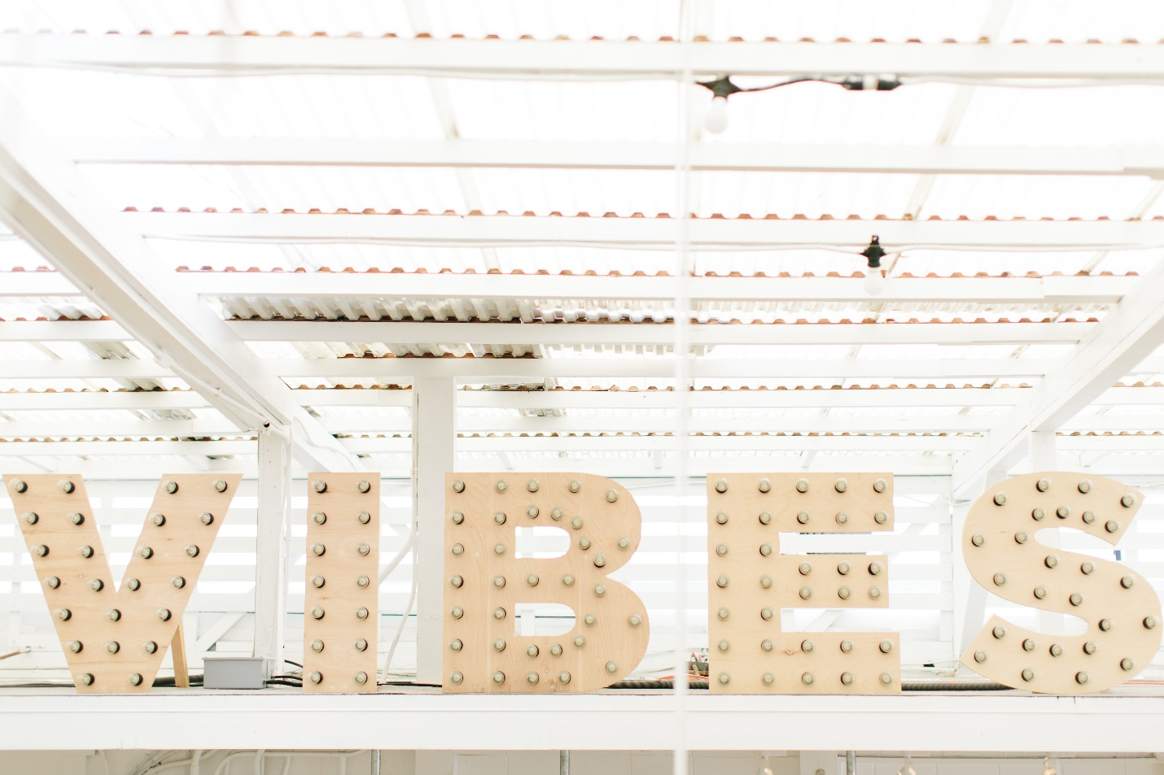

Tuesday 23

“There are two words that, when spoken, have the most unfathomable power to completely change your life.

Two words that, when they pass your lips, will be the cause of bringing absolute joy and happiness to you.

Two words that will create miracles in your life, wipe out negativity and bring you abundance in all things.

Two words that, when uttered and sincerely felt, will summon all the forces in the Universe to move all things for you.

There are just two words standing between you, happiness, and the life of your dreams….

THANK YOU.”

Gratitude and Love,

Adina x

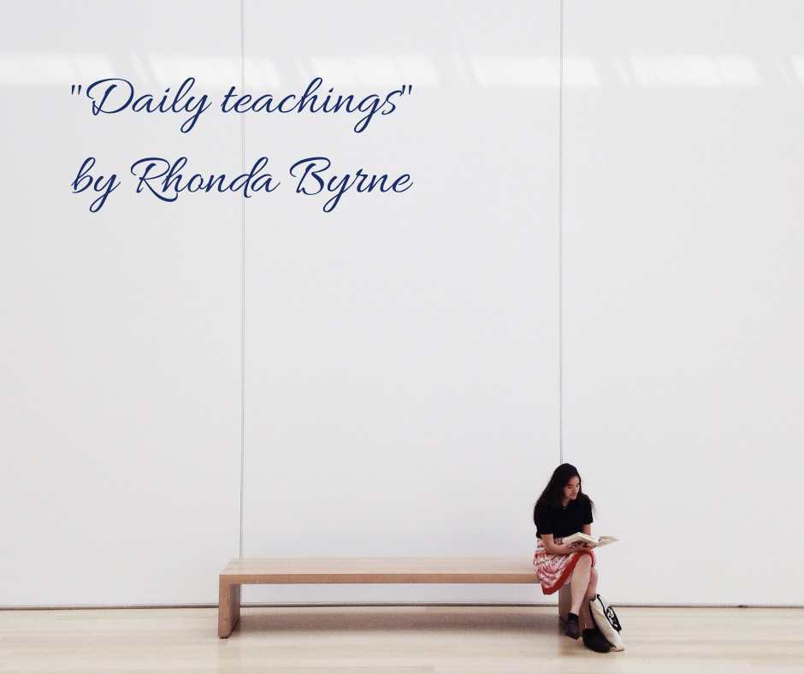

Wednesday 24

Do you ever wish you could erase your mistakes and start over?

I admit I do sometimes. But then I think: “Without the mistakes I’ve made, I wouldn’t be the person I am today.”

So instead of erasing my mistakes, I’m expressing gratitude for them!

What’s one lesson you learned from a mistake recently?

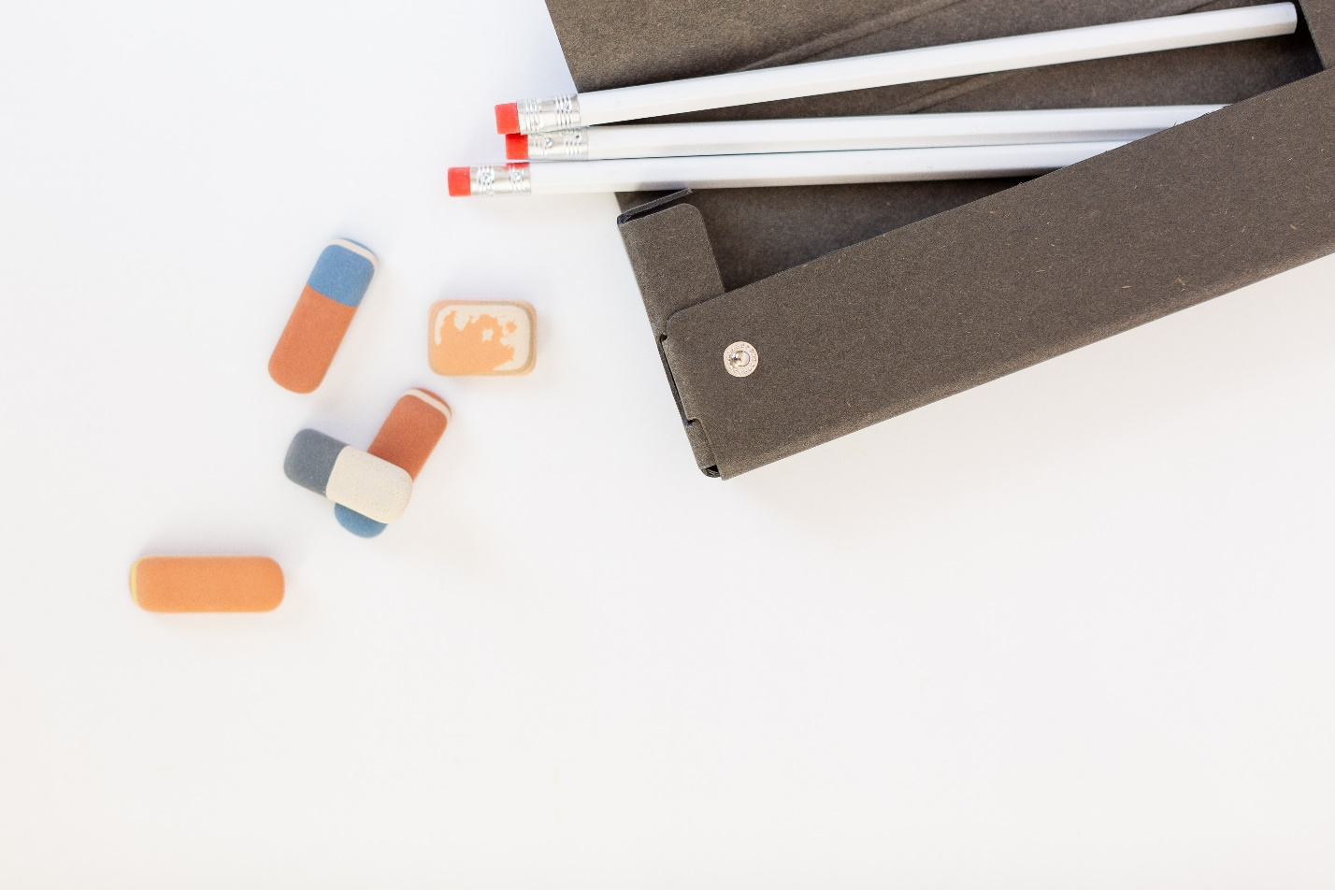

Thursday 25

Here’s the shortest explanation of how I got to where I am today: I started from the bottom (and by that I mean I was a waitress when I first moved to London and now I’m HERE (I am a therapist and a coach and I have my online business).

Pretty cool, huh? What questions do you have about my business?

I love sharing with you, so drop them below!

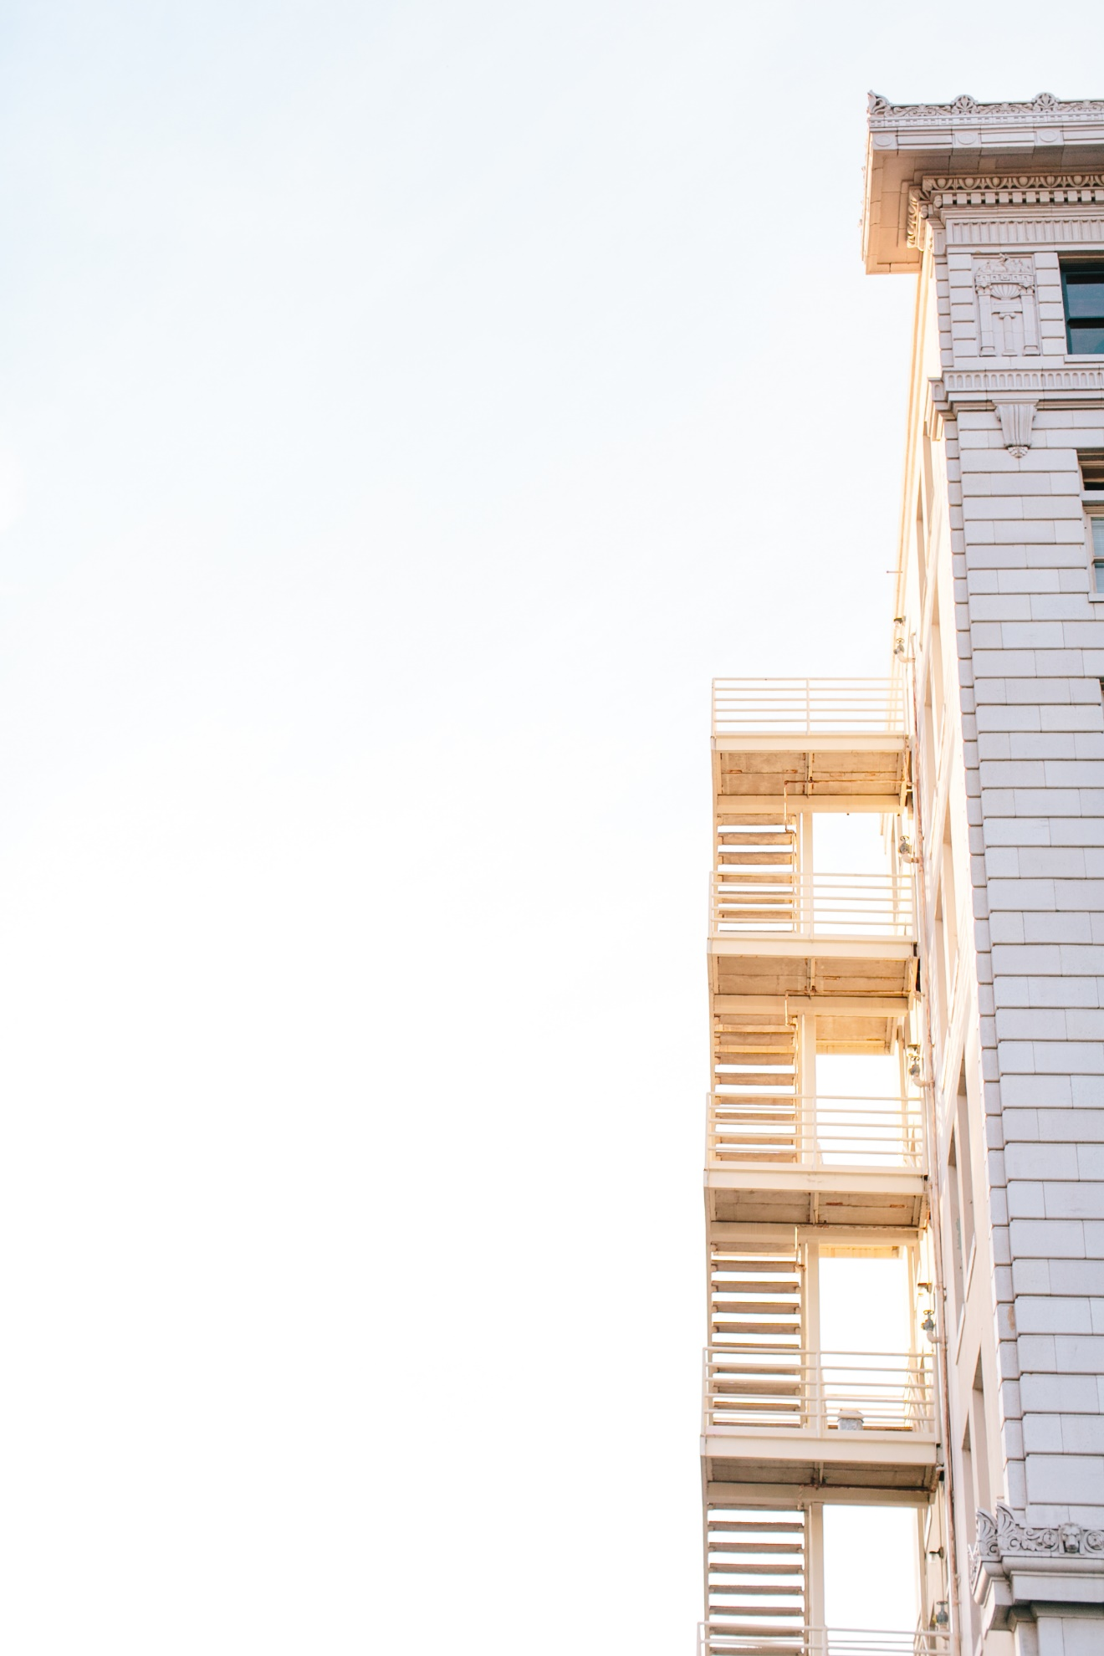

Friday 26

If you were stranded at sea, who would come to your rescue?

No doubt about it, I know I could count on my mentor to save the day. She has always been like a lighthouse for me, guiding me in the right direction with her wisdom.

Tag someone below that acts as your lighthouse to show your appreciation and send them some love today!

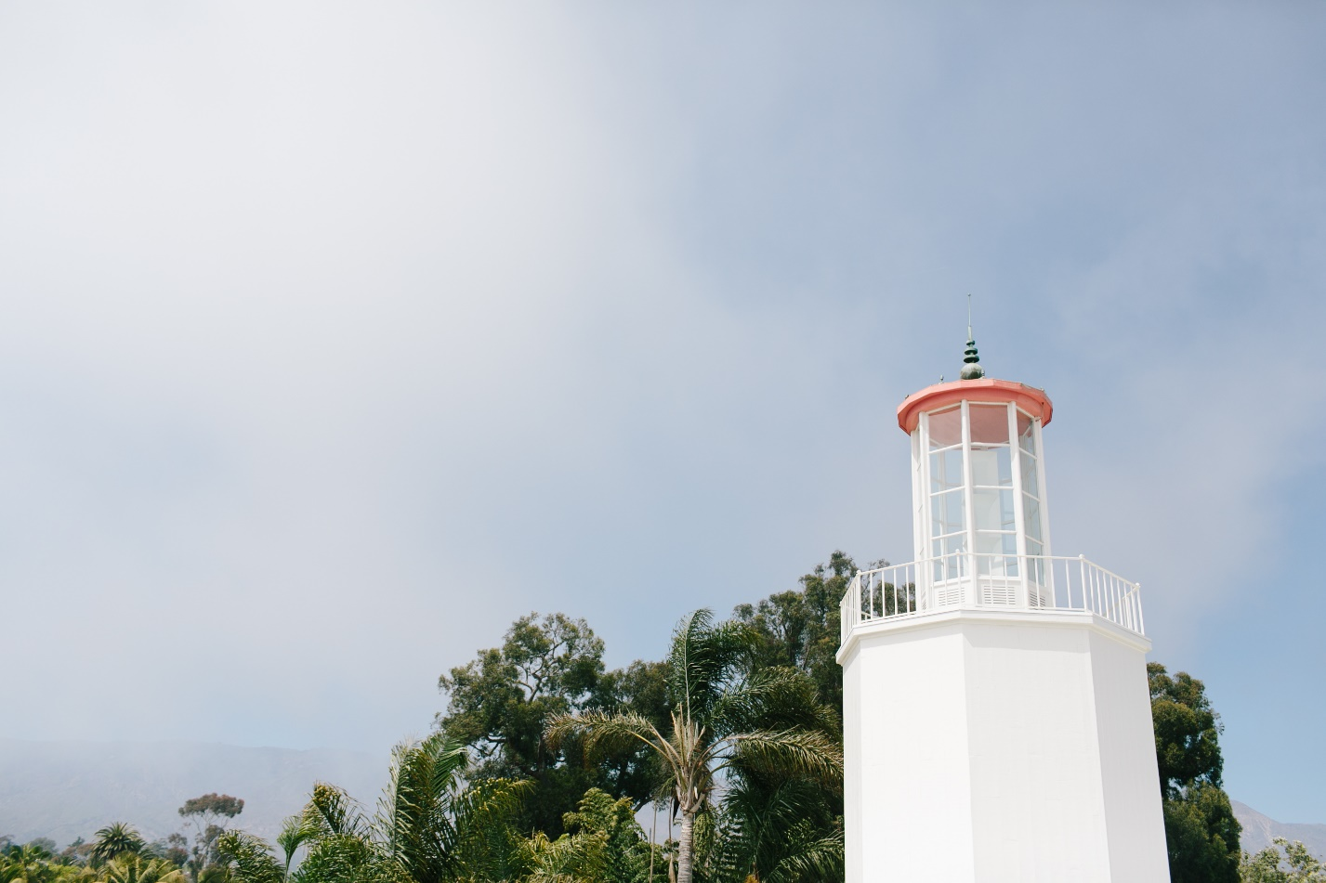

Saturday 27

Keep that in mind 😊

My 2 cents for today <3

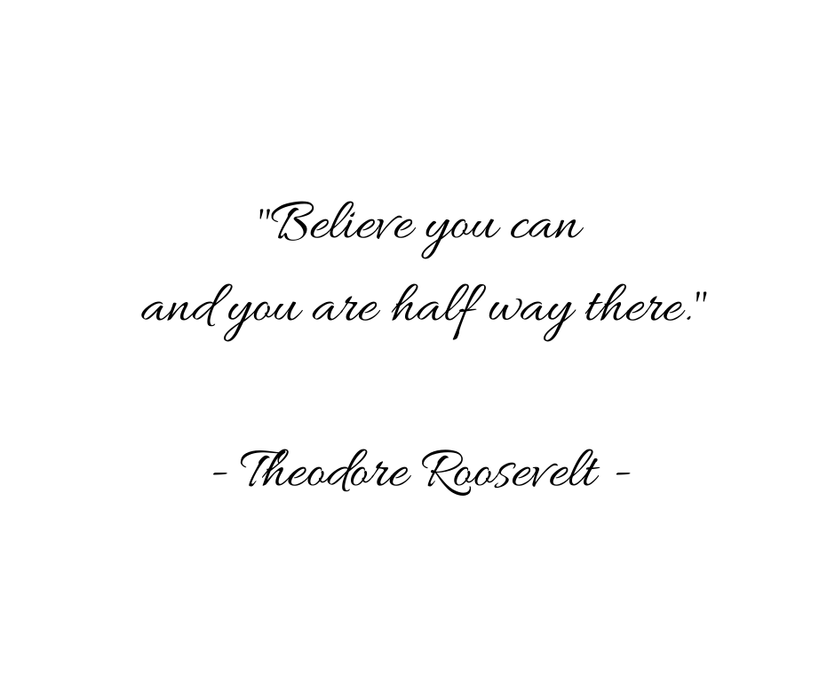

Sunday 28

Looking for an excuse to pour yourself a drink?

Here’s one: Today, I’m celebrating the week that passed, I’m celebrating my business and myself.

So CHEERS to that, beautiful souls! (And Salud! Proost! Viva! Slainte! Da! Cin Cin! Skal!)

Tell me, what’s in your cup to join me in celebrating?

