Monday 3 – Gamma Queens
Are you a #GammaQueen?

You are a complex type of woman, with some particular personality traits.

You are a connector.

A woman who is trusting, resilient and innocent.
You ooze Faith and Optimism. You know that everything will be all right in the end.
You are creating valuable relationships with the people around you.

You are a Catalyst:
Everything is a possibility for you. The gift of creating ideas is yours and that makes you a marvellous creator!
Idealistic, Transformational, Daring. You are championing others.
Making something wonderful where others see nothing.
Seeing the solution when there seem to be just problems.
You are a true Alchemist!

Family-focused.
You take care of the people around you. Devoted, reliable and giving. Gifts that cannot miss from a true Nurturer.

You are always giving amazing value, you are generous and loyal.
A person others can always count on!

Am I right? 😊

You are a Creator!
Most of all you’re Clever, Flamboyant and Charismatic.
Taking the risk, calculated risk, structuring and handling financial details.
Always paying attention when you are dealing with numbers and financial details.
A true force of nature!
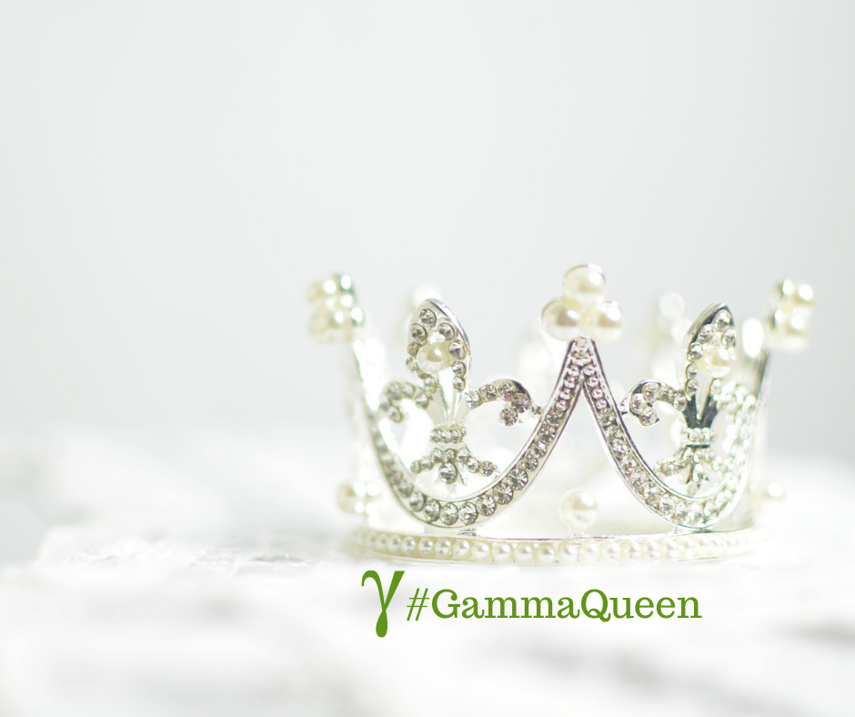

Tuesday 4 –
Today is about appreciation towards those who thoughts us.

Is about teachers. National Teachers Day!
This day meant to honour them was made by a teacher. None other than First Lady Eleanor Roosevelt herself.

Eleanor Roosevelt was more than Franklin D. Roosevelt’s wife, she has a history of civic duty and was an advocate for fellow teachers. Her love for education began at a young age when she was privately tutored and encouraged by her aunt Anna “Barnie” Roosevelt.

A teacher is not just limited to the classroom. It can be anyone who you look up to or has taught you lessons in life — a friend, a family member, or a mentor (just like Mr Miyagi in “The Karate Kid”).
The day is all about thanking teachers for imparting knowledge and wisdom and inspiring us to be better versions of ourselves.

Who is your favourite teacher?
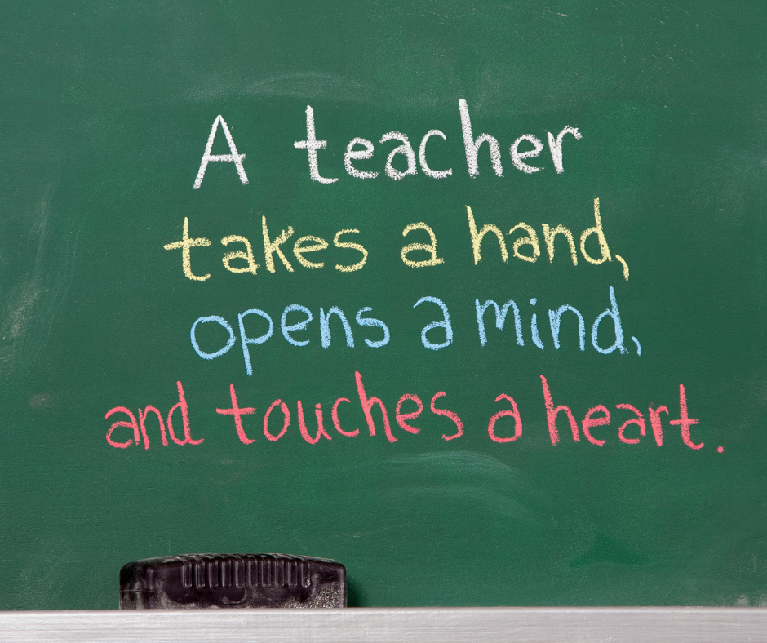

Wednesday 5 – daily teaching
“ Did you know that if your life wasn’t changing, you would not exist? Our Universe and everything in it is continually changing, because our Universe is made of energy.

Energy can exist only if it is in motion and changing. If energy stopped being in motion, our entire Universe and all Life would vanish.

Our lives are also energy, and therefore they too must always be in motion and continue to change. You cannot stop the motion and change your life, and nor would you want to.

The changing nature of energy gives us Life. It causes Life to grow and causes us to grow.”

Gratitude and Love,
Adina x

Thursday 6
#brainteaser #thursdayquestion
If it took 6 people 9 hours to build a barn, how long would it take 12 people to build the same barn?

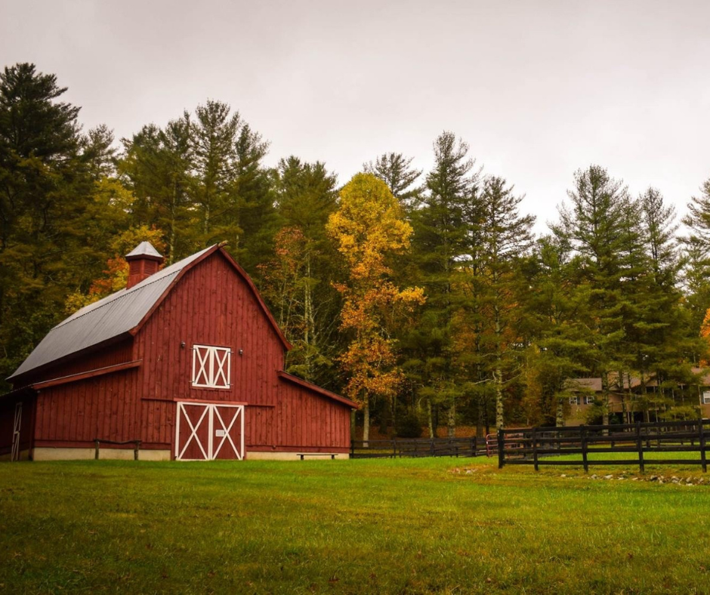
Friday 7
Here’s your Friday reminder that you can do hard things, like starting that project you have in mind for months.

What if you haven’t figured out everything?
Start with what you have!

You’ve got this! Tag someone below who needs to hear this pick-me-up today!


Saturday 8
If you want to be happy, be. - Leo Tolstoy

Nobody is stopping you.
Happiness is something that you can choose to feel.
By being grateful, appreciative towards what you already have.
So be grateful! Appreciate! Be happy!

Sunday 9 – daily teaching
DAILY TEACHING – DAY34
“ Think good thoughts.
Speak good words.
Take good actions.
Three steps that will bring more to you than you can ever imagine.”
Gratitude and Love,

Adina x
