Monday 24 – gq
Generation X (1961-1980) and Generation Y (1981-2000).
The fact that you are a #GammaQueen, is it a generation “thing”? Is it characteristic because you were born between 1961 and 2000?

Generation X is the one that went through life without internet and then with internet. This generation witnessed so many changes that never in history ever happened or will happen.

Gen X still reads newspapers, magazines, listens to the radio, and watches TV (about 165 hours' worth of TV a month). However, they are also digitally savvy and spend roughly 7 hours a week on Facebook (the highest of any generational cohort).
5 Characteristics of Gen X:
- They are more direct.
- Professionals that embrace feedback and don’t let negative feedback keep them up at night.
- Embrace work-life balance.\
- They have a hybrid relationship with technology.
- Gen Xers are more adept to collaboration.

Generation Y (Millenials) on the other hand are great with tech and digital.
5 Characteristics of Gen Y:
- They are digital native.
- Values flexibility and challenges the routine.
- Gen Y seeks work-life balance.
- Seeking for rewards and praise, they are results-oriented.
- They are ambitious and enjoys collaboration.
Do you find yourself in these characteristics? Which Generation are you?



Tuesday 25
Here’s a little reminder that we ALL need to hear every once in a while (myself included!): Be kind to yourself!

My beautiful souls, life is short.

That’s why we need to cut the negative out of our lives and focus on the positive instead.

Who’s with me?!

Wednesday 26
“Daily teachings” by Rhonda Byrne.

“You have been using the Secret all of your life – there is no time when you haven’t been using it. You are using it whether you bring things you want or things you don’t want. Every person, event, and circumstance – in every single day – comes to you through the law of attraction.”
Gratitude and Love
Adina x


Thursday 27
Agree or disagree: It’s cool to be kind!

The world needs more kindness these days.
You can actually live this phrase out by buying coffee for the tired mom behind you in line at the Starbucks, for example.

It could really brighten up her day!

This week, I encourage you to do a random act of kindness. Not only will it make THEM happy, it will boost your mood, too!

Let me know how it goes…
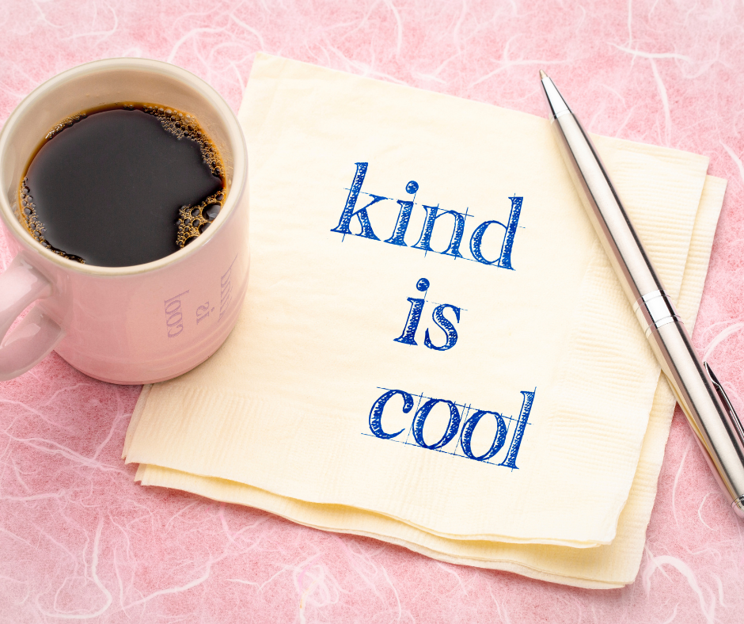

Friday 28
Happy Friday, my beautiful souls! Are you celebrating?!

Not only is it my favorite day of the week, but this week, I finished my first Membership Zestre, which I started last year, so why not celebrate?! My glass contains red wine and I want to know:

A) What are you drinking; and

B) What’s one win of the week you’re toasting to today?

Saturday 29
“Daily teachings” by Rhonda Byrne.

“The key to visualization is to keep the picture moving in your mind, and yourself moving in the picture. If you keep the picture moving like a movie, you can master visualization really quickly.

If the picture is static it is a lot harder to hold the picture in your mind.

Keep your visualization busy with lots of movement, and your mind will become so captivated it will not be able to think of anything else.”

Gratitude and Love
Adina x


Sunday 30
“There is always LIGHT. If only we are brave enough to SEE IT. If only we are brave enough to BE IT.” – Amanda Gorman.


