Monday 17 – Gamma Queens

As a #GammaQueen what is your main gift?

You are an influencer!

You built relationships and communities.

Positive, optimistic and charismatic. People want to be around you, listen to what you have to say because you are wise.

Your way of seeing things, your life experience makes you an influencer for others.

You create collaborations that bring value in Relationships and Communities.

Value brings success.

You are a success woman! And if you don’t think you are a success yet, just wait. Is in your destiny to be a success as a #GammaWoman.

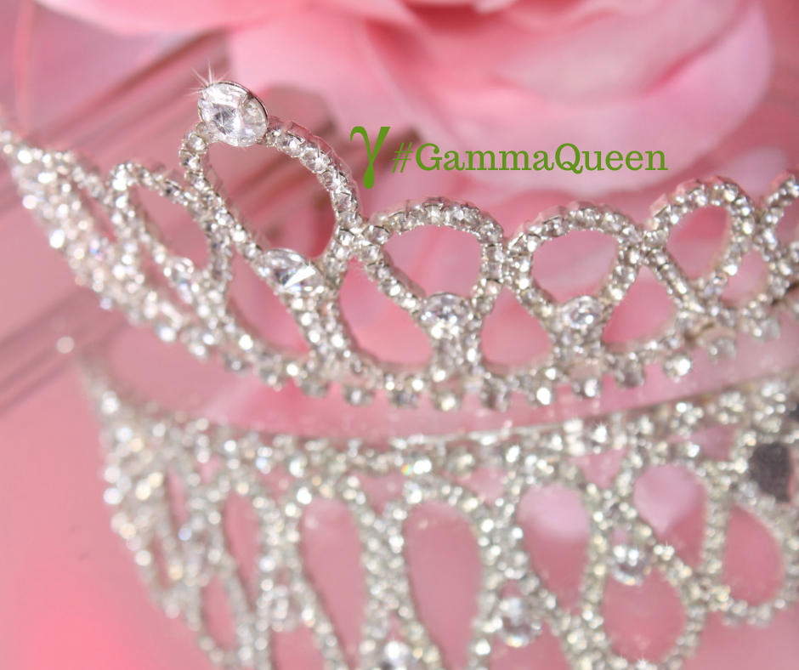

Tuesday 18 –

Dreams don’t work unless you do.

Do you agree or not?

I have to say, I agree.

If you have a dream, you have to take action toward it.

Do a plan, make baby steps one at a time.

What action are you taking today towards your dream?

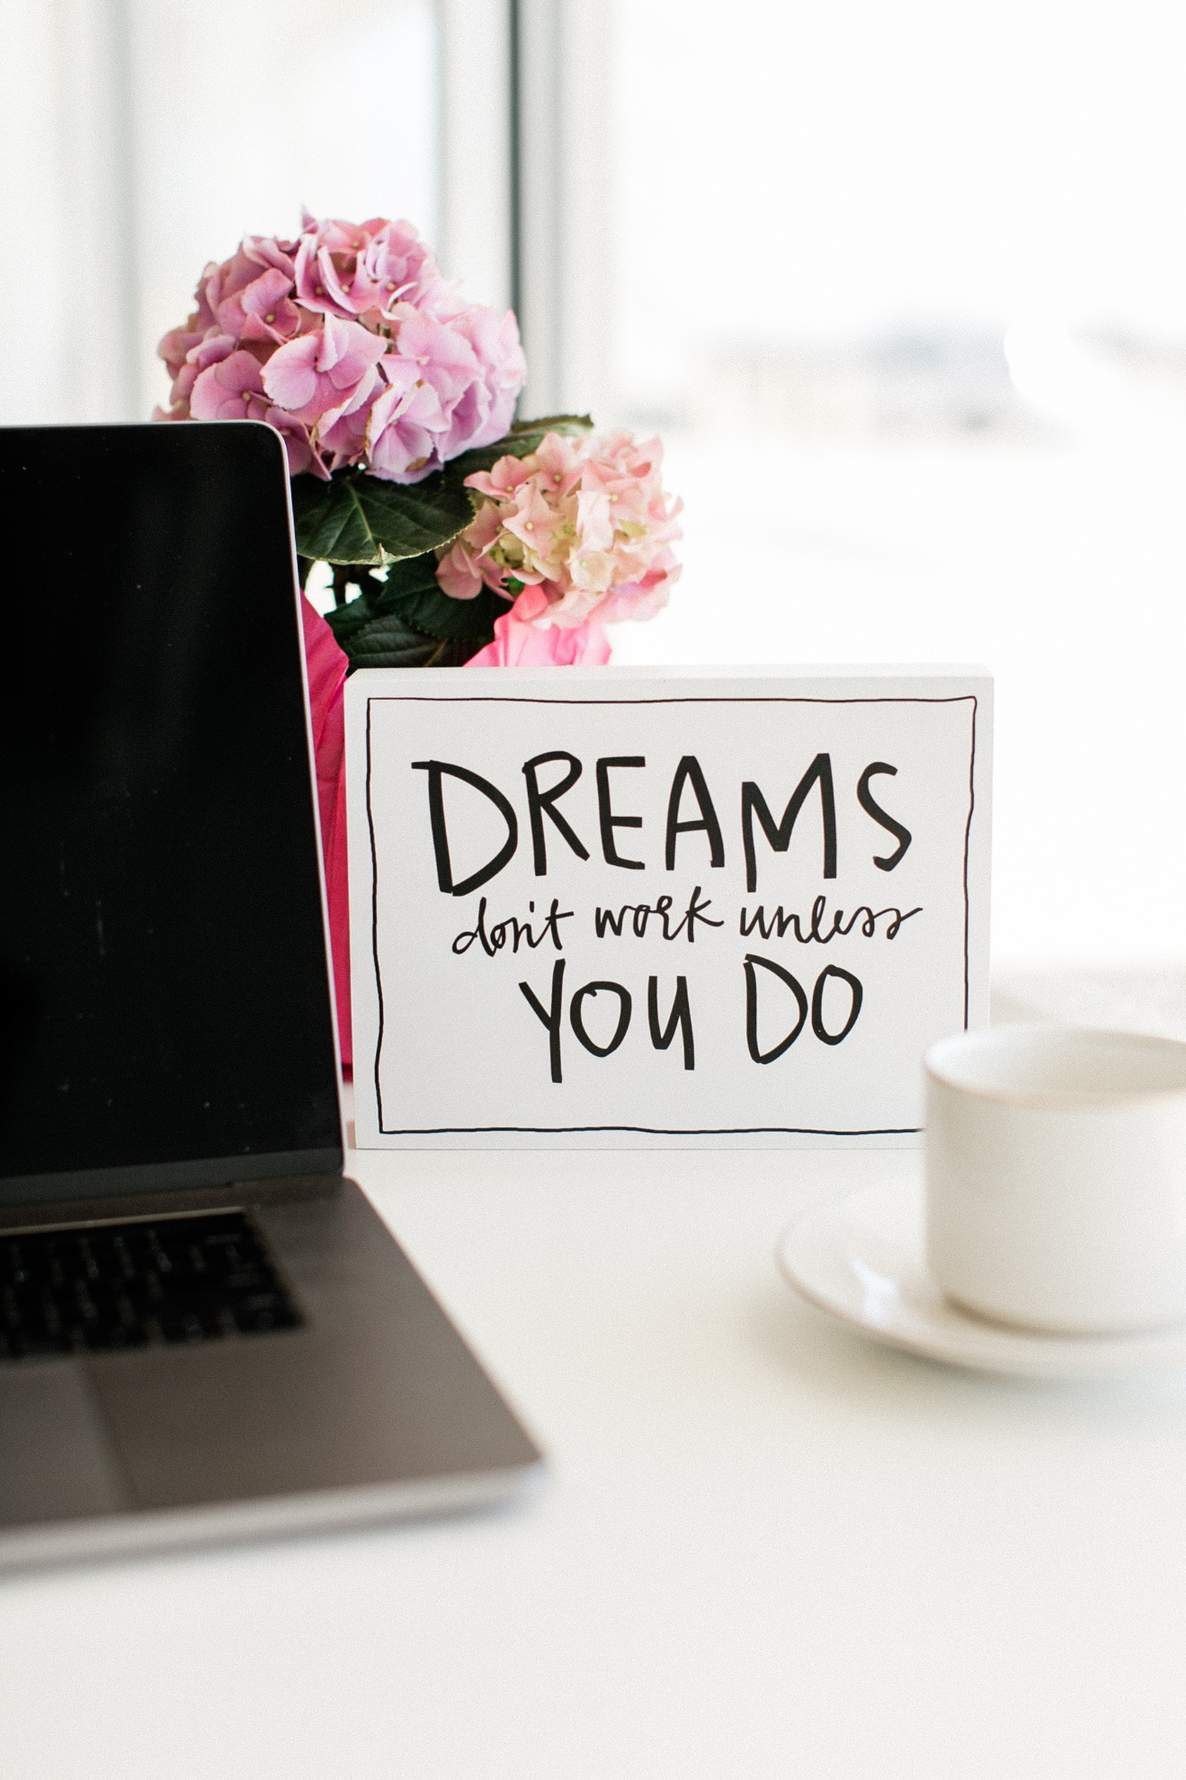

Wednesday 19-

How does your mission fuels your work?

My mission is to create a legacy based on Love and Forgivenss. Through Ho’oponopono and permission I want to built this Legacy.

That fuels my work every single day.

What about you?

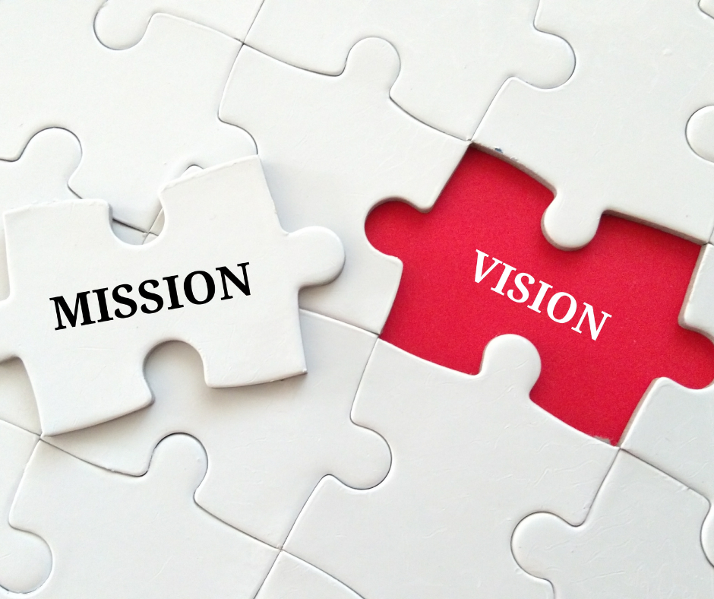

Thursday 20-daily teaching

“Daily Teachings” by Rhonda Byrne.

“A vision board is a tool to help you create the image in your mind of what you want.

As you look at the vision board you are imprinting the picture of your desire in your mind.

As you focus on your vision board it stimulates your senses and evokes a positive feeling within you. Then you have the two elements of creation – your mind and your feelings – working in full force.”

Gratitude and Love

Adina x

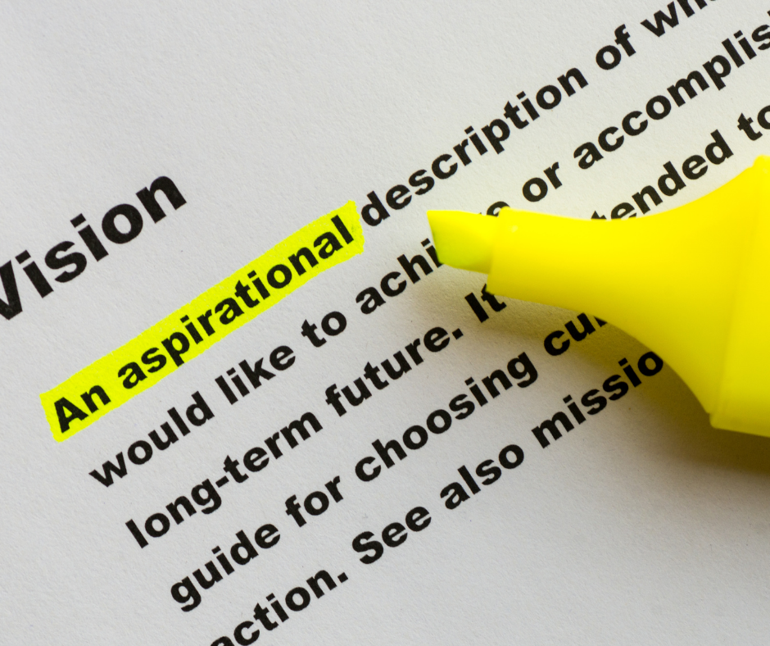

Friday 21

Anyone else need a little more peace in their lives?

I can’t be the only one, and I’m currently finding it in quiet morning walks.

Where are you finding peace these days?

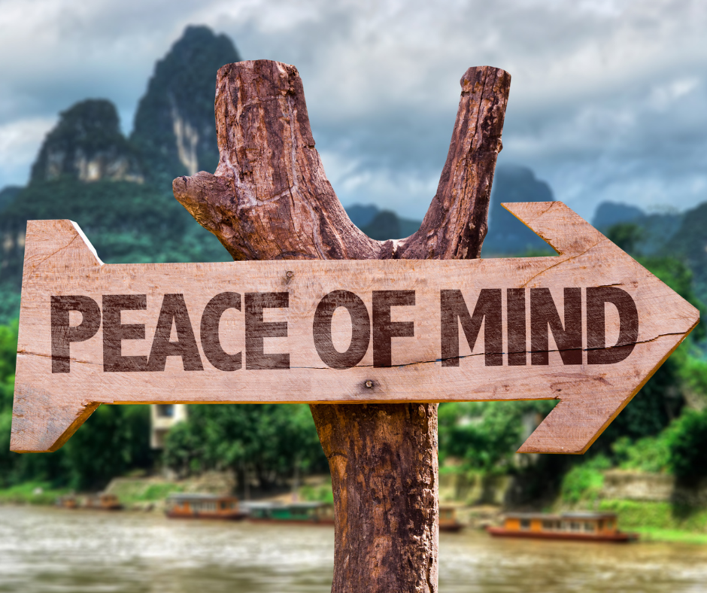

Saturday 22

When life gives you lemons, do you:

A) Make lemonade;

B) Learn to juggle;

C) Add a little vodka and soda?

I choose A, but whatever you decide to do with any sour points this week, I hope you make the most of it!

So, really, what do you fancy: A, B, or C?



Sunday 23 – daily teaching

“Daily Teachings” by Rhonda Byrne.

“It is so important that you are grateful for everything in your life.

Many people focus on the one thing they want and then forget to be grateful for all the things they have.

Without gratitude you cannot achieve anything through the law of attraction, because if you are not emanating gratitude from your being, then by default you are emanating ungratefulness.

Be proactive and use the frequency of your being to receive what you want.”

Gratitude and Love

Adina x

