Monday 7 - gamma queen

You are a #GammaQueen! You deserve to be treated like you want.

Jaiye John said one time:

“Your limits don’t have to be like a living electric fence that electrocutes whoever touches it.

The limits can be like a bright fence where says: I am treated with respect, honour and compassion.”

How do you want to be treated?

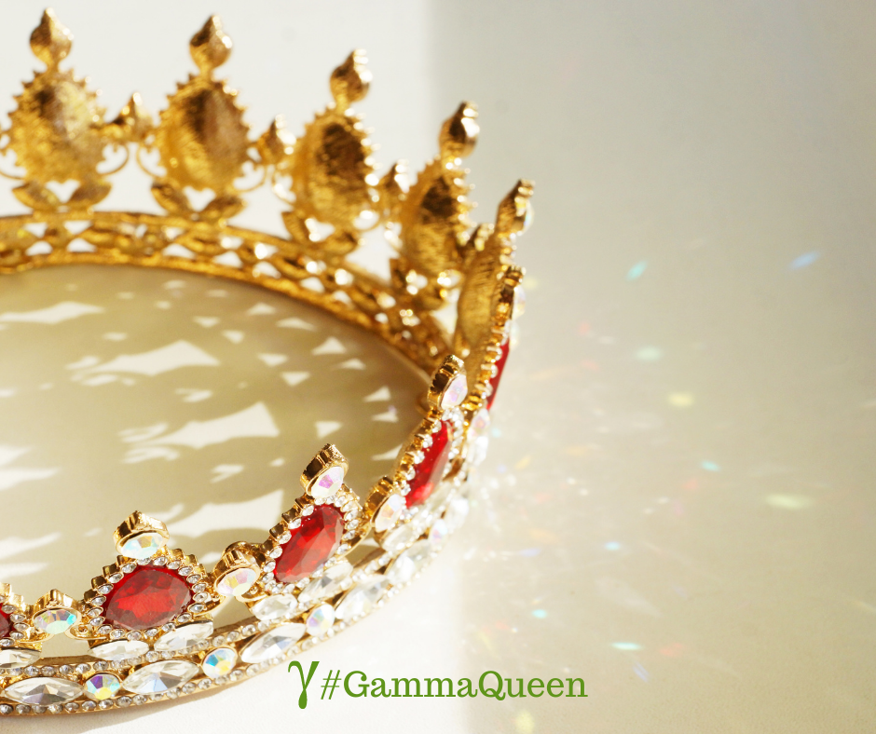

Tuesday 8

Who’s your best friend?

As an online business owner some days I feel like my best friend is my laptop because I spend so much time with it.

But at the end of the day when I close my laptop, all I really want to do is call up my bestie, to chit chat for hours.

So, would you like to share with me who is actually your best friend?



Wednesday 9

Ever feel like life should come with a delete button?

I could’ve used one that in the past. I would have given anything to start over!

When it comes to my business, though, I always consult with my mentor  when I need a fresh start. It never fails to shape past blunders into necessary learning.

How do you get a fresh start?



Thursday 10

Time check! When it comes to punctuality, how would you describe yourself?

A. Always running early

B. Always running late

C. Right on time

Without a doubt most of the time I am right on time. Happens to be late sometimes.

But in the wise words of Julie Andrews in The Princess Diaries: “A queen is never late. Everyone else is simply early”.

At least that’s what I tell myself! Haha :D

No matter which option you resonate with, thank you for taking the TIME to read this post!

I would love to hear your answer: are you A, B, or C?!

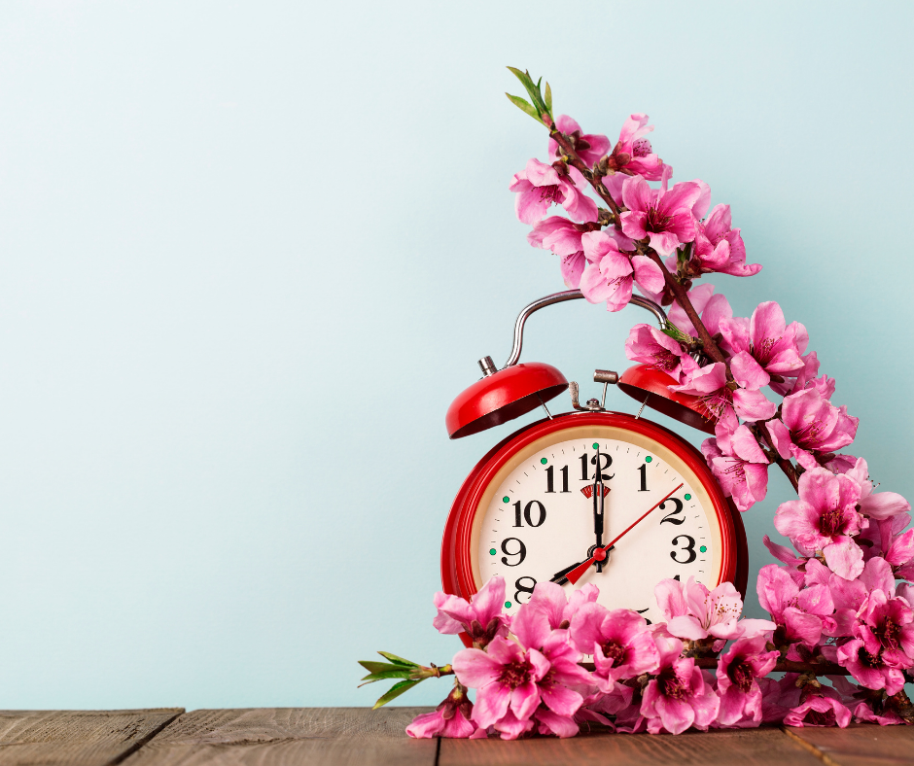

Friday 11

When life gets crazy, what brings things back into focus?

When I have a lot to deal with, I continue to remind myself why I’m here.

I started this business create a safe environment for people, an environment based on Love and Forgiveness, and that is exactly what I’m doing.

What important reframe gets you back on track?

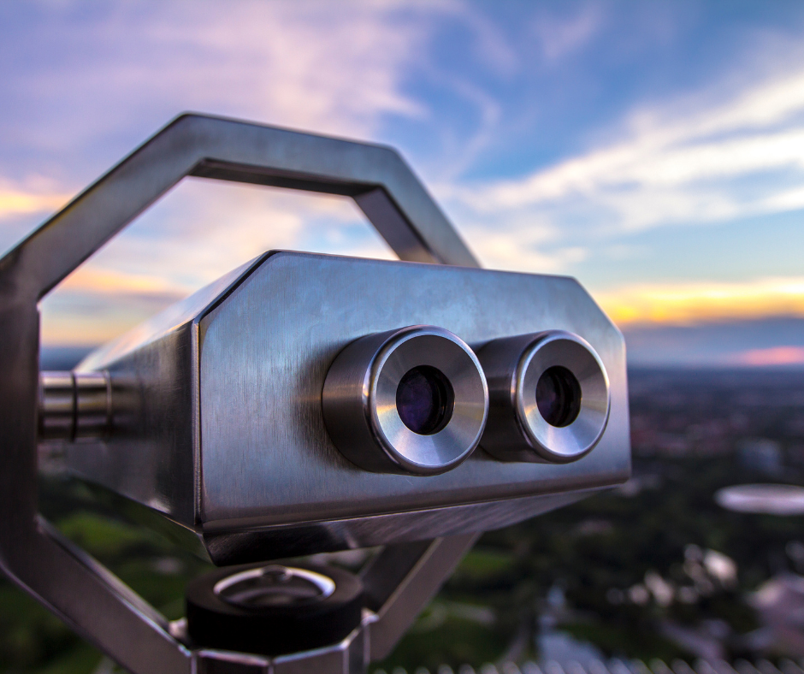

Saturday 12

“Daily teachings” by Rhonda Byrne.

“There is no force of hate. Hate is simply the absence of love, just as darkness is the absence of light. Poverty is the absence of abundance, sickness is the absence of health, and sadness is the absence of joy. All negativity is simply the absence of something positive.”

Gratitude and Love

Adina x

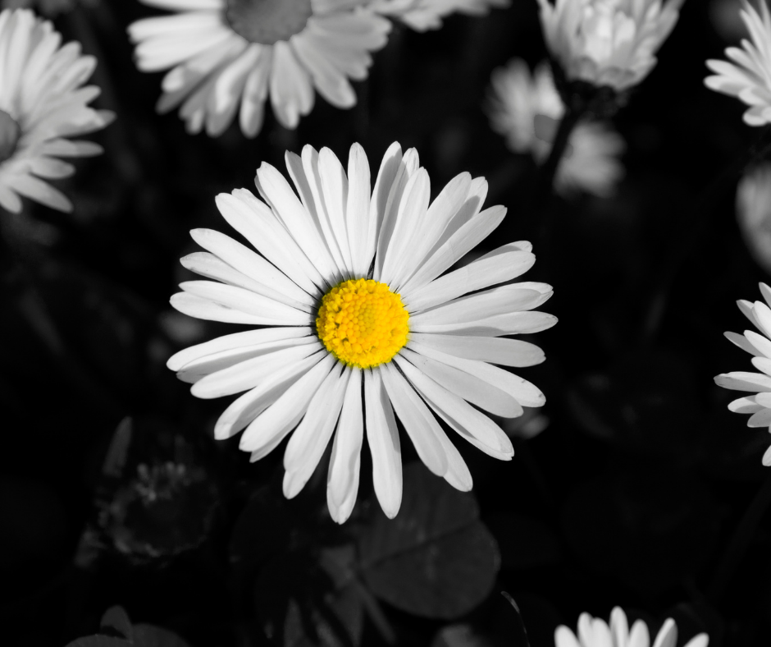

Sunday 13

Hooray, it’s Sunday!

That means a brand new week is about to start, but it also means that new chances are waiting for us. I am so excited!

Can anybody else relate?!

How do you feel this Sunday?

