Monday 30th of may

The #GammaQueen is an energetic mentor!

A mentor who been through a lot herself and now she is guiding other women through similar difficult times.

She understands how to use the energy in such a way that it heals, it liberates, it raises the vibrational centres of her mind, body and soul.

By doing this for herself she's confident and excited to guide other people on a similar energetic journey.

She knows how to talk to herself kindly. She teaches other women how to talk to themselves gently.

To talk like they are:

- A child – “Is ok to be sad. I am here for you. I am not leaving you alone.”

- Best friend – “You are brilliant! I am so proud of you. You deserve the best.

- Favorite gift – “You deserve that every investment you make to come back at you a thousand times more.”

- The Sun – “You brighten up my day and warm my life!”

- Beloved pet – “You are the most loved soul in my life.”

- A stranger – “Can I help you with ‘this’?”

How do you talk to yourself during difficult times of your life?

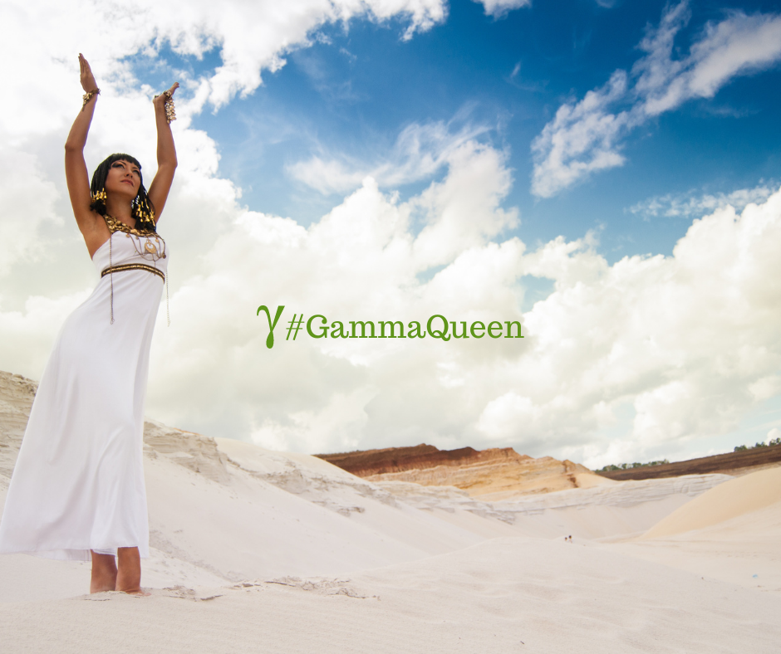

Tuesday 1st of june

Global Day of parents!

In 2012, the UN General Assembly declared the first ever Global Day of Parents.

Since then, it has been held annually on June 1 to honor parental units around the world.

Being a parent is one of the most universal experiences, but it’s definitely not a walk in the park.

In Romania today we celebrate Child’s Day.

Children’s Day is not just an event in Romania, it is also celebrated in many different countries.

Many schools have special events to celebrate Children’s Day in Romania.

Some teachers give out certificates as a way of showing their appreciation for each child on this day. Community events, including art exhibitions displaying children’s work, are held to celebrate Children’s Day.

Children’s Day is also promoted through newspapers, blogs, social media, television, and radio journalists in Romania.

Some families have special dinners to celebrate Children’s Day at home.

Children’s Day in Romania became a national holiday in 2017.

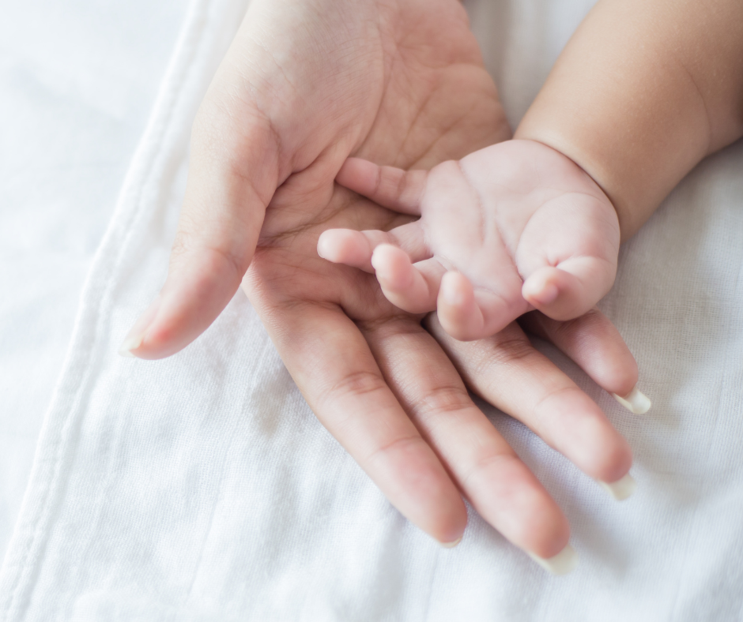

Wednesday 2nd

“Daily teachings” By Rhonda Byrne.

“It is so important that you are grateful for everything in your life. Many people focus on the one thing they want and then forget to be grateful for all the things they have.

Without gratitude you cannot achieve anything through the Law of Attraction, because if you are not emanating gratitude from your being, then by default you are emanating ungratefulness.

Be proactive and use the frequency of your being to receive what you want.”

Gratitude and Love

Adina x

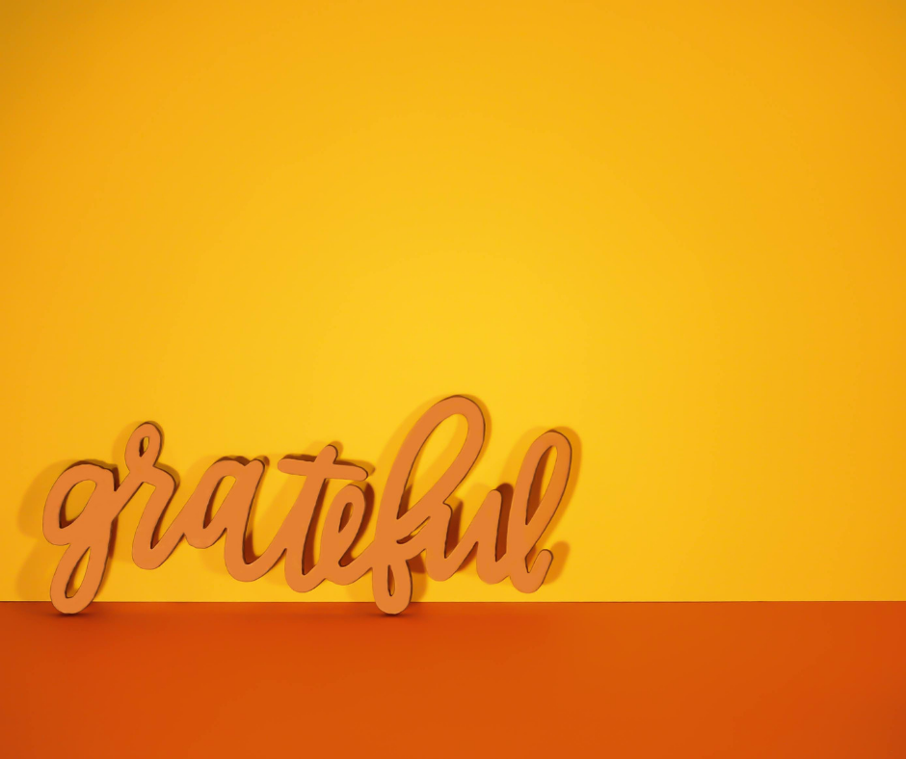

Thursday 3rd

If you could repeat an experience what it would be?

Maybe a day at the spa? Something really special that you would love to happen again.

Repetition is a key element in everyday life.

Daily routines give us a sense of stability and direction. We may not think about it that much, but repetition is also a good example of how our personal tastes are constructed.

So what would you repeat?

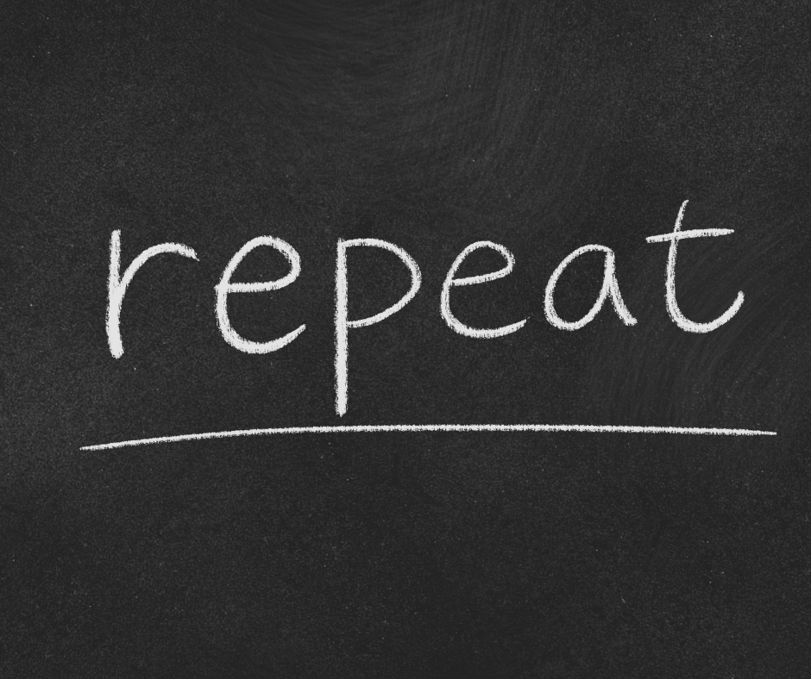

Friday 4th

Do you own a cat?

Today is National Hug Your Cat Day!

Ancient Egyptians worshipped, revered, and spoiled their cats (sound familiar?).

They were seen as symbols of grace and poise — traits cats are still associated with today. There’s a lot of cat hugging going on all the time, but make an extra special attempt during National Hug Your Cat Day on June 4.

The best way to celebrate? Scoop your regal cat right off the ground and snuggle the heck out of it until it feels the love.

Sounds like a pleasant activity we can all get behind, no? So grab your kitty BFF and celebrate.

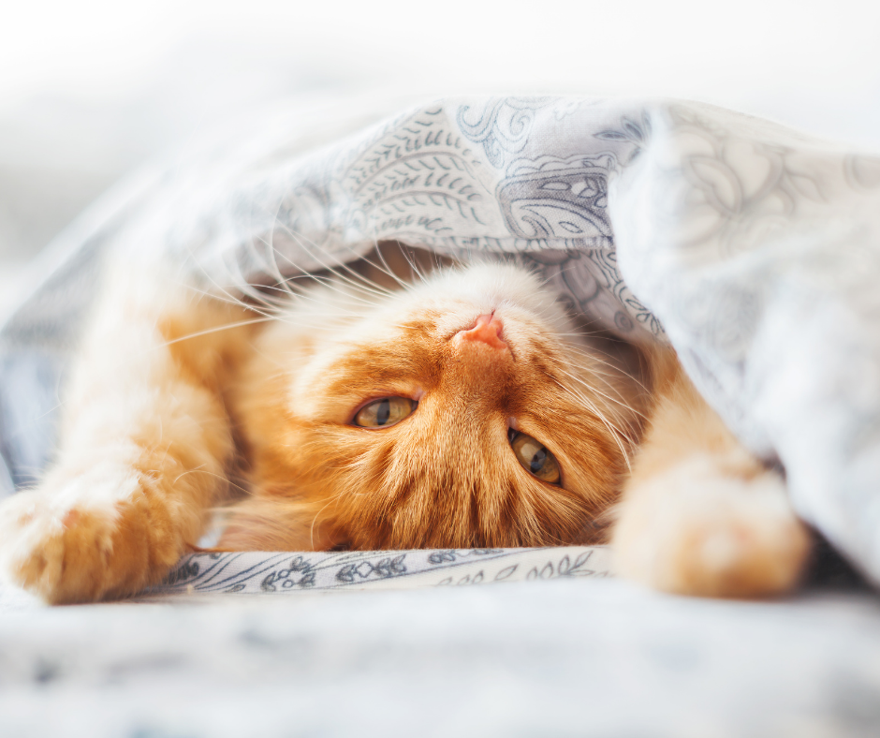

Saturday 5th

“Daily teachings” By Rhonda Byrne.

“A vision board is a tool to help you create the image in your mind of what you want.

As you look at the vision board you are imprinting the picture of your desire in your mind.

As you focus on your vision board it stimulates your senses and evokes a positive feeling within you.

Then you have the two elements of creation – your mind and your feelings – working in full force.”

Gratitude and Love

Adina x

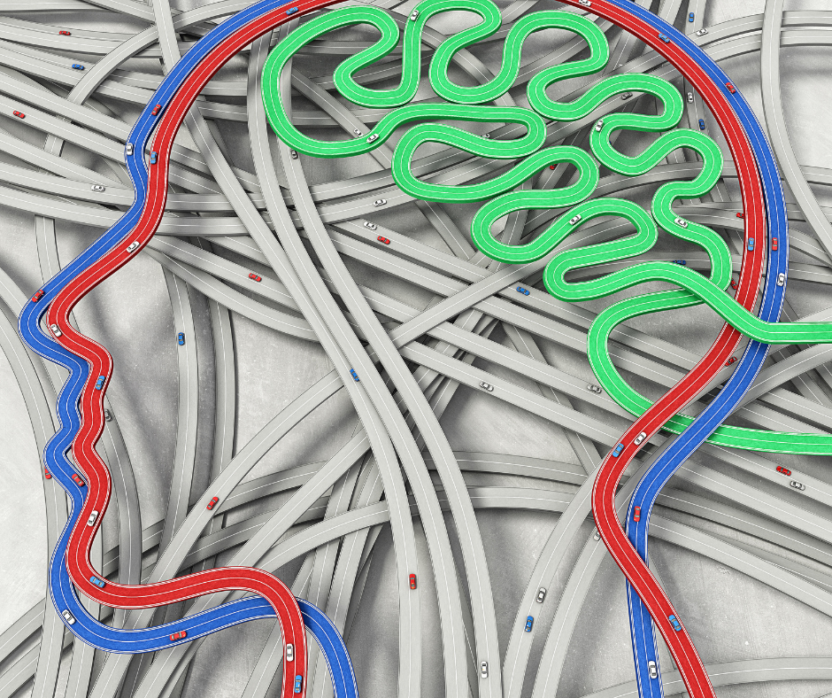

Sunday 6th

“No act of kindness, no matter how small, is ever wasted.” – Aesop

What is the smallest act of kindness you have done this last week?

