Monday 8 th

“Don’t let yesterday take up too much of today.” – Will Rogers

To put it in another way: let it go.

Today is the present, yesterday is already the past.

A new week, a new beginning, and you have a new chance.

Do your best considering today’s circumstances, not yesterday’s.

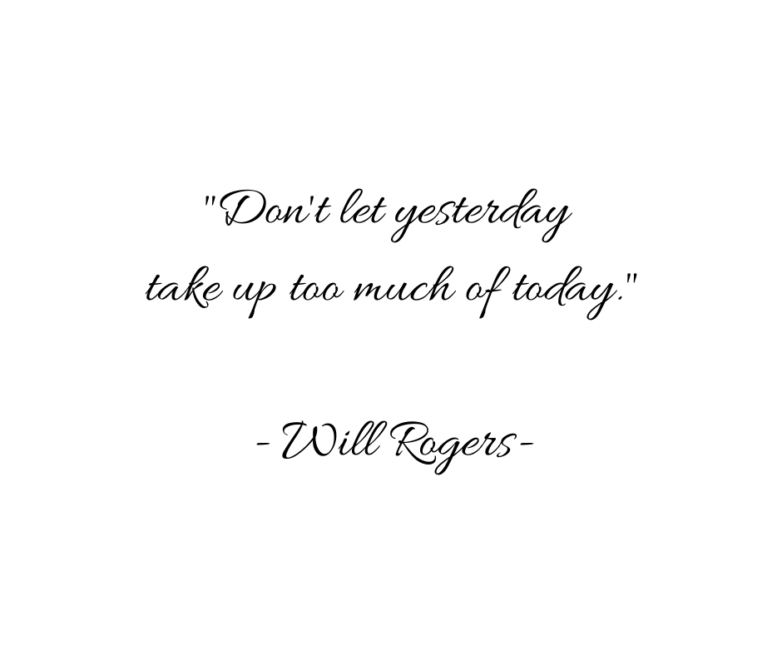

Tuesday 9

Is it just me, or does an uninterrupted cup of tea in the morning make the entire day*?*

Thanks to some peace and quiet as I sipped*,* I'm feeling energized to start the day!

What simple joys have started your day off on the right foot?

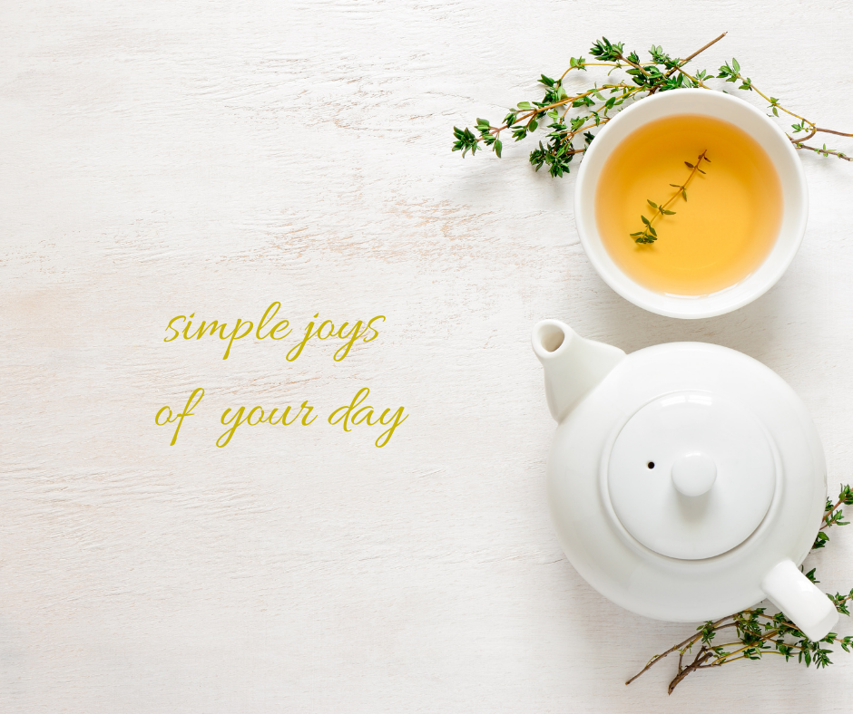

Wednesday 10

I have a crush and I’m not afraid to say it!

They’re always on my mind. When they call me, I get butterflies…

I’m talking about the beautiful souls I am working with, of course! Who did you THINK I was referring to?!

Who do you have heart eyes for?



Thursday 11

“We may encounter many defeats but we must not be defeated” – Maya Angelou

Every time you feel like there is no way out of a situation, take a step back and remember that the stairwell to success is tricky sometimes.

The road is over when you decide to quit.

If you keep trying you will find your success eventually.

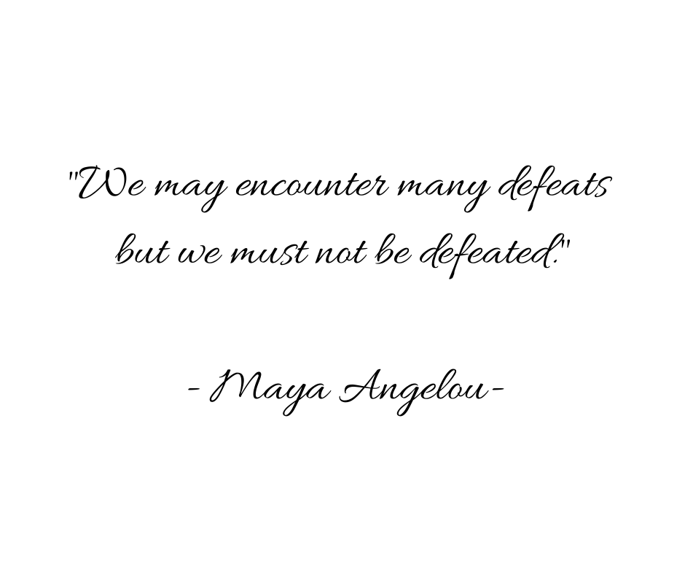

Friday 12

Hey, beautiful souls!

What is a question that people ask you over and over again that makes you feel like a broken record each time you respond?

One of the questions that I’m most frequently asked is “what is Ho’oponopono?”

I always give the same answer: is about love and forgiveness <3



Saturday 13

Here’s your saturday reminder that you can do hard things, like avoiding the refrigerator until lunch time, even though the yogurt parfait is calling your name.

Haha

You’ve got this! Tag someone below who needs to hear this pick-me-up today!

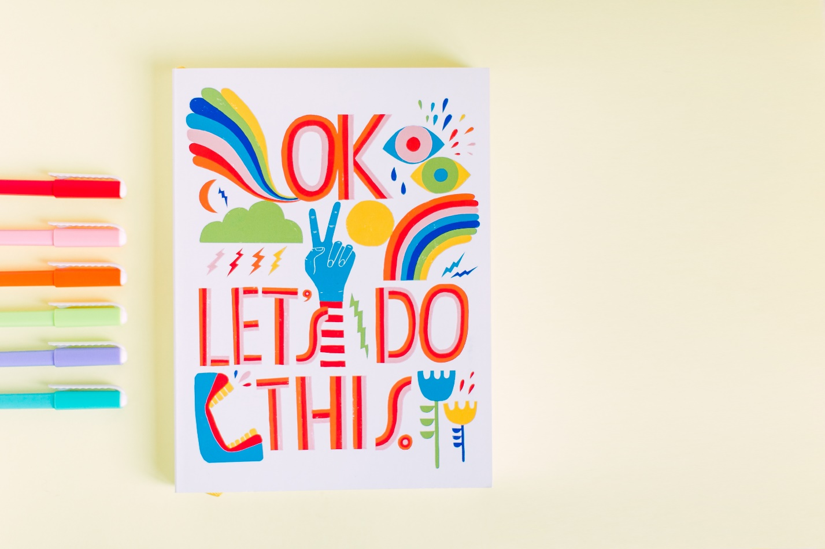

Sunday 14

I want to ask you something if it’s ok…

Don’t hold back!

If you were to describe your perfect Valentine’s Day, how would it look?

