Monday 1

Ever notice how relaxing with a drink in your hand can melt the worries of the day?

What's your go-to drink to make everything seem better?

#anotherrandomquestion #question #favoritedrink

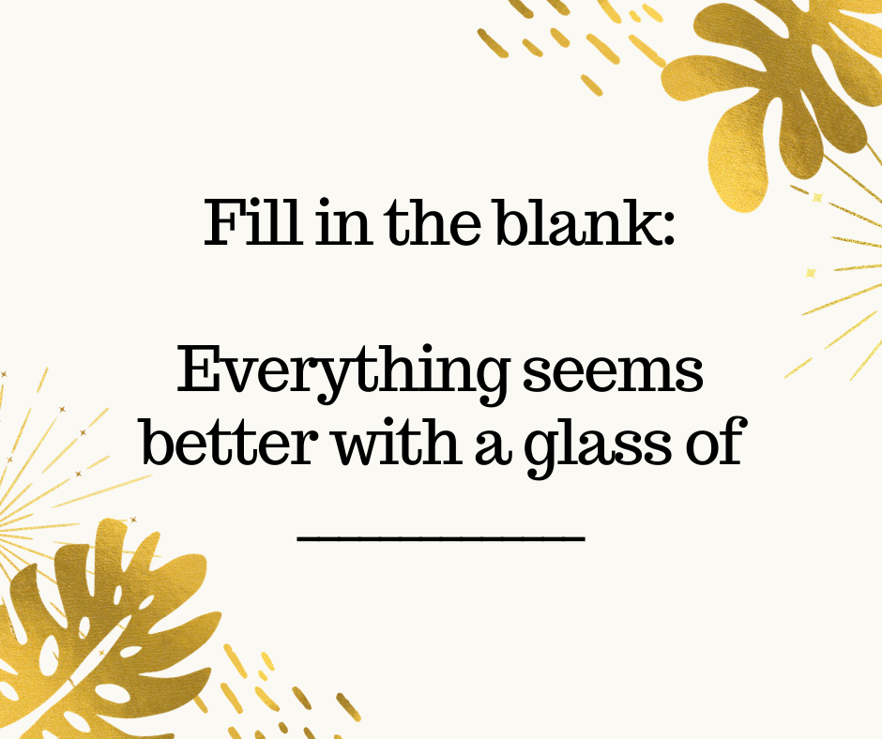

Tuesday 2nd

Happy Groundhog Day!

What do you think?

Are we in for 6 more weeks of winter or an early spring?

I think the spring is close! I can’t wait for the warm days, flowers and all the nature to come back to life.

#Groundhogday #holidays #springiscoming

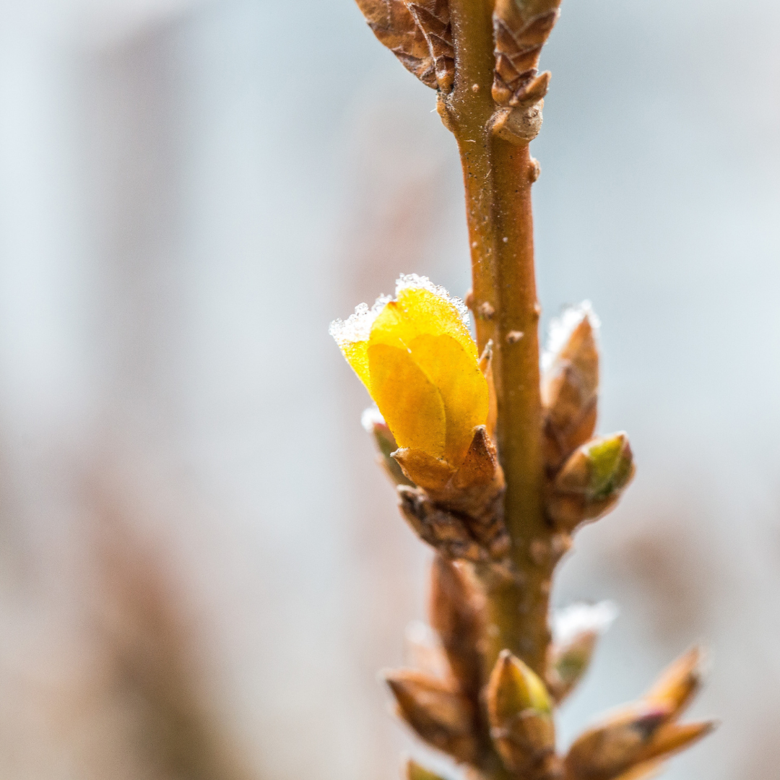

Wednesday 3

The only certainty in life is uncertainty.

Stop fearing it and embrace it.

You may be surprised by the beautiful things that happen.

Expand your limits, your boundaries. How can you know for sure if you can do or can’t do if you do not try?

Do you remember any situation where you expanded your boundaries and it went out ok eventually?

#inspirationalquotes #quotesforlife #uncertainty

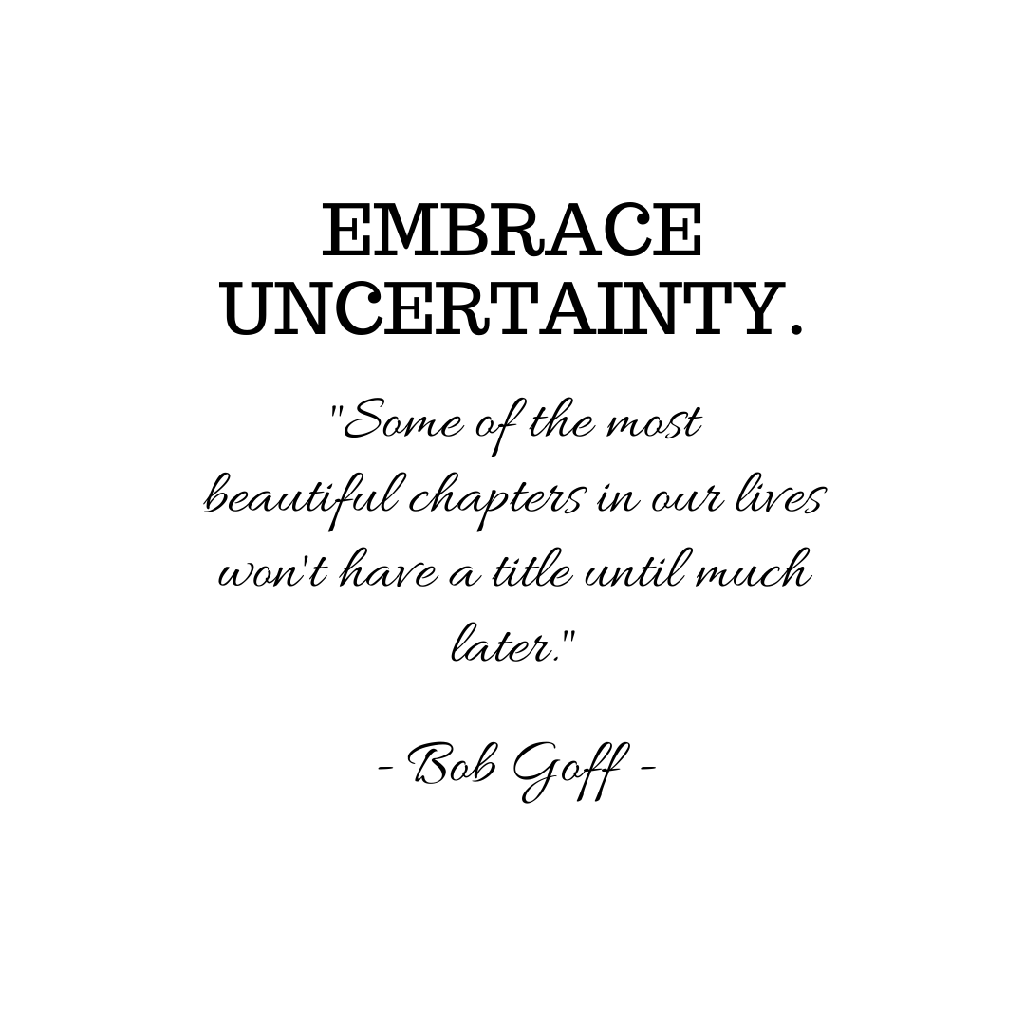

Thursday 4

Hey, I have a bright idea!

Using ONLY emojis, comment below with what your ideal day.

How would you look? Where would you be? How would you feel?

Ready… go!

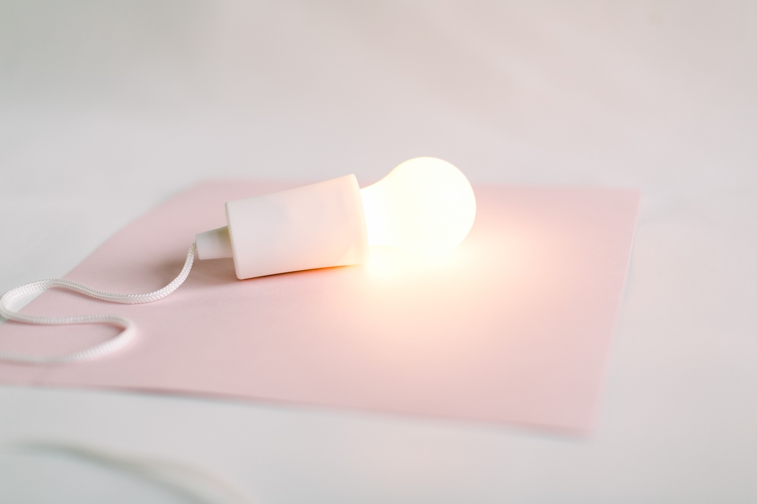

Friday 5

Want a snapshot of my perfect day?

Whether I’m working or taking a day off, I love to start my mornings with a cup of tea.

I get a midday boost from doing some meditation, and I make sure to write in my journal/agenda before the day is over.

Want to share a snap of your perfect day with me?

I would love to hear it.

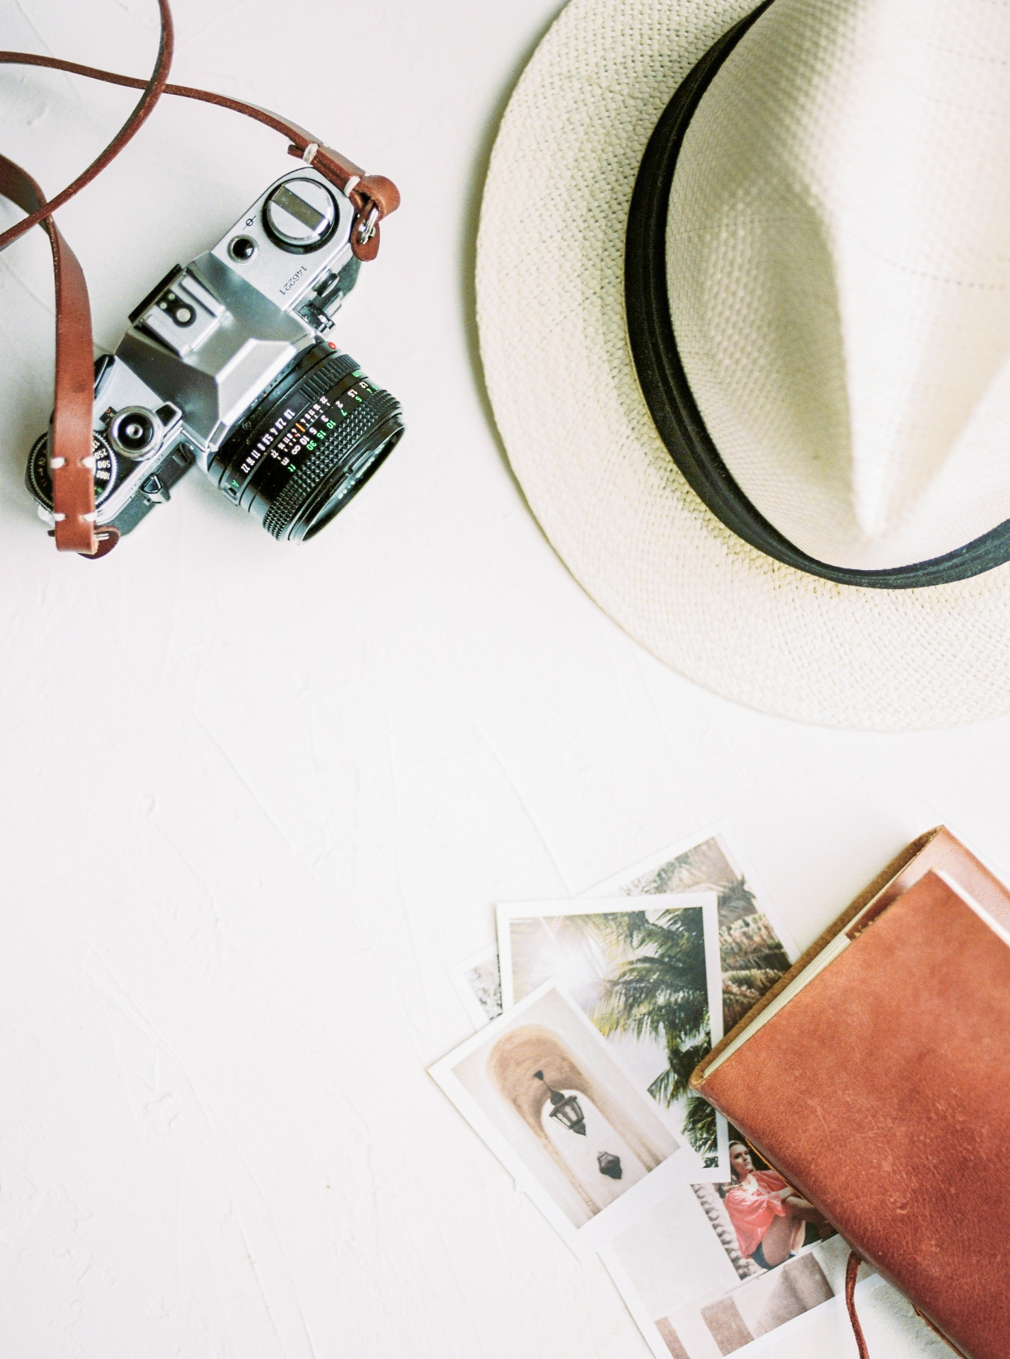

Saturday 6

“Happiness is the new rich. Inner peace is the new success. Health is the new wealth. Kindness is the new cool.” - Syed Balkhi

What makes you happy today?

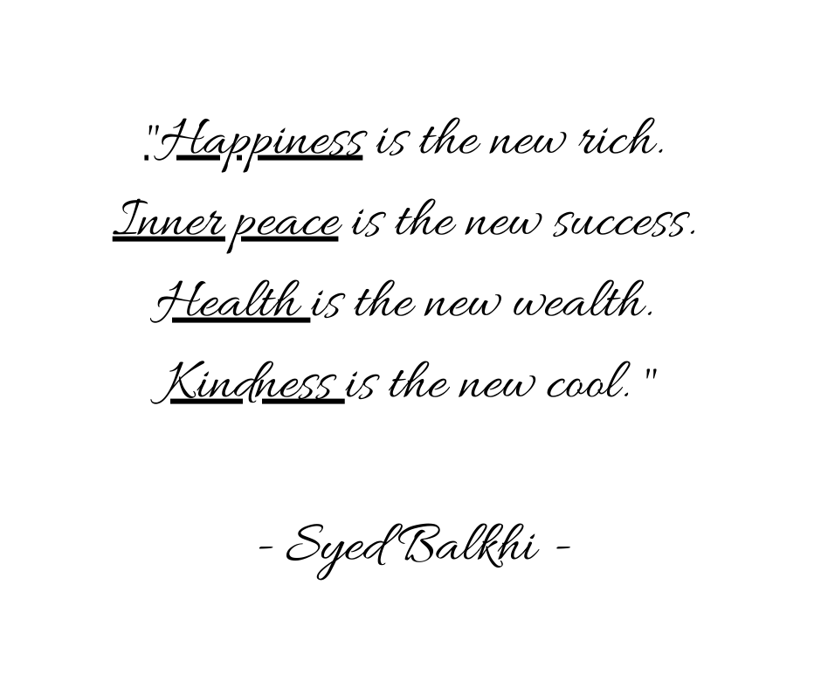

Sunday 7

That time when you can stay in bed all day is here again! Sunday!

A lazy day full of possibilities:

- Lay in bed all day, watching Netflix or reading a book.

- Throw on oversize clothes and have brunch with your family.

- Relax doing some meditation or yoga... or both.

- Let your mind flow and imagine the best of your life, feed your subconscious mind with big dreams.

How do you spend your Sunday?

