Monday 26

Just a short message for today...

“Planet Earth and humanity need you. They need you, and that is why you are here”

Gratitude and Love,

Adina x

“Daily teachings” by Rhonda Byrne.



Tuesday27

National tell a story day! Either talk about a story you heard, invented or read.

The celebration encourages every generation to tell stories. That includes the youngest storytellers to most experienced.

It’s a great opportunity to practice your storytelling skills.

Do you have a story to share?

Drop it in the comments 😊

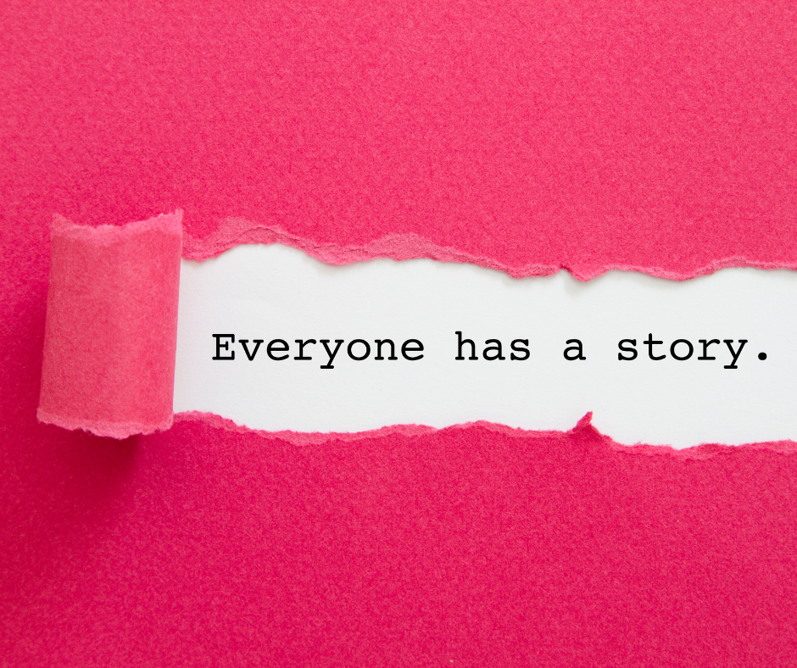

Wednesday 28

Great Poetry Reading Day

Today we celebrate Poetry <3 It’s a celebration that first been hosted in 1994.

April 28th marks the observance of National Great Poetry Reading Day. This day celebrates distinguished poetry and the notable poets who wrote them.

What is your favorite poetry of all time?

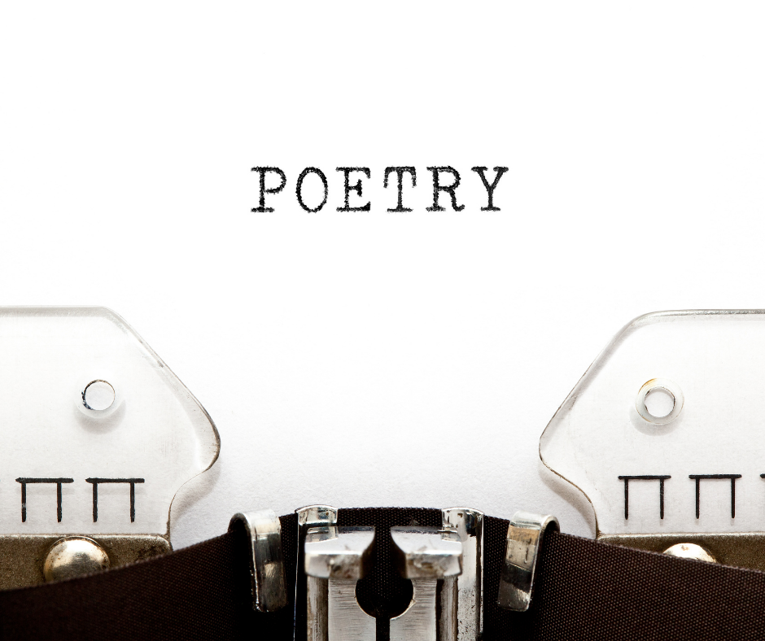

Thursday 29 daily teaching

“Daily teachings” by Rhonda Byrne.

“ From the moment you are born, you have a cosmic partner who never leaves your side throughout your whole life.

This cosmic partner has unbelievable contacts, and unlimited means and ways of doing anything you want.

Time is no obstacle, size is no problem, and space doesn’t exist for your cosmic partner. There isn’t anything your partner cannot do for you.

And all you have to do is follow the cosmic rules. Ask, and then really believe that in the moment you ask, what you desire is already yours.

Imagine it – the entire Cosmic Universe batting for you!”

Gratitude and Love,

Adina x



Friday 30 last day of april

Here goes the 4th month of 2021. How was it for you?

I had an incredible month!

Full of activities and flow of ideas. Can’t wait to put the wheels in motion 😊

I will share with you soon...

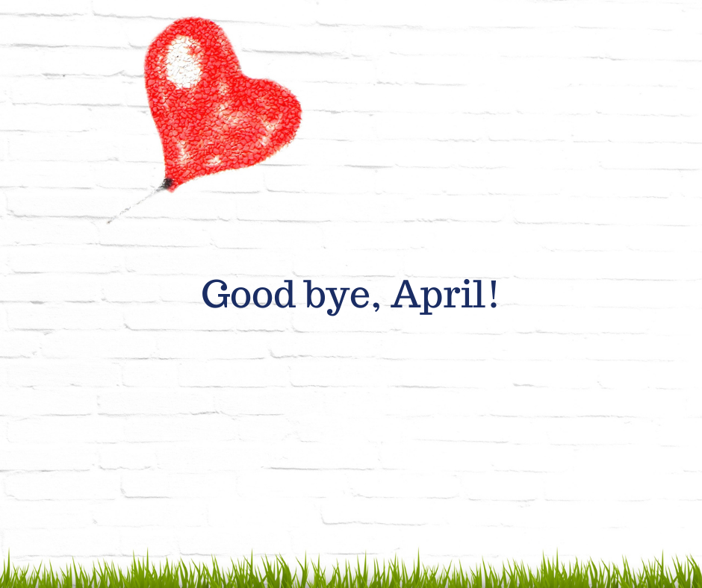

Saturday 1 – hello may!

What are you looking forward to this month?

My calendar is looking pretty busy right now 😊

 To say I’m excited would be an understatement.

What’s your May looking like? I would love to hear the details!



Sunday 2 – happy easter

Happy Easter, my beautiful souls!

