Monday 19th

Have you ever noticed how you can make time for the people and things that matter most to you?

The 24 hours you get every day are not a limitation.

Each precious hour is an opportunity to make time for what matters most to you.

It’s not about having time. It’s about making time.

#maketime #mondaythoughts #mindsetiseverything



Tuesday 20

National Look Alike Day

Did you ever hear the expresion „there’s someone else out there who has the same face as you”?

Most likely there is. There are over 7 billions people in the world, and somewhere out there is another you.

Same face, different person.

The holiday was created in 1980 by television reporter Jack Etzel.

Have you ever met your doppelganger? :D



Wwenesday 21

“Daily Teachings” by Rhonda Byrne

“To create your tomorrow, go over your day tonight when you are in bed just before you fall asleep, and feel gratitude for the good moments.

If there was something you wanted to happen differently replay it in your mind the way you wanted it to go. As you fall asleep say:

- I will sleep deeply and wake up full of energy. Tomorrow is going to be the most beautiful day of my life. - ”

Gratitude and Love,

Adina x

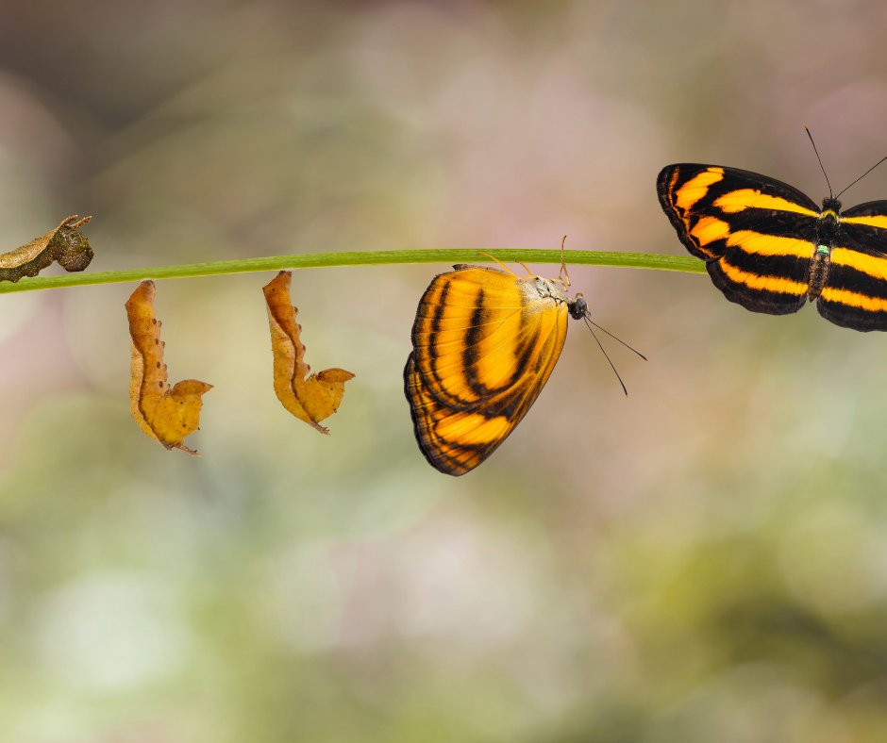

Thursday 22

In 1970 was the first ever Earth Day. 20 milion Americans protested in the streets for more enviromental protections.

20 years later, Eath Day becomes globally popular. 200 million people organized and united, fighting for climate protections across 141 countries.

Today The Earh Day is celebrated worldwide.

If you’re looking for an event, like a group cleanup project, or climate strike rally to join, visit the global interactive map on Earth Day Networks’ website.

There are many things to do to support our planet, and multiple ways to get connected locally to your community on Earth Day.

You don’t have to plant a forest to enjoy Earth Day.

Even if you feel like reusing your metal water bottle instead of buying a plastic bottle or a styrofoam coffee cup doesn’t make much of a difference, your small acts can change and improve the world we live in.

Now that you have awareness that climate change is affecting all of us, do your part to make positive changes wherever you go, no matter how small, they are significant, and this is your chance to improve our world.

Wendell Berry said, “The earth is what we all have in common.”

Happy Earth Day - a day to focus on protecting the one thing we all have in common.

#happyearthday #earthday #savetheplanet

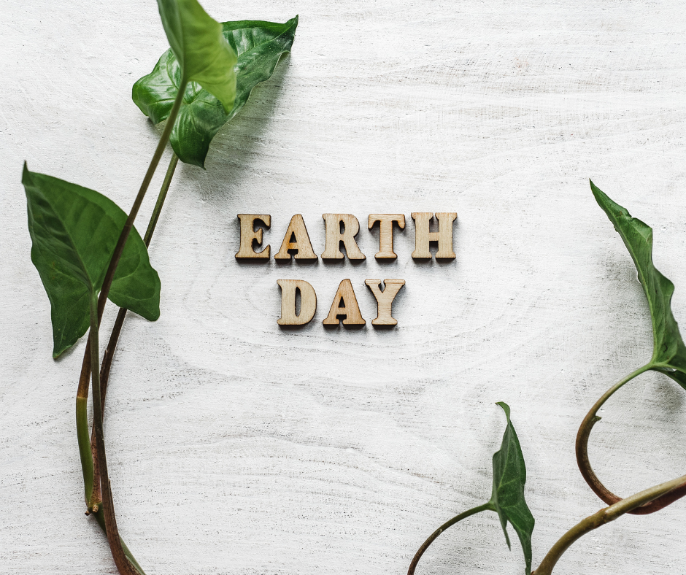

Friday 23

I love books! Who’s with me?

UNESCO loves books too so they proposed World Book Day as a day of celebrating the joy of reading.

It’s a day to celebrate the privilege of being able to read, so head to the library or curl up on the couch and just be a bookworm!

What is your top 5 favorite books?

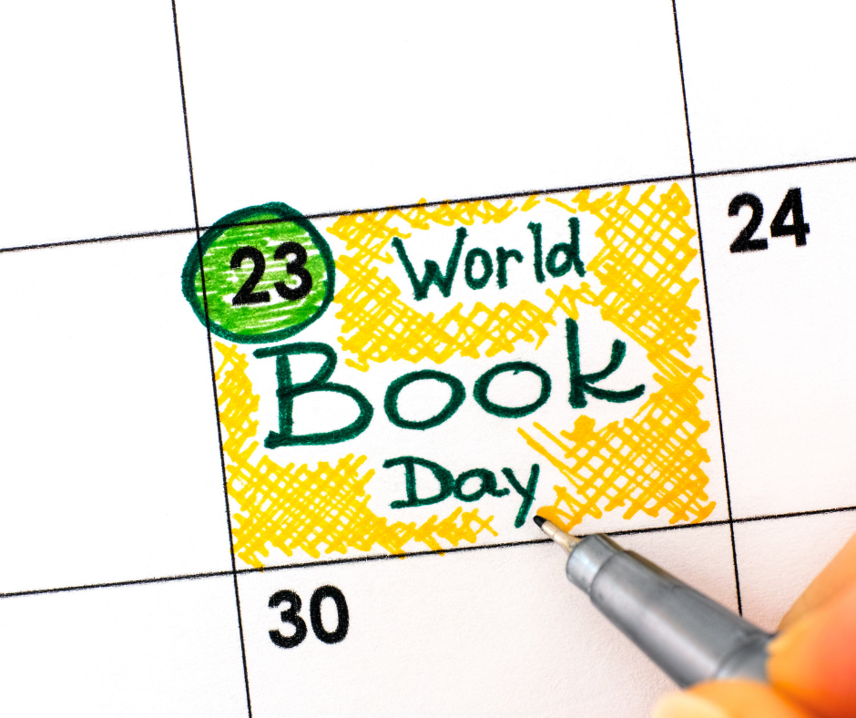

Saturday 24

The only true opportunity you're handed is a brand new day.

Use each day to take action and create the life you want!

“Opportunities don’t happen.

You create them.” – Chris Grosser

#quotestoliveby #saturdaymotivation #mindsetiseverything



Sunday 25

“Daily teachings” by Rhonda Byrne

“A feeling that greater possessions, no matter of what kind they may be, will bring contentment or happiness by themselves, is a misunderstanding.

No person, place, or thing can give you happiness.

They may give you cause for happiness and a feeling of contentment, but the Joy of Living comes from within.” (Genevieve Behrend)

Gratitude and Love,

Adina x

