Monday 12

How was your weekend?

Monday is the day to set your intention for the week!

What do you plan to accomplish until Sunday?

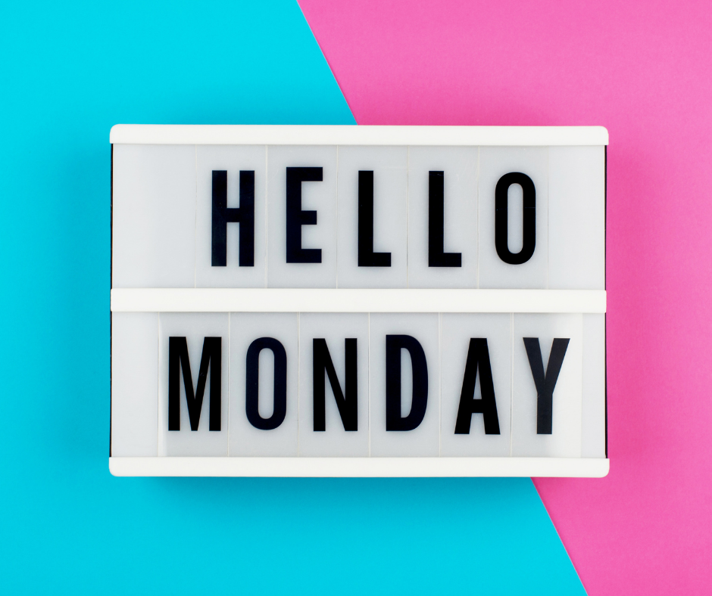

Tuesday 13

What are you waiting for?

Do you need an impulse?

Would you feel ready if you had five extra hours each day?

You’re not alone.

I made those excuses, too! And 2 years, I still don’t have the 5 extra hours.

But I’m building the business of my dreams anyway, and it feels fantastic.

Tell me something you’re starting, beautiful soul... ready or not! 😊

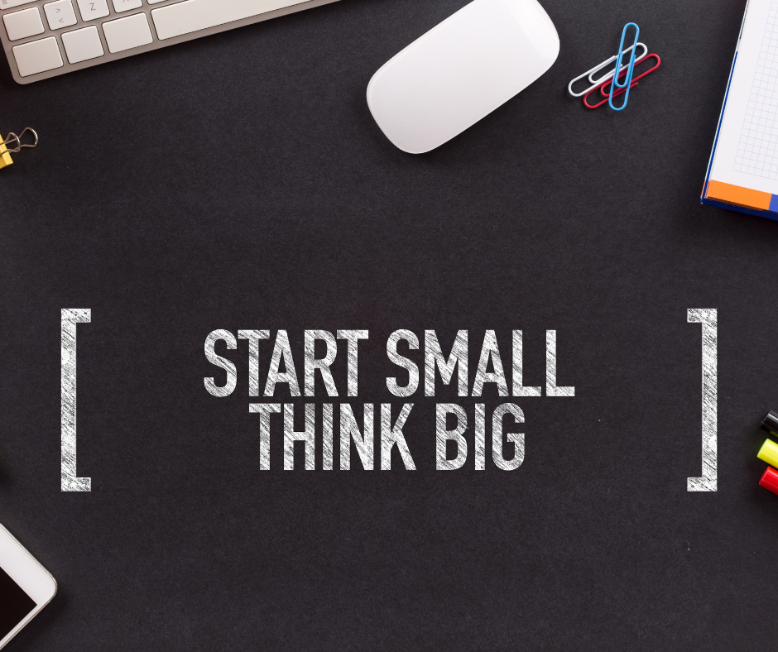

Wednesday 14

“Daily Teaching” by Rhonda Byrne

“Good is underneath every single thing that appears to be negative.

If we can know that good is all there is, including in a negative situation transform into all good.

Most people keep the good away from themselves because they label something as bad, and then, of course, that becomes their reality.

But there is no bad in the Universe; it is just our inability to see things clearly from the bigger perspective. Peace comes from knowing that good is all that exists.”

Gratitude and Love,

Adina x

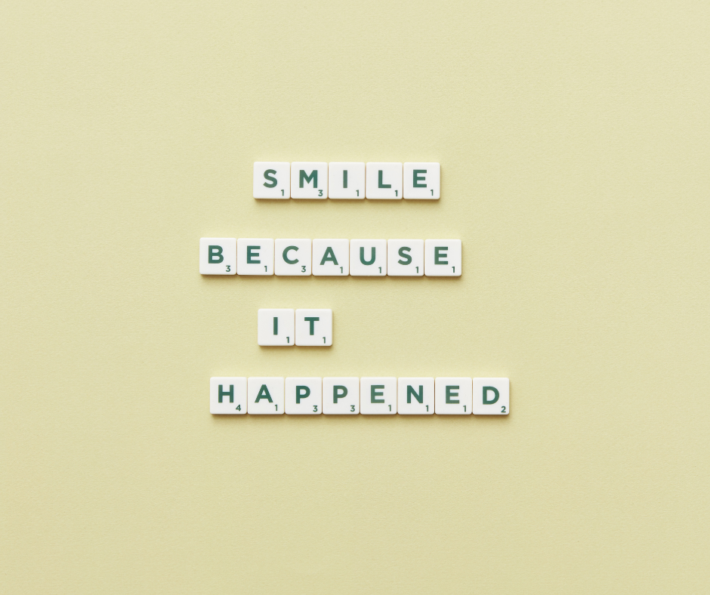

Thursday 15

“Happiness is not about having what you want.

Is about appreciating what you already have.” – Rabbi Hayman Schachtel

While material possessions may bring comfort, they don't always bring happiness.

True happiness comes from gratitude. Focus on appreciating what you already have.

That's the path to true happiness.

#attitudeofgratitude #thursdaythoughts #happinessproject

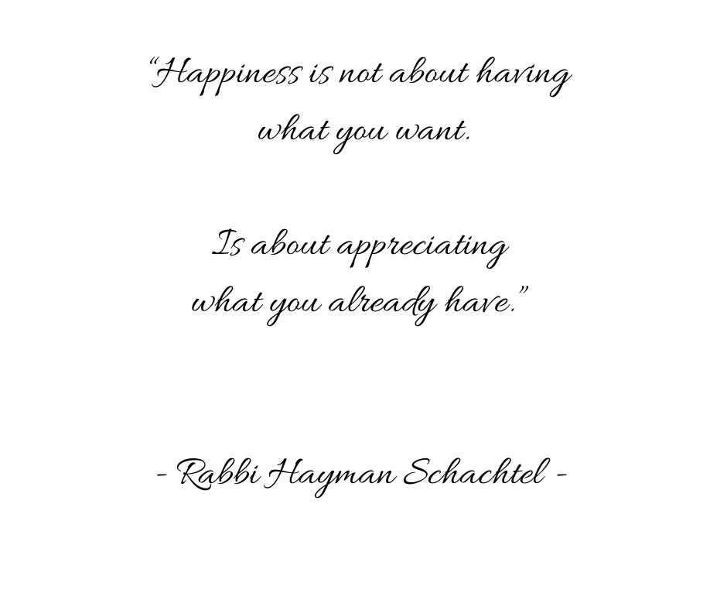

Friday 16

Want to hear how my work week typically flows?

Wednesday is usually busiest, filled with live sessions, but it slows down by Friday which is reserved for planning the next week.

Finally, I spend the weekend with my family, not working at all 😊

What’s on your agenda for the weekend?

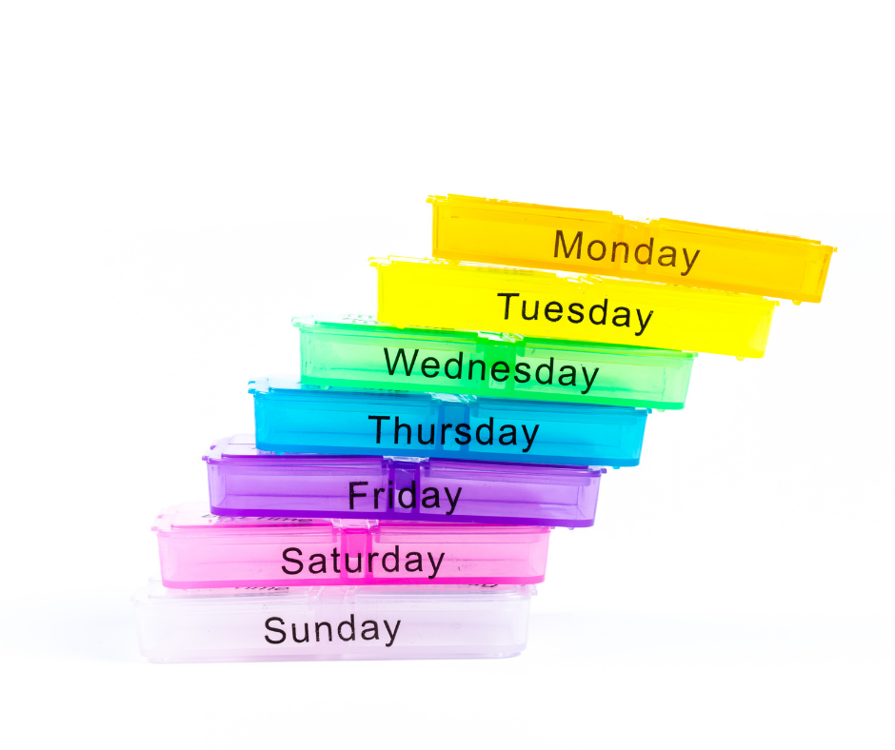

Saturday 17

Are you one to set goals or go with the flow?

I need a clear “bullseye” to get anything done, but often what’s more important than a goal is how I’ll treat myself when I reach it!

Setting goals is so much more fun when there’s an incentive at the other end.

Tell me, what are you working toward, and more importantly, how will you reward yourself when you get there?



Sunday 18

“Daily Teaching” by Rhonda Byrne

“You are in a partnership with the law of attraction, and It is through this partnership between the two of you that you are creating your life.

Each person has their own personal partnership with the law of attraction. You use the law for yourself; everyone else uses the law for themselves. You cannot use the law of attraction on someone else, *against their free will*.

And when you think about it, thank goodness the law operates this way. If it did not, then anybody else could create something in your life that you did not want.

You create through your thoughts and feelings, and no-one but you can think your thoughts or feel your feelings.”

Gratitude and Love,

Adina x

