Monday 7th

Looking ahead in the month, I have some super fun things planned, like the Membership Zestre for my romanian community and soon we will start to work with the Agenda Planner Zestre for 2021.

December is definitely an exciting month, and I’m so happy you’re here!

What are you looking forward to in the next few weeks?



Tuesday 8th

Ever had a moment in life when suddenly everything just “clicked”?

There were times in life when I felt like something was missing, I couldn’t put my finger on it but I knew there must be something more.

Then I became a coach and a therapist and everything started to come together. It was the part of me that made me whole.

Have you found your missing piece yet?



Wednesday 9th

What’s the weather like where you live?

Here in London, it’s pretty cold.

Whether it’s cold and snowy in your neck of the woods or the white caps of the ocean waves are as close to a “White Christmas” as you’ll ever get,

I hope you’re enjoying your Wednesday!

I certainly am, as I’m getting ready to have the weekly live in my Zestre group tonight.

But before I do that, I just wanted to say that wherever you are in the world, thanks for letting me be a part of it!



Thursday 10th

“Action conquers fear.”

May that be your mantra today (and everyday!) to overcome even the biggest fears in your life.

I’ll be saying that over and over again.

Do not let the fear overwhelm you!

You’re strong, you are powerful, you can do it!

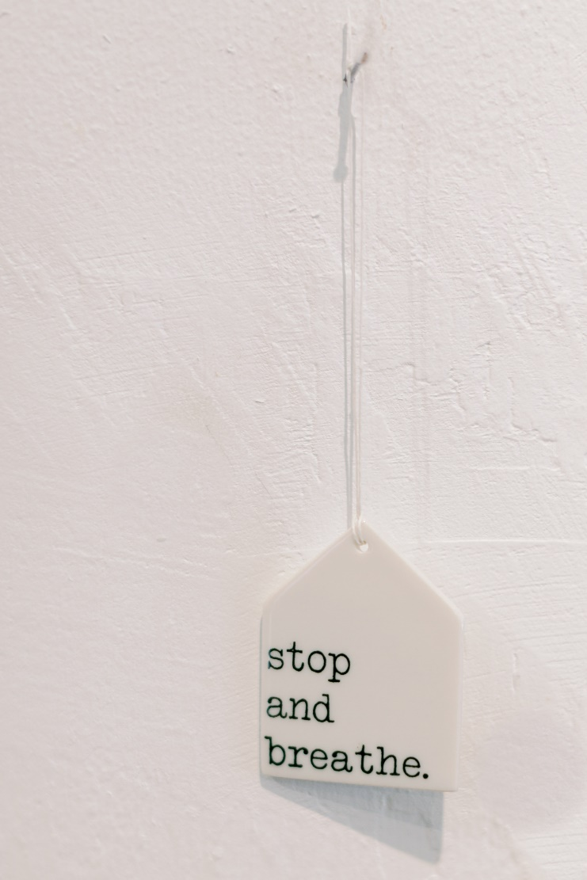

Friday 11th

What does your favorite book say about you?

When I was a kid, I couldn’t get enough “The Fairytales” book .

The first book that made me cry was “The Chicken” and I absolutely loved “Romeo and Julliet” in high school.

I have read “The Sherlock Holmes” series multiple times, but if I had to pick an all time favorite (not fair, I know, but I’ll do it if you do!) it would be… Sherlock!

Now you! What is your all time favorite read?



Saturday 12th

“Success is not final, failure is not fatal: it is the courage to continue that counts” – Winston Churchill

At times, might seems difficult to go through life. To keep going you must remind yourself why you are doing it.

What is your mission? What is your biggest “why”?

I keep going because I can see at my clients how much they are progressing, and my mission is to bring love and forgiveness.

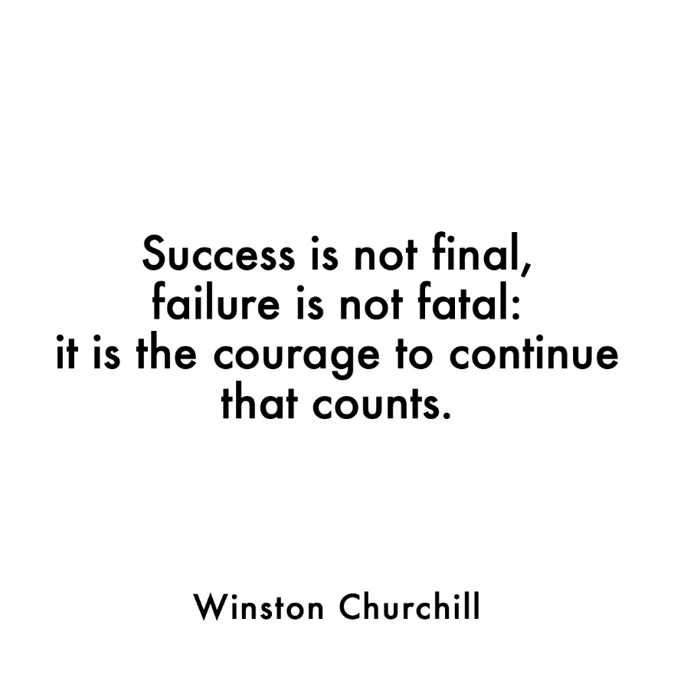

Sunday 13th

18 days remain until the end of 2020!

Not so much left of it, isn’t it?

I know it’s been a rough year for most people, but if you can search for 3 things that you are grateful for, what would it be?

Even if you can’t see in the turmoil of days, good things are there, you just find to stop for a second and pay attention.

