Monday 30th November- good bye november, good month

Here we are!

New week, end of the month. How was november for you?

What went well? What went wrong?

What could have you done differently?

Whatever November brought you, tomorrow starts a new month, and the end of 2020.

New plans, new opportunities!



Tuesday December 1st  hello decemeber, what do you bring?

Hello, December! Be kind to us <3

The 1st of December marks the beginning for the season of Advent, it’s name suggests the time to prepare for Christmas.

It’s time for magical moments and retrospectives, and of course, new plans!

It is a magical month, with Christmas happening and the New Year, is that time of the year when we make plans, we hope for the best for 2021 and often say “starting in January I will do…..”

What will you start new in January? 😊



Wednesday december 2nd plans for decemebr

This month I have many plans with my Romanian community.

Monday we had the Vision Board masterclass, now I am preparing the Membership for emotional release that will start in 2021.

It will be a busy month!

What are your plans for December?

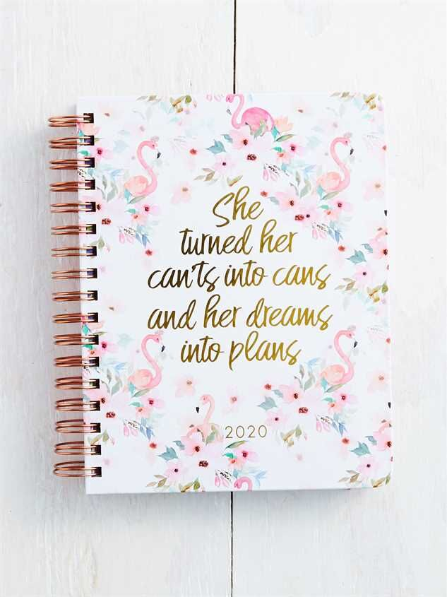

Thursday december 3rd the opportunitea

Want to hear something fun? I started my business because I saw an “opportunitea” and took it.

Okay, not REALLY… I started it because love helping people, but the pun was fun, right?

Looking back, it really was an opportunity for me and I feel like it’s what I am meant to be.

And THAT’S a cause to raise a glass (or mug) to!



Friday december 4th gratitude

It is that day of the week when I remind of… gratitude <3

What are you grateful for today?

Maybe a friend who is by your side, maybe to the lady who hold your door when your arms were full of shopping bags?

You can find reasons to be grateful in everything. Have you found your yet?



Saturday December 5th

Cheers to life’s simple pleasures, friends!

Every day is full of micro-moments of joy, like coffee or the sunset.

You just have to be looking for them.

What’s one of life’s simple pleasures that you love?

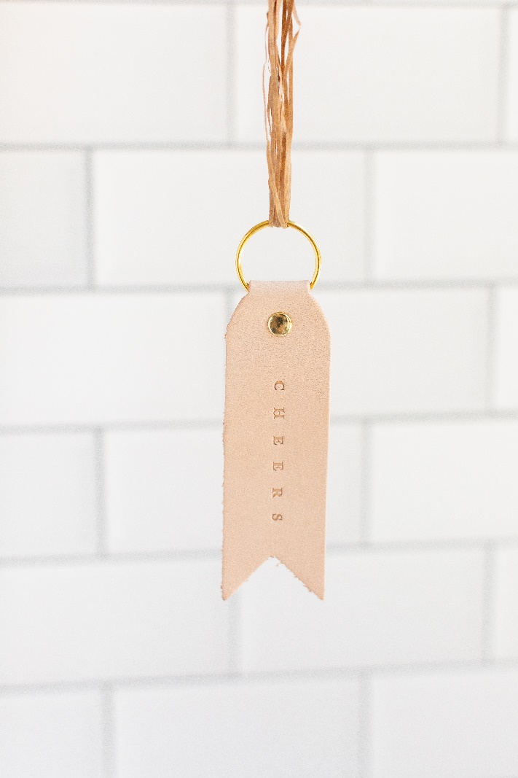

Sunday December 6th saint Nicholas day

6th of december is Saint’s Nicholas Day!

The legendary figure of St. Nicholas is derived from Nicholas of Myra who officiated as a bishop in 4th century Greece.

During his lifetime he developed a reputation for gift-giving by putting coins in other people's shoes, which accounts for many of today's Christmas traditions that involve leaving gifts in shoes or boots.

He s celebrated in some places around Europe, being a reason for children to receive presents.

Do you celebrate this day? If so, what did found in your boots this morning?

