1. Monday

Just as there are seasons throughout the year, there are seasons throughout our lives that change too.

When I first started my business, I was

Now I’m so grateful for these changes, because it’s a reminder that nothing lasts forever.

What season are you in today?

* 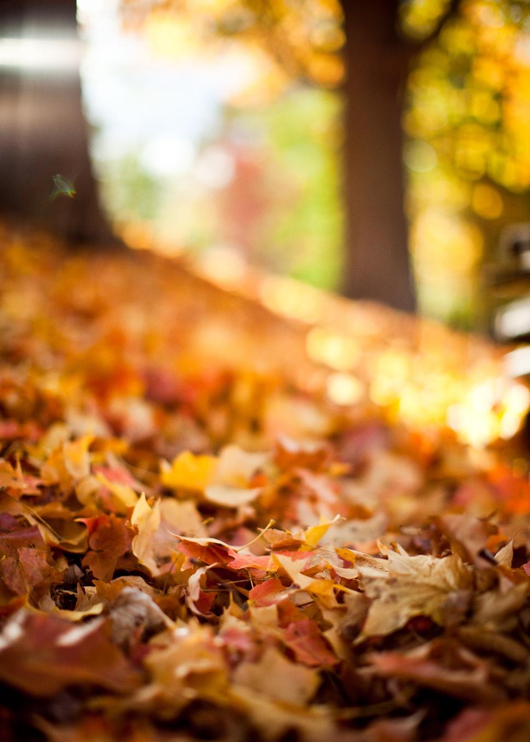

1. Tuesday

They say you can’t pour from an empty cup, and that’s definitely true in my life and business too.

It’s so important to make time for self-care and give yourself grace when feeling a little overwhelmed by life.

That’s why today, I want you to share your tips about what do you do to refill your cup everyday.

Do you have a ritual for self-care? What makes you feel better?

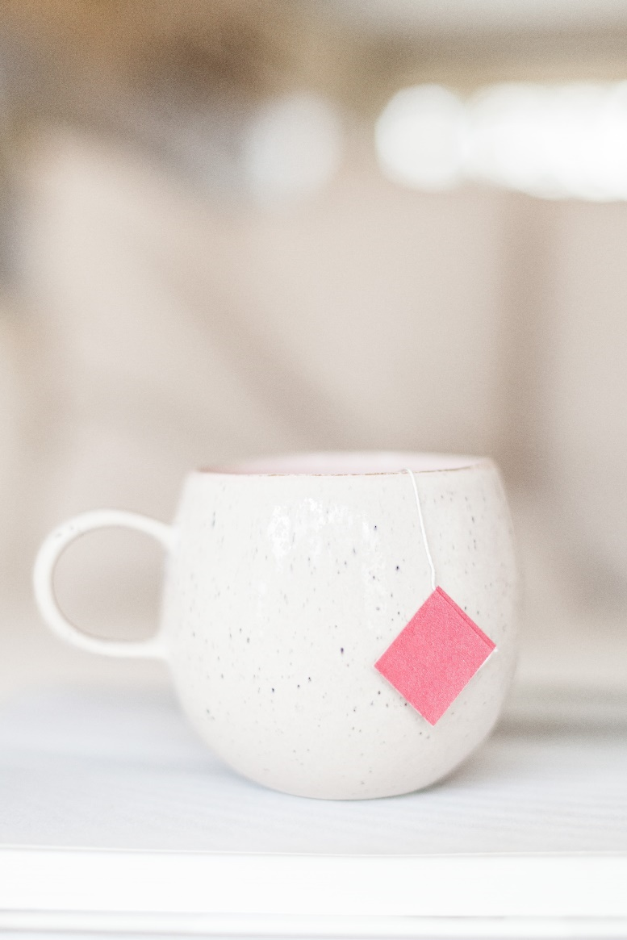

1. Wednesday

How do you get through the really tough times?

When you were a kid and needed encouragement, you could always count on your parents, or siblings maybe to give you a hug and say “you can do this”.

These days, when there are plenty that you want to achieve and so, with big dreams, come big teams!

Who do you have in your corner, urging you forward and fist bumping you along the way?



1. Thursday

Sometimes the simplest days contain the most profound ideas.

Today, I spent the day at home, working in my livingroom,and I accomplished plenty of things*.*

The day was filled with lovely moments and I wished I could bottle up the peace I felt and save it for a busy day.

What’s your workday preference… slow and simple or busy and exciting?



1. Friday

Isn’t life an adventure?

If someone would’ve told me I’d be a therapist 10 years ago, I wouldn’t believe it.

It’s nice to know that reality can be far greater than your wildest dreams.

Could you have predicted where you’d end up today? What was you plan initially?



1. Saturday

Wanna know something?

There are moments in life when you need people who push, pull, and believe in you, even when you don't believe in yourself.

I'm blessed to have this community of like-minded people to share the ups and downs with.

Thank you for filling in my gaps and helping me bring a new dream to life

What are you grateful for today?

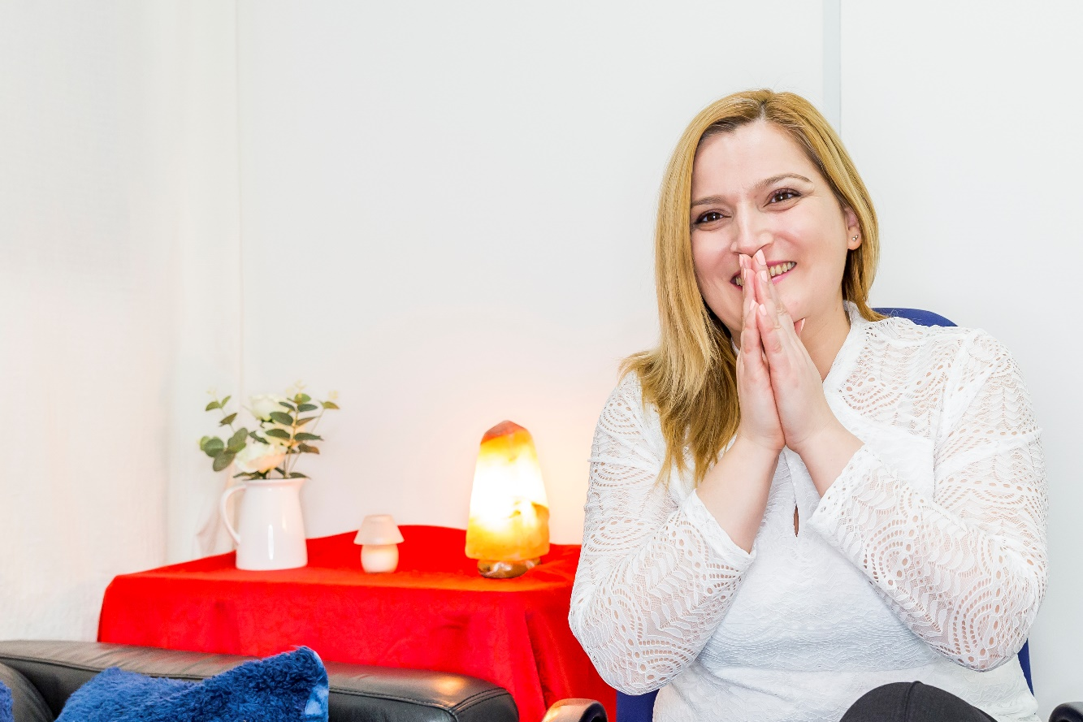

1. Sunday

Quick reminder for everyone reading this: There are 1,440 minutes in a day

It’s ok to take 5 minutes and just sit down and relax, is even better to take 10 or 15 considering is Sunday!

What will you do with your precious time today?