Monday 23 november

Let’s start the week with gratitude!

What are you grateful for today?

I am grateful for my children, my job, my romanian community!

I am very happy and pleased with what is going on right now and i look foward to 2021.

I am grateful for being healthy and well, greatful for my life.

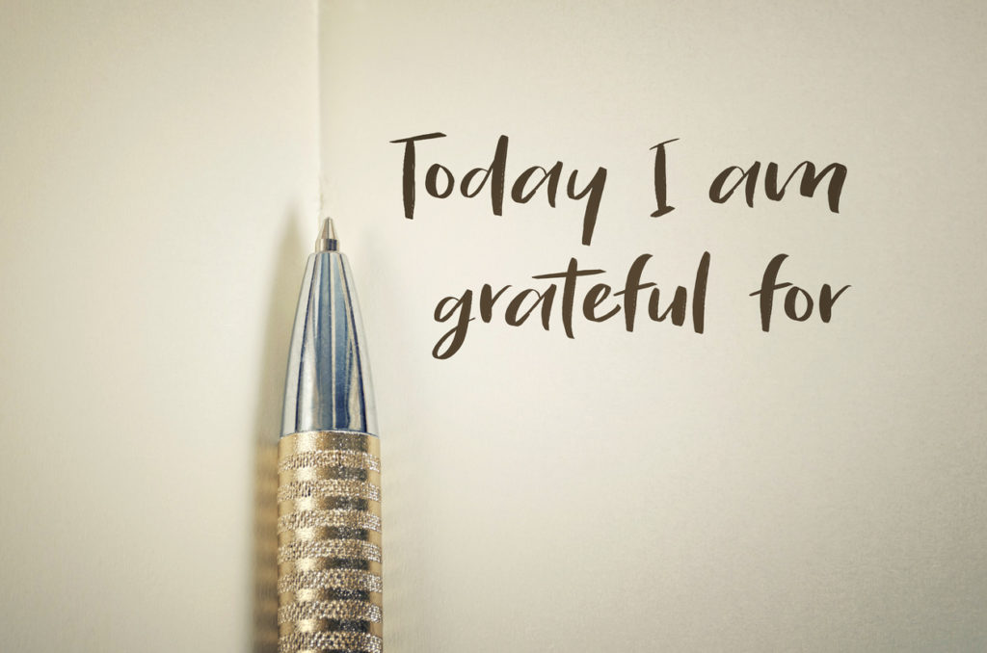

Tuesday 24 november- celebration

I celebrate my life everyday, i celebrate myself everytime i achieve a goal.

I like to celebrate everything, from small to big succeses.

What do you celebrate? Can you find at least a reason to celebrate daily?

They say it is important to keep your positive energy level high, and this is a way to do so.

The Univers will know you celebrate, that you are grateful and will send you more things to celebrate in your life.

Find you celebration! Comment below and share with me 😊

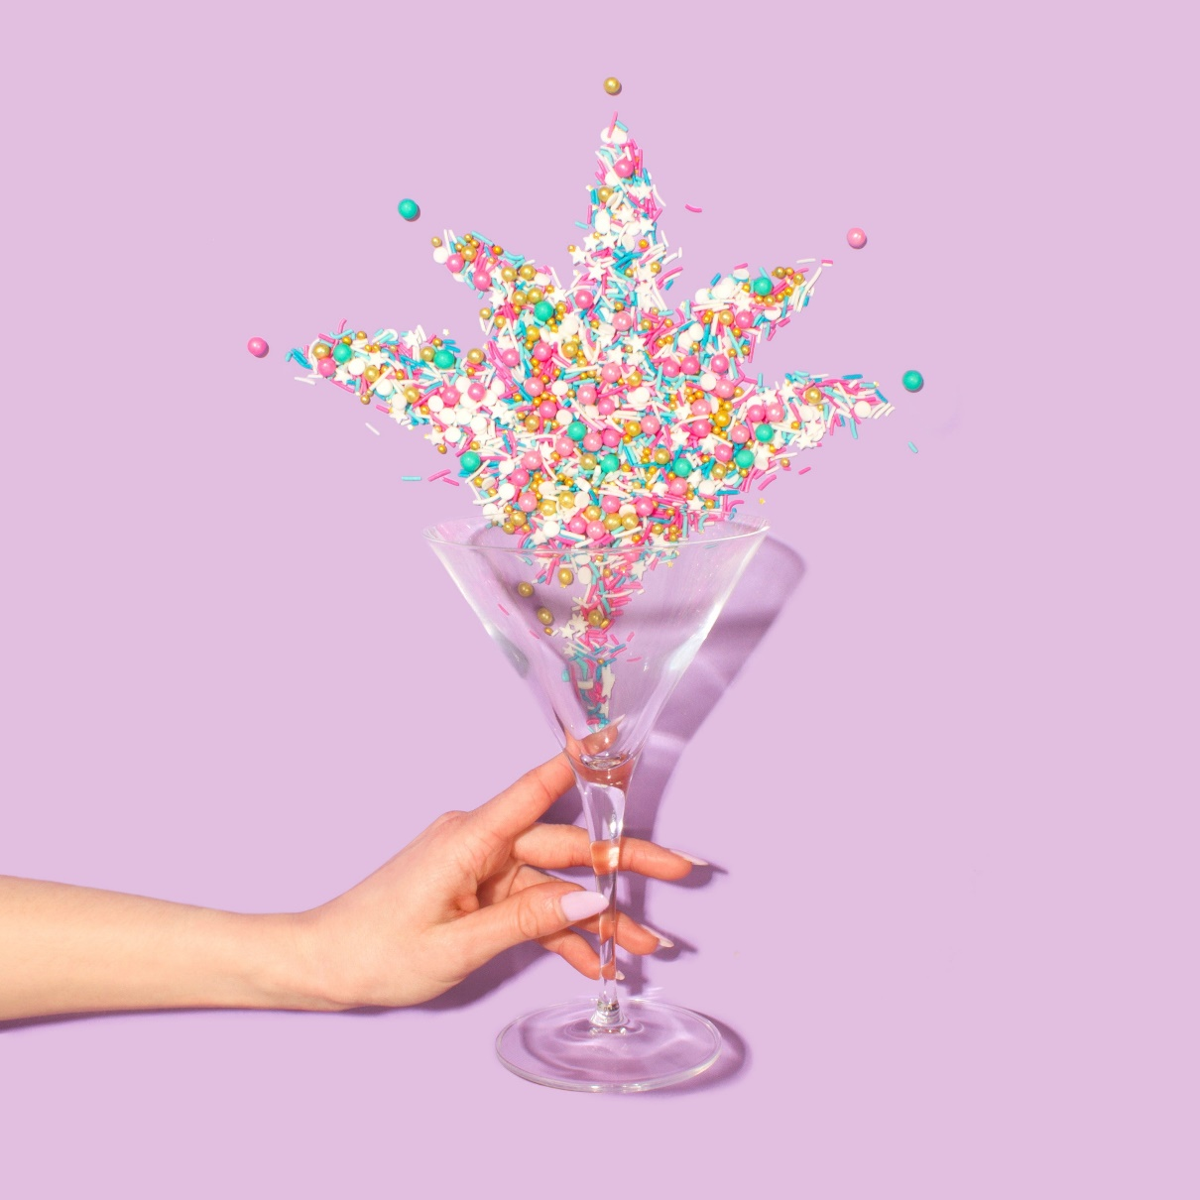

Wednesday 25th november- positivity

Think positive and positive things will happen! You heard that before, right?

It sounds simple, but it is not so simple, is it?

We have to start from somewhere, there must be a begining.

Begin with being grateful, thank for what you have, focus on what you have.

What positive thoughts do you have everyday?

Do you apply the Law of Attraction in your life?

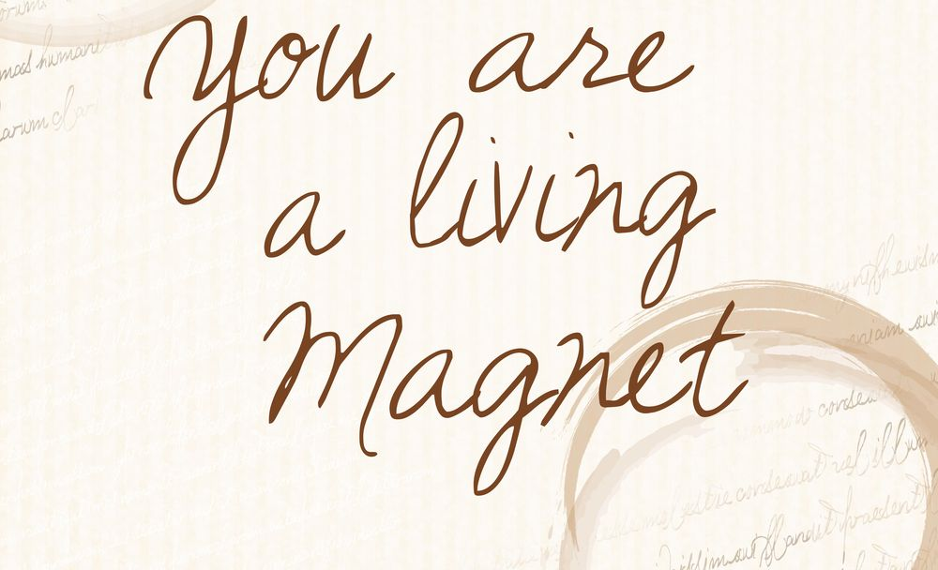

Thursday 26 november- where in the world are you right now?

Hey, i was wondering...

Where in the world are you right now?

I m in London, UK by the way 😊

And i was curious where are you from. Yes, you, the person reading this!

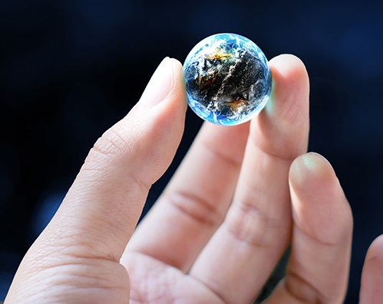

Friday 27 november- where in the world would you like to be?

Yesterday i asked you where in the world are you, but today i want to ask you something else.

Where in the world would you like to be?

If it wasn’t the CoVid or any other thing happening right now, where would you like to tarvel?

Somewhere sunny? Somewhere cold?

Spice the comment with emojies! Pack the bag and let’s go!

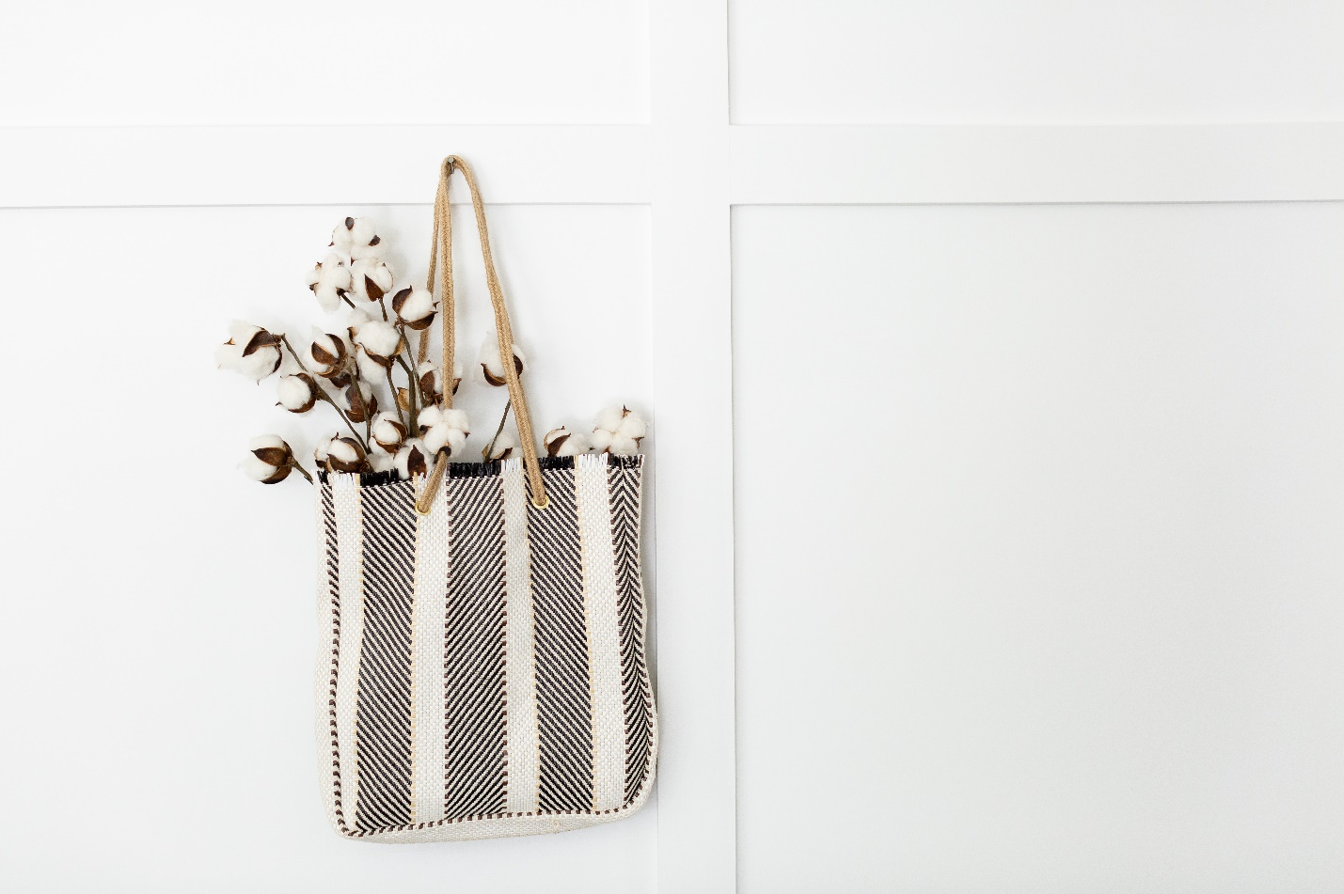

Saturday 28 november- how was the week?

Hello Saturday!

How was your week? Anything to celebrate?

I had a wonderful week, full of positive experiences and lots of smiles!

Tell me about you last few days and how it was 😊

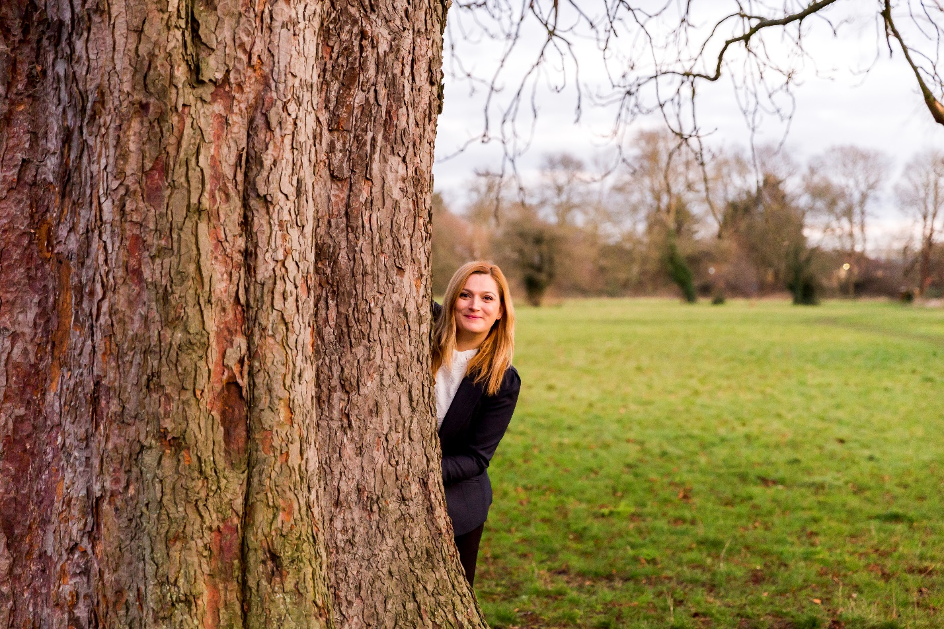

Sunday 29 november- relaxation

What books or movies have you seen lately? Anything interesting to share?

Today is for relaxation. How do you use your Sunday?

I would like to spend the afternoon relaxing with something sweet and a movie or a book 😊

A day to just relax and recharge is what we all need to start fresh. Don’t forget to the „STOP button” every once ina while.

You worth it!

