Monday 21 st –

Do you know what happens today?

Apparently, Jupiter and Saturn are going to align, both planets will be so close to each other and they will look like one giant bright star in the sky.

Astrologers call this phenomenon “The Great Conjunction”, or in this case, “The Christmas Kiss”!

Earthsky.org says “Jupiter-Saturn conjunctions happen every 20 years; the last one was in the year 2000. But these conjunctions aren’t all created equal. The 2020 great conjunction of Jupiter and Saturn will be the closest since [1623](https://en.wikipedia.org/wiki/1623) and the closest observable since [1226](https://en.wikipedia.org/wiki/1226)! 2020’s extra-close Jupiter-Saturn conjunction won’t be matched again until the Jupiter-Saturn conjunction of March 15, 2080.”

Can you belive that? We will be witnesses for something HUGE!

Energies will change, everything will change…

What do you think about this?

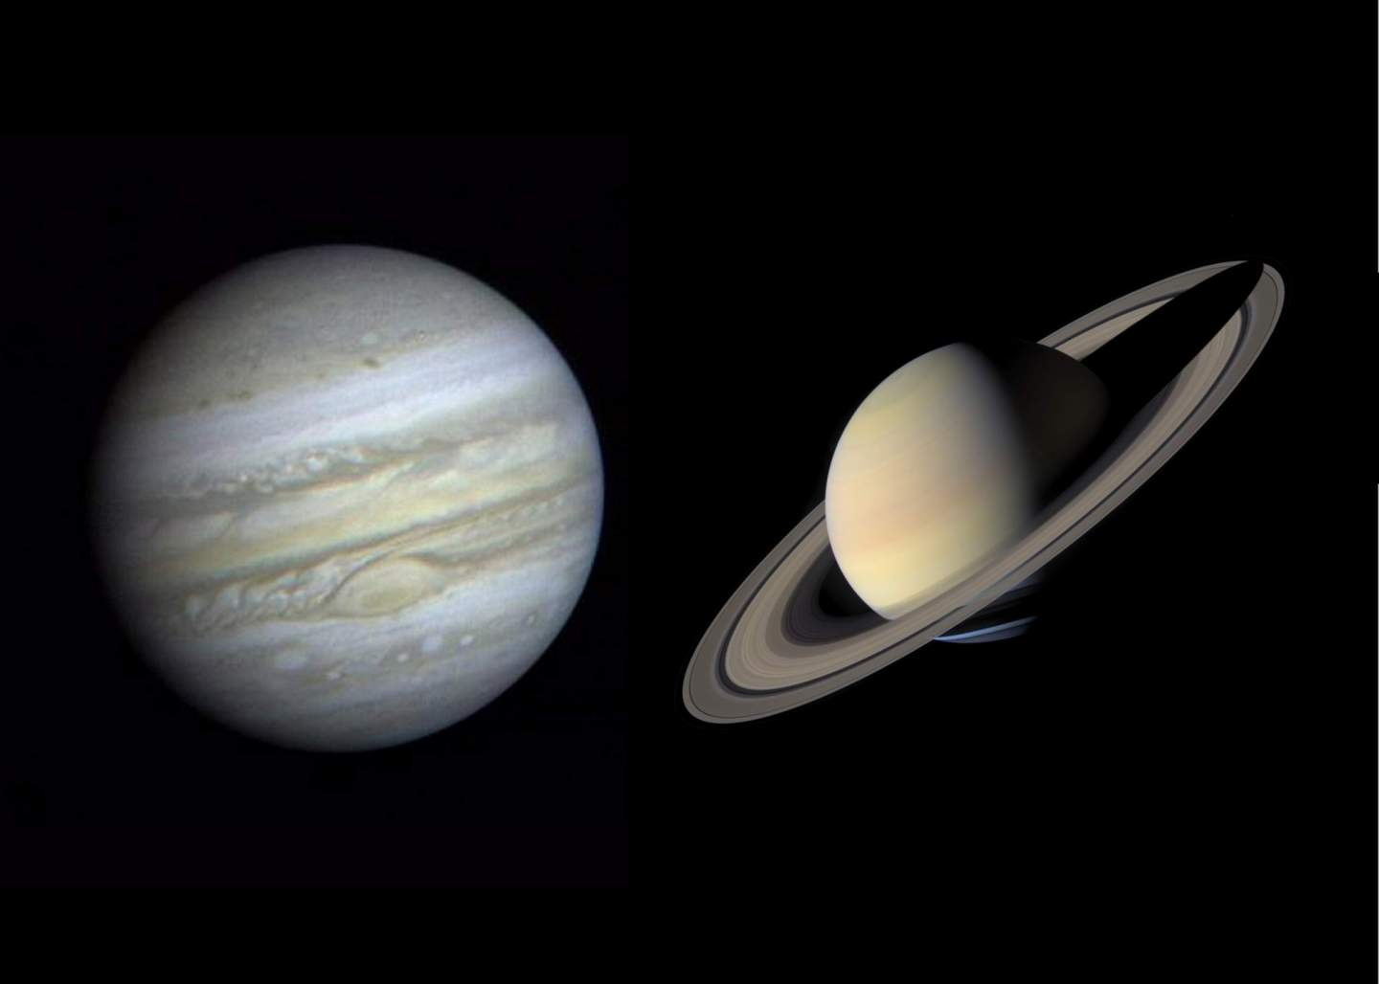

Tuesday 22nd

Hey! Have you seen “The Great Conjunction” yesterday?

It’s said that we just started a new 200 years era… I m so excited about this!

I wonder what future will bring…New and exciting things, I m sure!

What do you think?

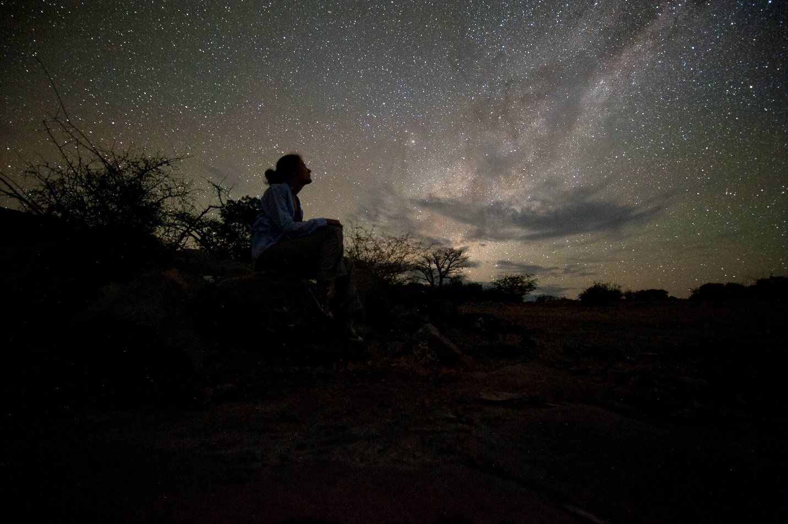

Wednesday 23rd

2 days left until Christmas…

Are you ready? All good?

When it comes to holiday shenanigans, are you more Clark Griswold or Mr. Grinch?

I love holiday tradition! Though, for me is a bit hard being away from my family in Romania.

What do you love most about Christmas?



Thursday 24th

So, this is it, right?

Tomorrow the Christmas is happening! Are you excited?

I wish you all the best, I hope you are staying safe and healthy, I will have few days off for the holidays and I will relax 😊

Do the same! Take a break and just enjoy this period of the year.

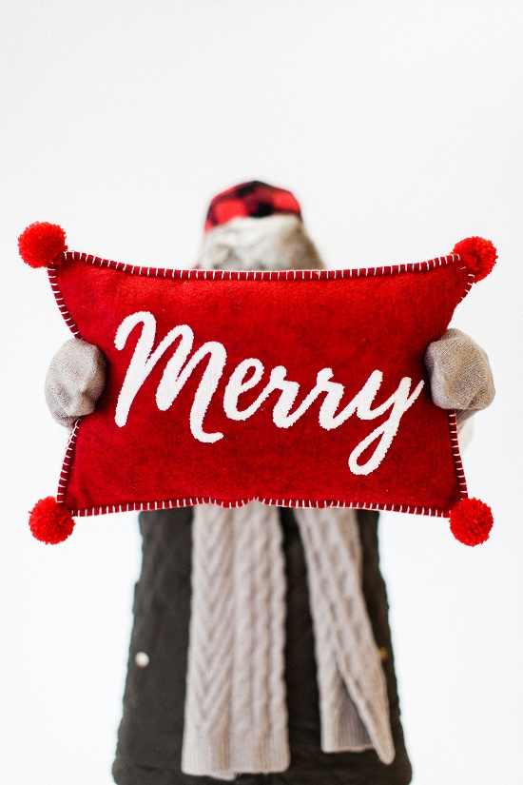

Friday 25th

We wish you “Merry Christmas!”

Whether you’re enjoying the day with loved ones or peacefully alone, I/we hope you’re doing fine.

Us? We’re spending the day relaxing in our home.

How are you spending the holiday?

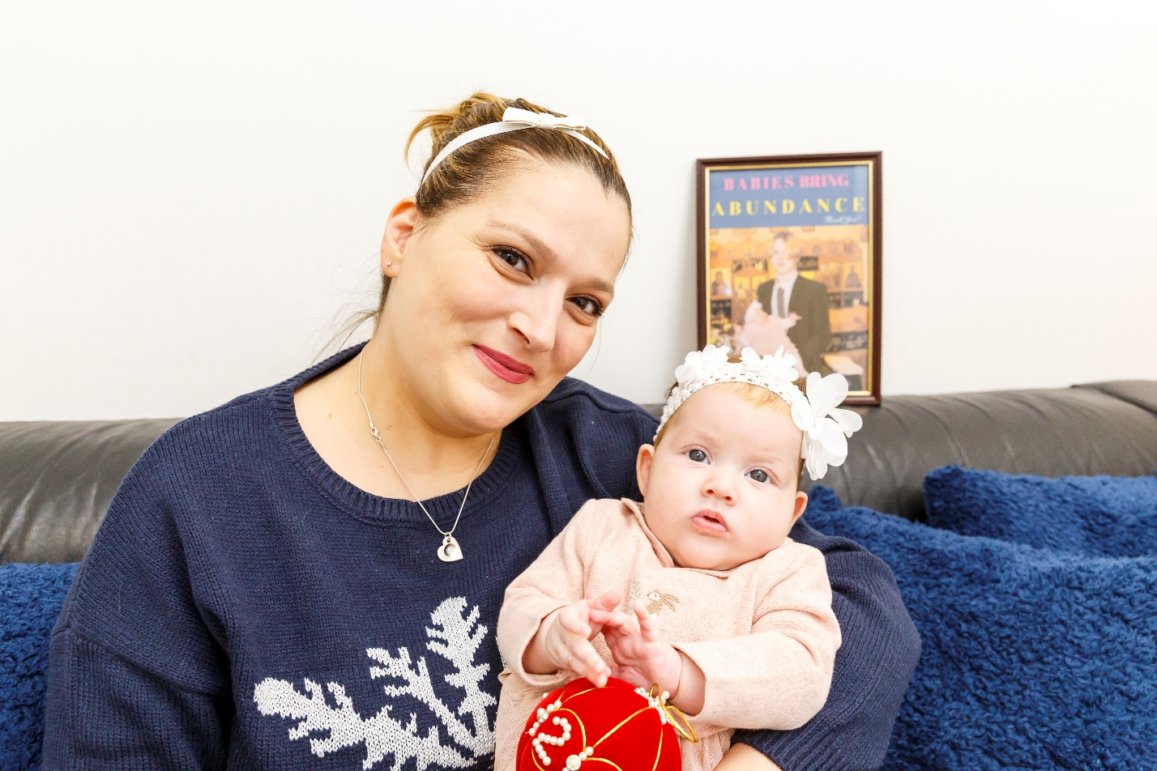

Saturday 26th

Gratitude…

Take a minute and just think. What are you grateful for today?

I am grateful for my family, my friends, my home, for everthing I am, for what this year brought me with good and bad.

Everything I experienced had taught me a lesson, so I am grateful for it 😊

Practice gratitude everyday!



Sunday 27th

In the 3rd day of Christmas my true love gave to me…

Still relaxing 😊

How are you doing? Had a nice Christmas?

What plans do you have for next week – the last week of 2020?

