1. Monday

Have you ever thought about how a click of a camera button has the ability to capture a moment in time?

Pretty amazing!

There are many once-in-a-lifetime memories that I love to reminisce looking through old photos.

There are some day-to-day moments that make my heart happy, too, like the magnolia trees that line my block, whether or not they’re in bloom.

I need to make an effort to take pictures of it so I can cherish the memory forever.  What is something that you see everyday that brings you joy?

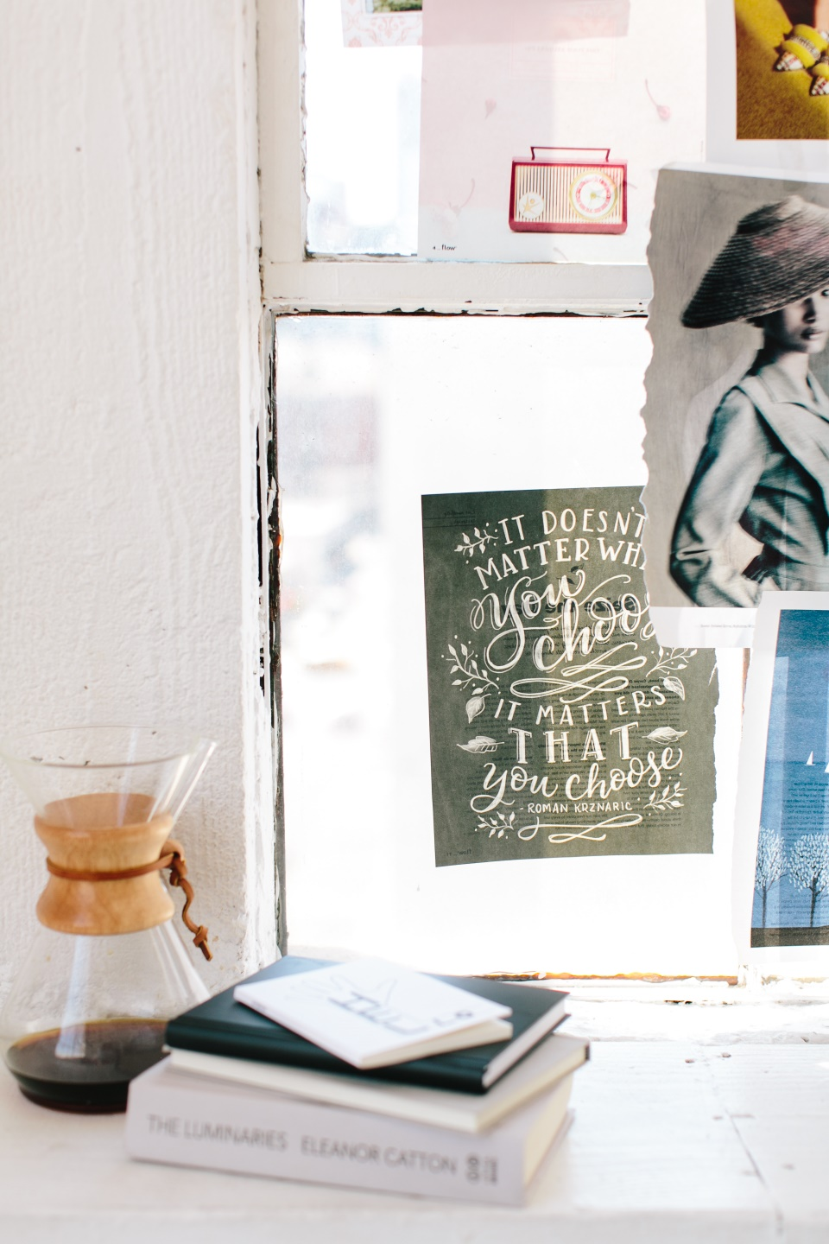

1. Tuesday

I’ve got a life hack coming your way! Ready for it?

Just like our phones and computers need to be turned off and updated every once in a while, so do WE!

That’s right, sometimes the best way to stay fresh is by unplugging!

I’m taking my own advice by putting my phone down and stepping outside for some fresh.

How about you? What helps you feel refreshed?

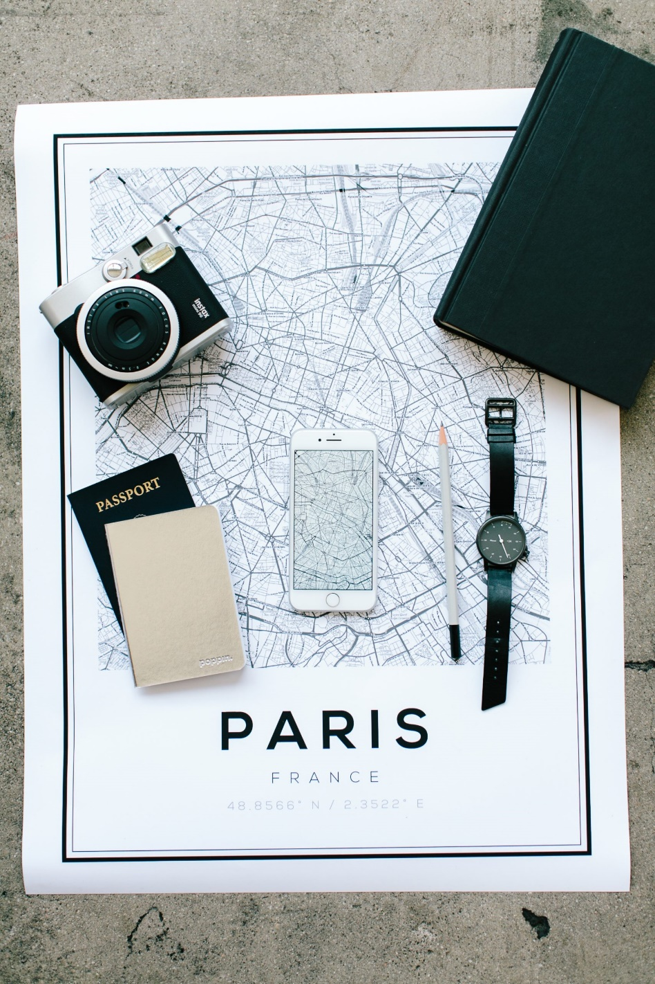

1. Wednesday

If I’m being honest, I was terrified when I started my business few years ago.

But I knew that there were so many possibilities waiting for me outside of my comfort zone, so I went for it!

I’m so glad I did, because I’ve been able to serve amazing people.

Their heartfelt words gave me all the warm fuzzies. There’s so much joy in what I do, and for that I am so very thankful.



1. Thursday

Is there anything you are a bit insecure about?

Maybe some people might not feel confident enough or they are the intensely shy.

Although they struggle with this, they are working every day to turn things around by quelling their anxiety with daily meditation*.*

What are you insecure about, and how do you overcome it?

Regardless of what it is, know this friend: you are enough!

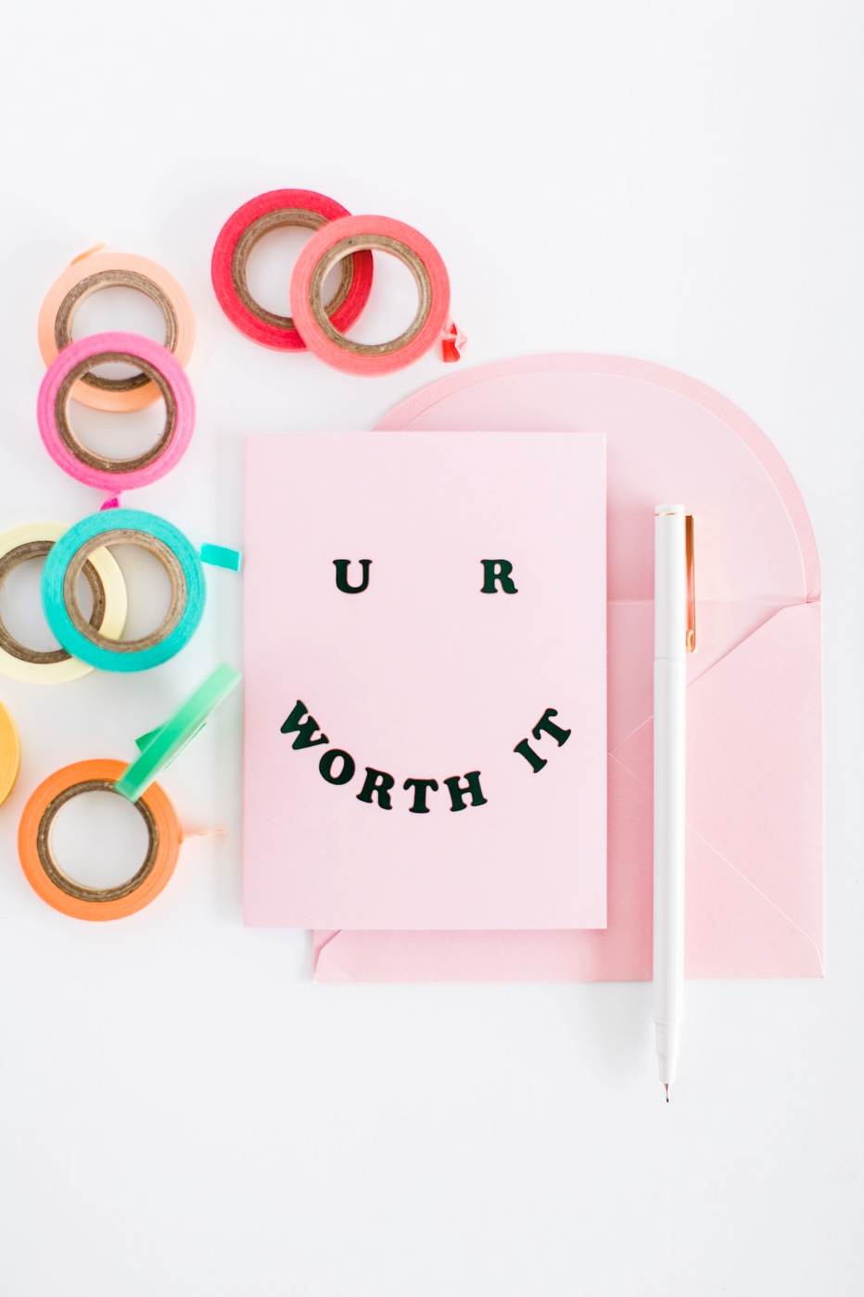

1. Friday

Who else has the itch to travel?!

Travelling is an amazing experience that gives you extraordinary insight and it reveals a whole new world.

Also, helps you discovering yourself. You could find out new things: like how you feel about different cultures, about different languages, how you feel far away from your homeland.

Travelling is something that everyone should do every once in a while.

What location is on your travelling bucket list?

Drop an emoji hinting at your dream holiday and let’s see if I can guess the location!

Ready? GO!



1. Saturday

What do we use daily?

Words for example, we all use words all the time. There is a quote from “The Education of Henry Adams” (1907) by Henry Adams saying:

“No one means all he says, and yet very few say all they mean, for words are slippery and thought is viscous.”

I have a question for you today: When people are describing you, what words do they use?

What three words describe you best?

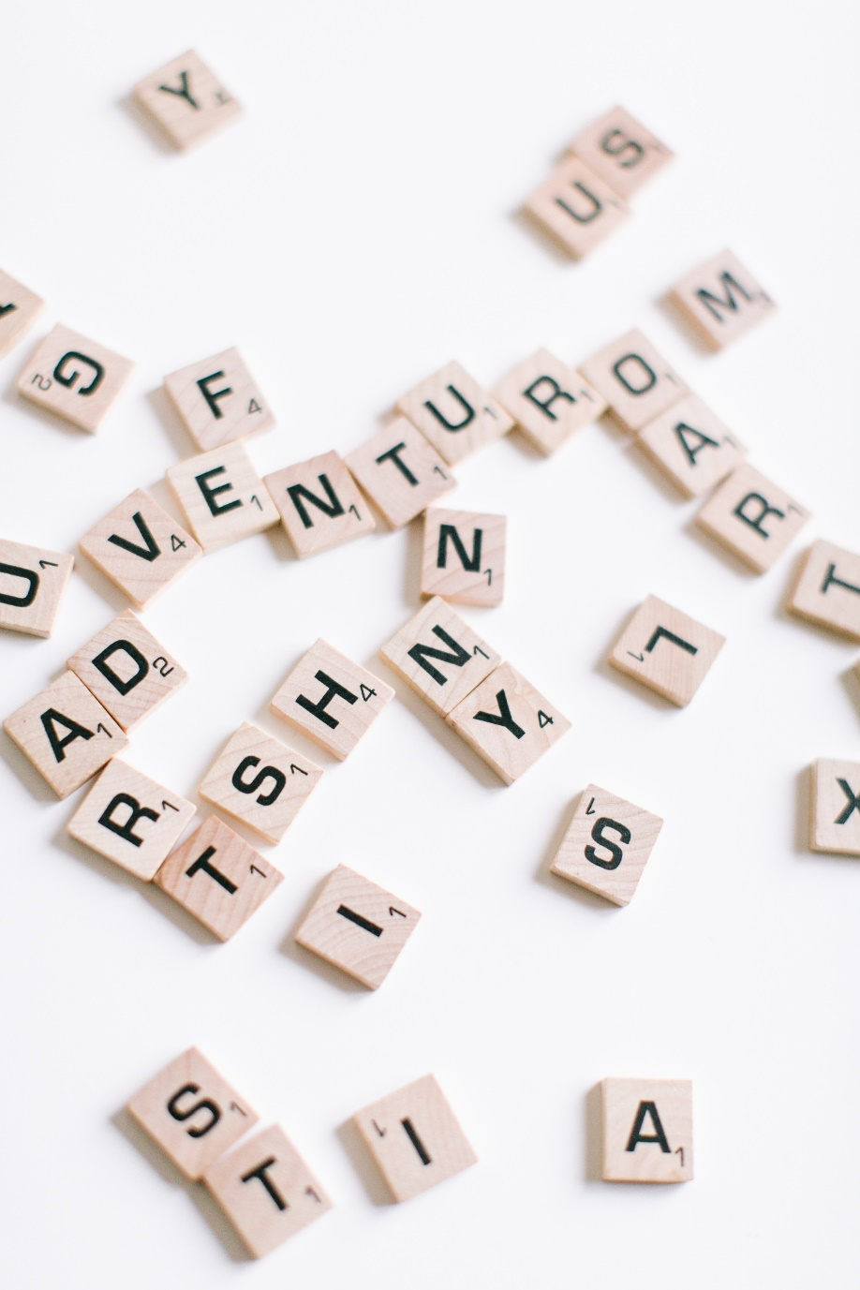

1. Sunday

Are you ready to balance and align you Body, Mind and Spirit?

As a therapist/coach you change lives, you help clients discovering themselves and make the best out of everything.

But that can make you feel emotional, physical or mental turmoil sooner or later.

This will help you align and balance the 3 realms through Coaching, Counselling and Reiki and become the Creator of an Irresistible Signature Program that will propel you as an expert in your field.

So, be honest… Are you willing to give it a try?

