Monday 16th November

When I was first learning the ropes of being a therapist, I have to admit it wasn’t pretty.

I made some mistakes, like everyone else,and I didn’t have much to show for all of my hard work.

But I kept climbing, and eventually I got to where I am today, and I couldn’t have done it without all the hard work and determination*.*

So, friend, if you are looking for a sign to not give up, this is it.

Vow to keep going, even on the hard days!



Tuesday 17th November

“Be the change that you wish to see in the world “- Mahatma Gandhi

Sounds powerful, doesn’t it?

And it can be if you have big plans and a dream to follow.

The change must start from somewhere. It can start with you!

Changing things in your life, from bad to better, can create a chain reaction which could set off a chain of similar effects. That makes “better” becoming “best”.

May you days be the best! Make the change starting with you.

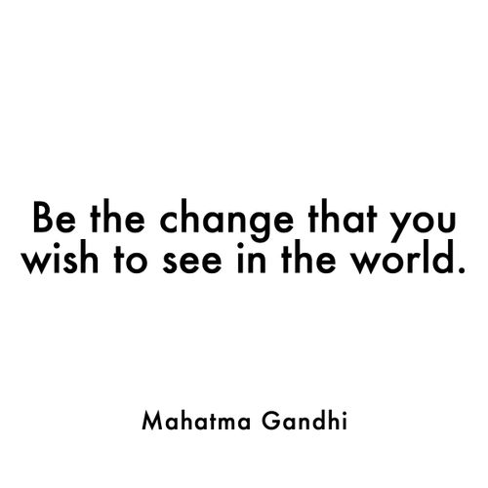

Wednesday 18th november

I find inspiration in people and everything that surrounds me.

If you pay attention to details, you will find the inspiration you need even when you think there is no inspiration left.

Let the Universe inspire you with all his marvelous things!

Where do you find inspiration for your business/career?

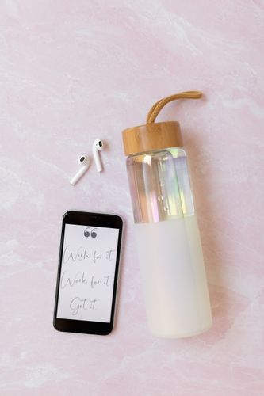

Thursday 19th November

I think we could all use a little more gratitude in our lives, right?

Today, I want to take a moment to say THANK YOU for following along with my journey on social media.

It’s people like you that inspire me each and every day.

I appreciate you! Tell me, how long have you been hanging out in this corner of the internet?



Friday 20th November

Are you a worry wart or more carefree?

I spent many days worrying about things that hadn’t happened yet.

In the last years, though, now I choose to worry less and live more.

How about you?

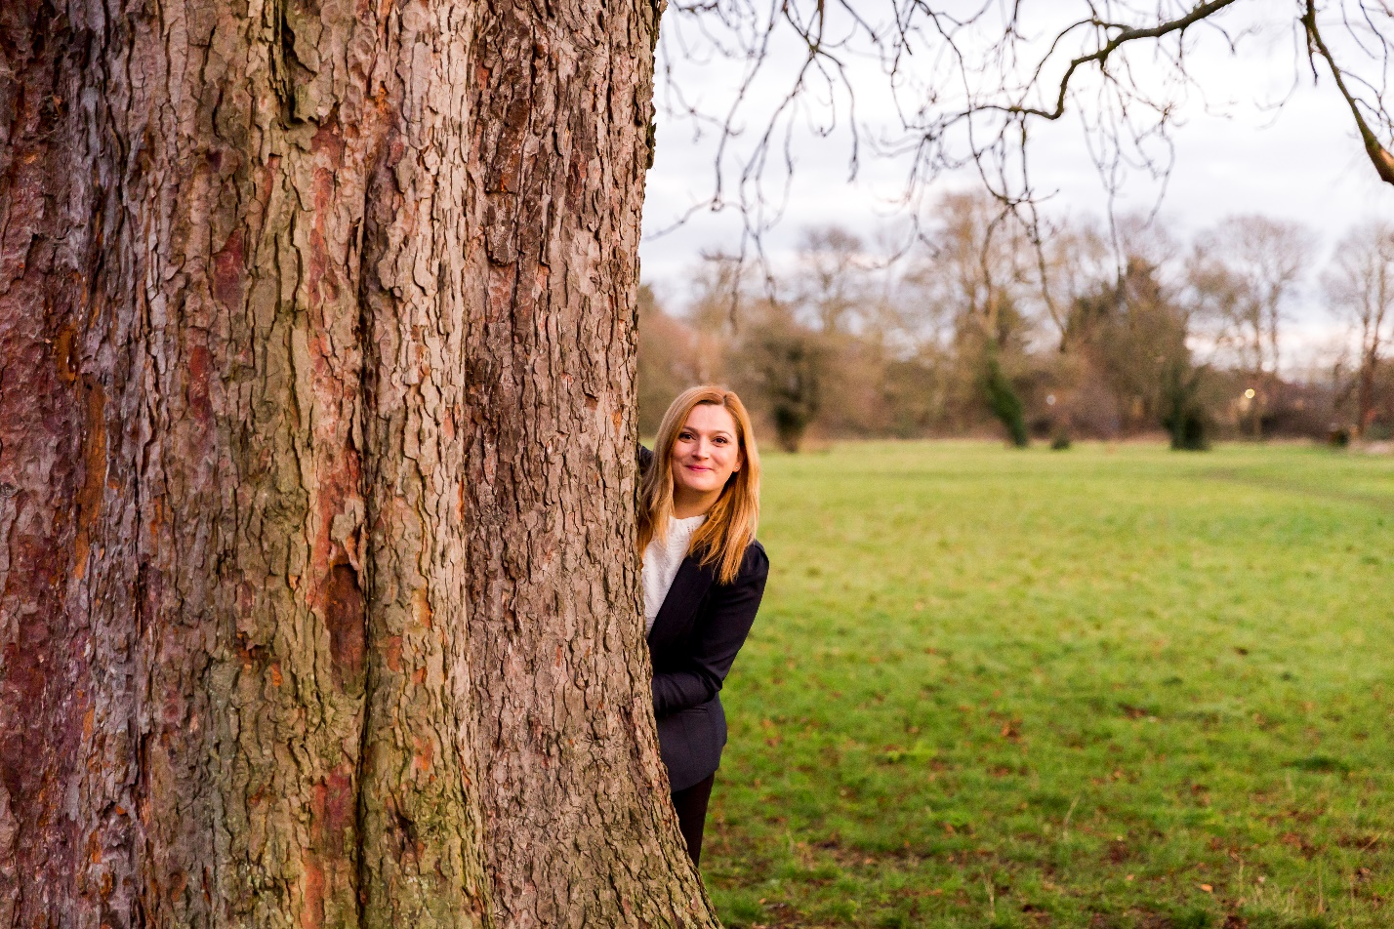

Saturday 21st November

I thank God every day that I get to be a therapist.

It’s fulfilling because I can help so many peopleand the best part?

I can feel every positive energy coming to me from them!

What are you grateful for?

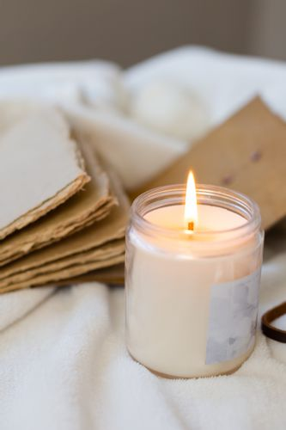

Sunday 22nd November

Today is a day dedicated to relaxing.

You’ll find me resting in my bedroom, wearing comfortable clothes, and sipping on my tea.

Does it get any better? What are you up to this weekend?

